Political Correctness at Santa María de Valdediós, Villaviciosa, Asturias

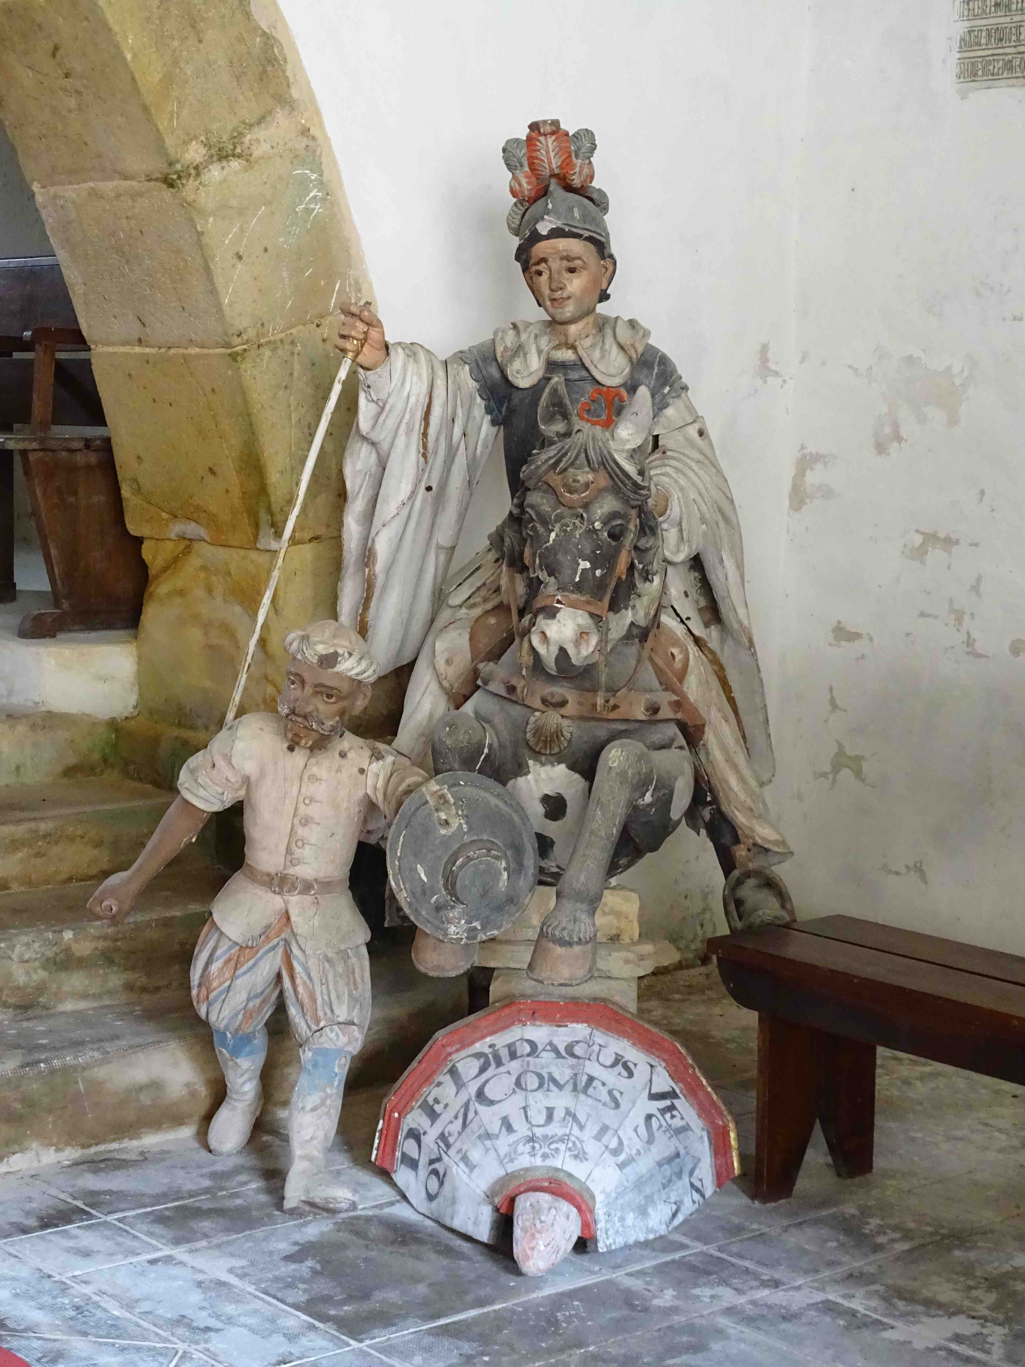
Statue of Don Francisco Diego Velázquez, 1763 – 1767, made by Francisco de Nava, now in a side chamber of the cloisters of Santa María de Valdediós

The monastery complex of Santa María de Valdediós is a delightful place to visit. Rich in ecclesiastical history and art spanning more than a millennium, Santa María de Valdediós also bears witness to more recent changes in political sensibilities in Spain.
Located in the verdant Puelles valley some eight kilometers to the south of the Asturian city of Villaviciosa, the monastery complex at Valdediós (“Valley of God”) includes the 9th-century church of San Salvador, the 13th-century church of Santa María with its attached 16th- to 18th-century cloister, and a number of out-buildings, including a hostel for pilgrims traversing the coastal branch of the Camino de Santiago.
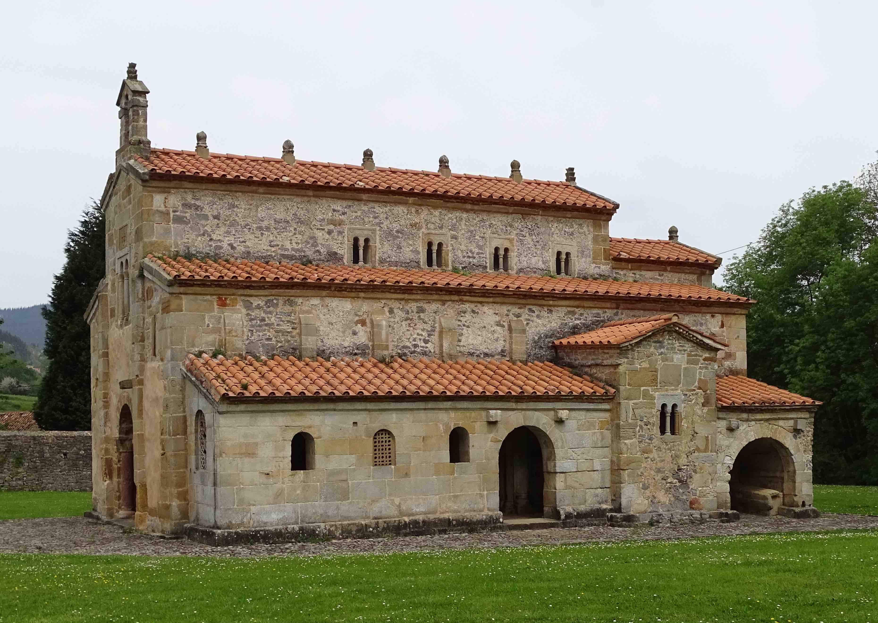
San Salvador de Valdediós from the south.

The small, three-aisled basilica of San Salvador—a UNESCO World Heritage site—is one of the most important pre-Romanesque structures in northern Spain. It is unique among Medieval Spanish churches in having a consecration inscription; dating to the year 893 (during the reign of Alfonso III), this inscription is located in a porch annexed to the southern flank of the church and records the names of the seven bishops who attended the consecration, including three from as far away as Santiago de Compostela, Lugo, and Zaragoza. The well-preserved San Salvador church itself, which was probably constructed around 875, is notable for its architectural and painted decoration that attests to the development of an indigenous Asturian artistic style which arose under Carolingian, Byzantine, and Moorish influences.
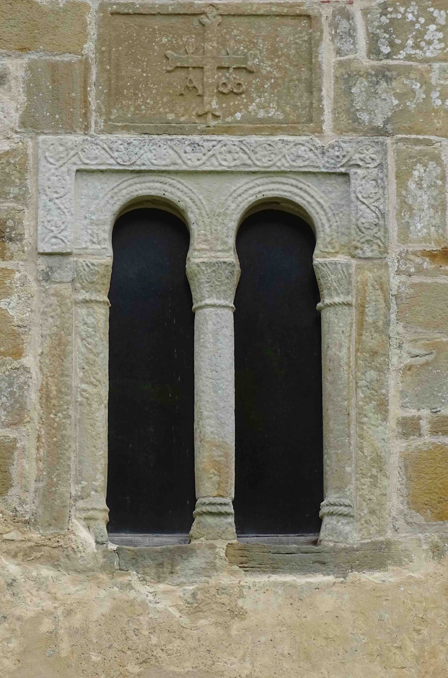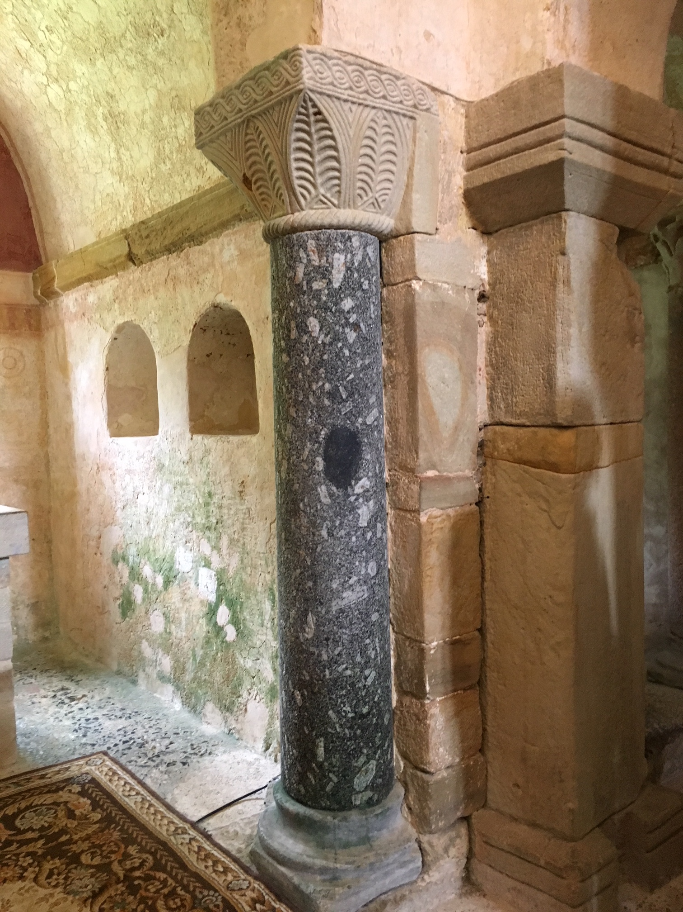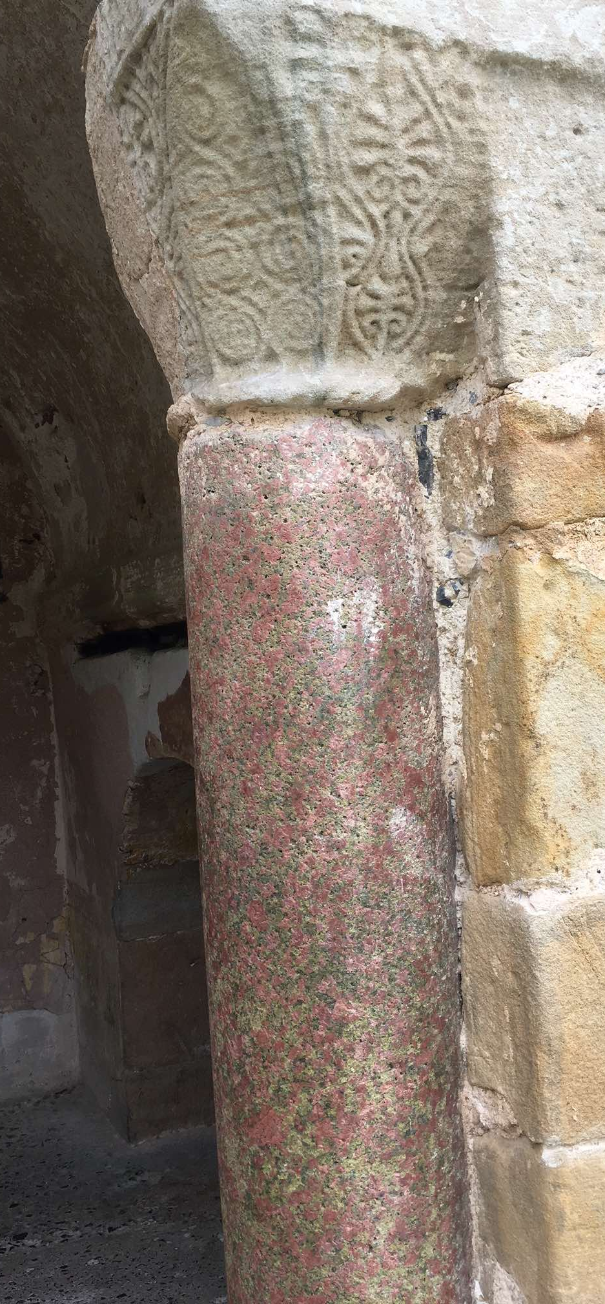
San Salvador, west façade San Salvador, central apse San Salvador, west façade
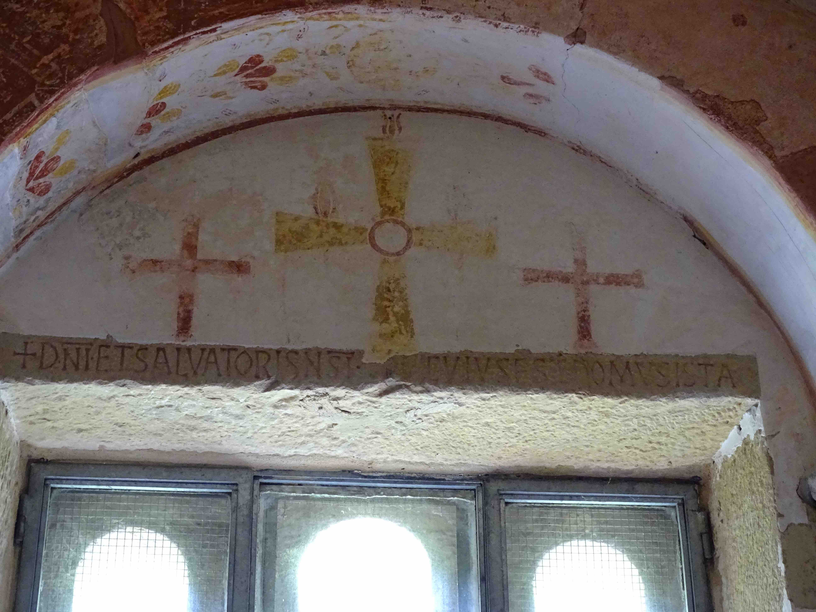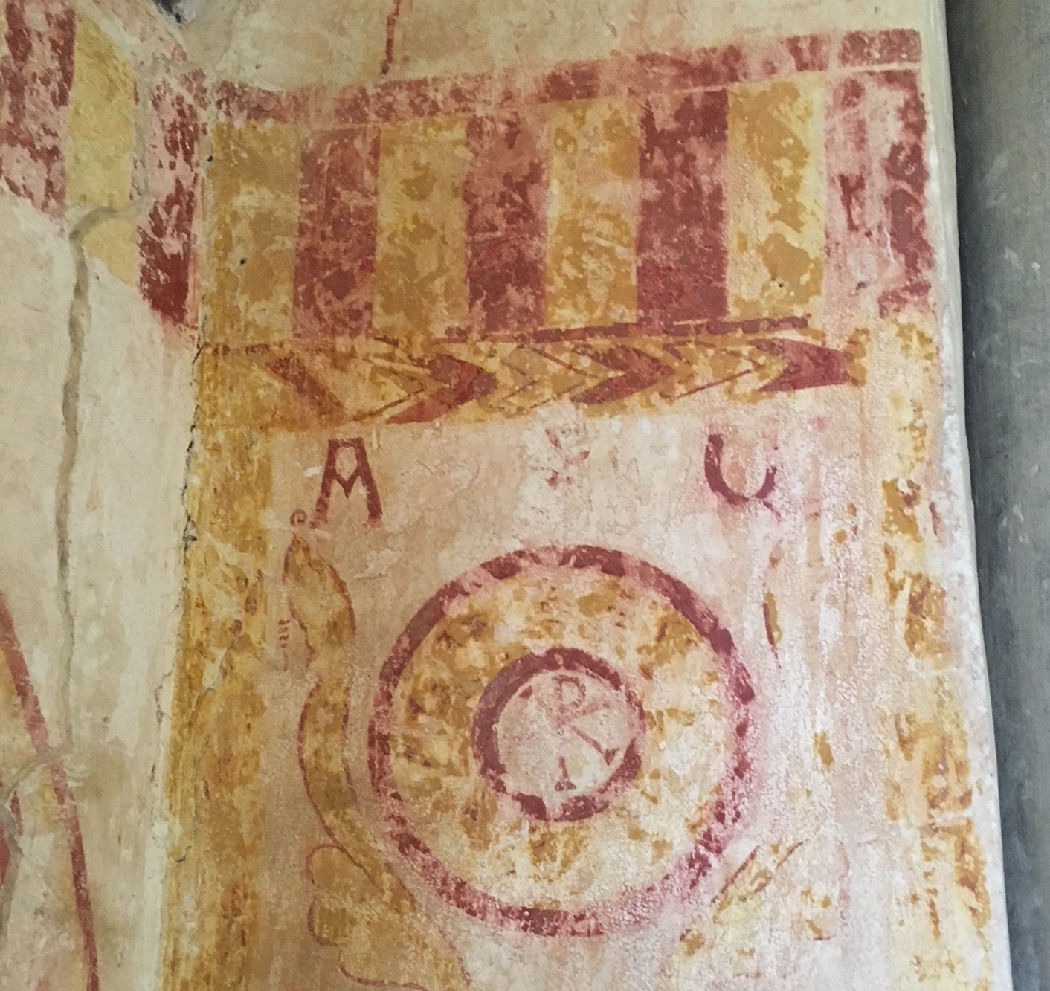
San Salvador, central apse San Salvador, north aisle

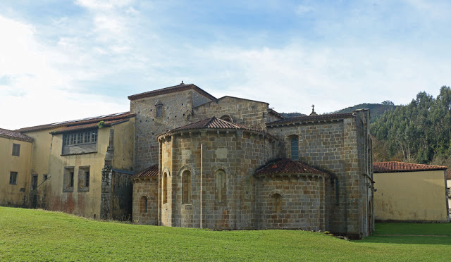
Santa María de Valdediós from the east

A few dozen meters to the south of San Salvador lies the sprawling Santa María monastery. Originally established in 1200 by French Cistercians in the reign of Alfonso XI, an inscription carved over the northern portal attests that construction on the church itself began in 1218. Built immediately adjacent to the Rio Valdediós, over the centuries the Santa María complex has suffered from a number of devastating floods that inundated the church nave to a level of three meters and damaged the cloisters to its south; it is a miracle that the large basilica itself survived this flooding, although it did experience significant subsidence, especially along its north face.

In the 19th century, following the French invasions of Spain and the disentailment legislation of 1835, the Santa María complex fell into decline and ceased to function as a monastery after the death of the last Cistercian monk in 1862. Acquired by the Archbishopric of Oviedo, Santa María then served as a seminary until 1954. In 1986, the government of the Principado of Asturias and the Archbishopric began a major restoration of the complex, and in 1992 the Cistercians attempted to reestablish a monastic order at Santa María. By 2009 this attempt was abandoned when the remaining monks—the prior Jorge Gibert Tarruell and two others—were assigned elsewhere, and the Santa María complex reverted to the control of the Archbishopric of Oviedo. In 2016, the monastery was placed under the control of a newly created Carmelite order, Las Hermanas Carmelitas Samaritanas del Corazón, whose fifteen resident nuns and novices now oversee the Santa María complex and the pilgrim hostel.

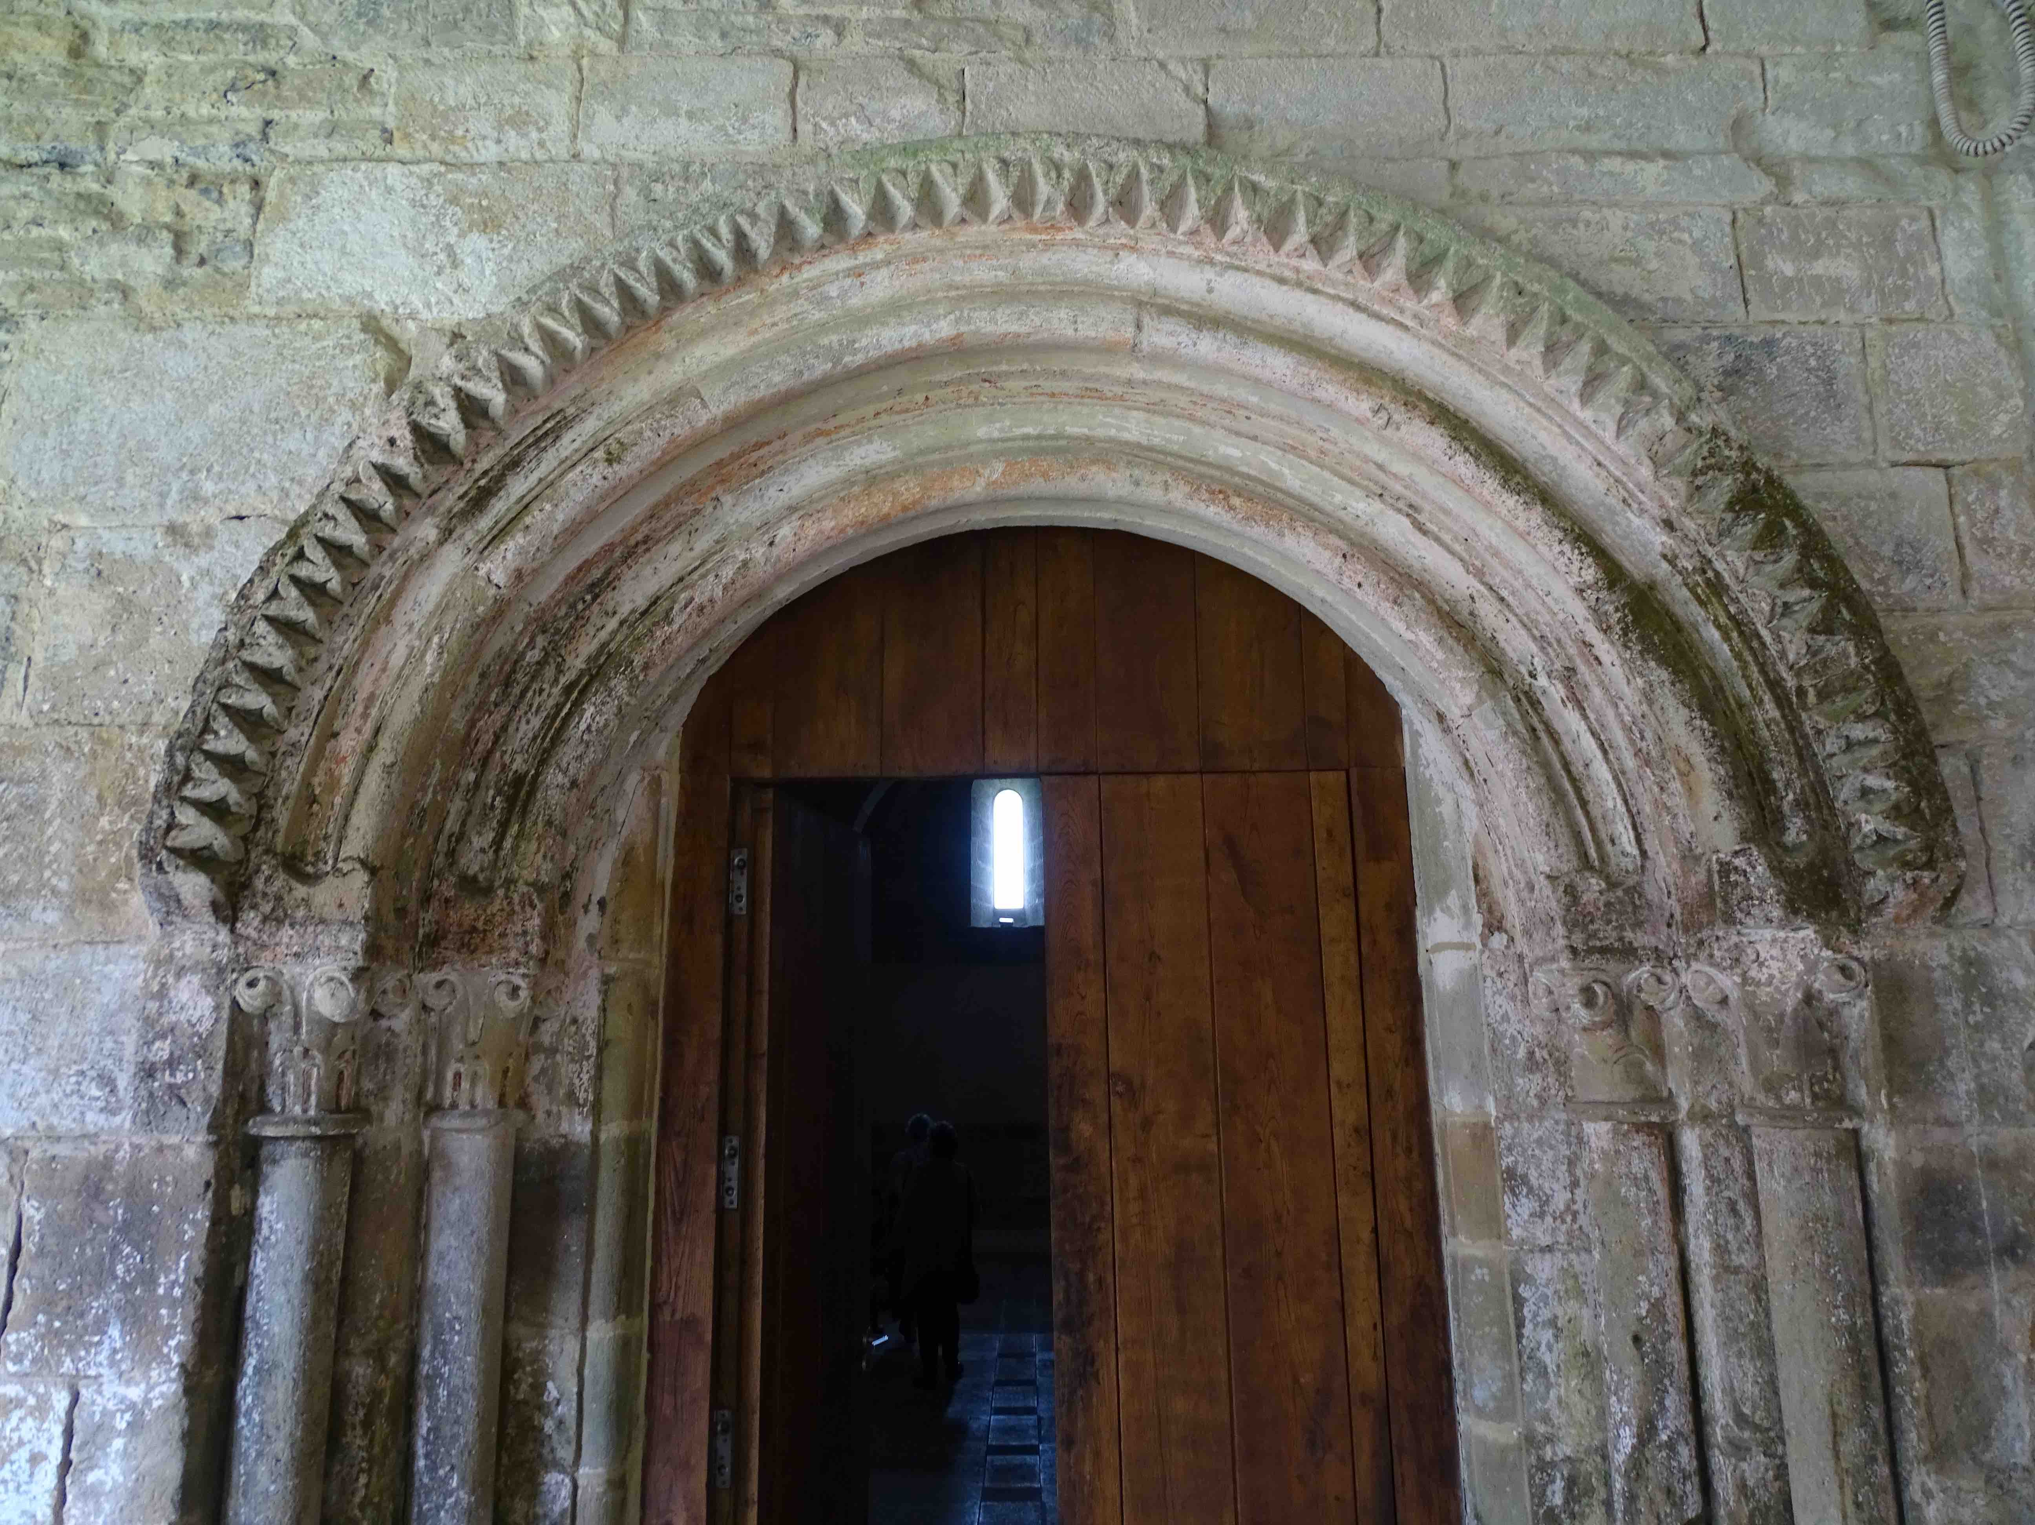 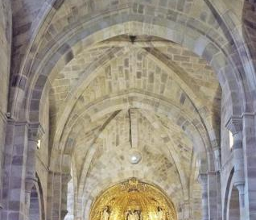Santa María, “Puerta de los Monjes” from cloisters. Santa María, ribbed vaulting on central nave.

The largest Romanesque structure in Asturias, the 13th-century church of Santa María de Valdediós presents a combination of traditional Romanesque low rounded arches and tall soaring ribbed vaults that anticipate Gothic forms. Notable among the church’s furnishing is the magnificent Baroque retablo mayor, the work of Manuel González Manjoya dating to 1750. Among the many charming details of the retablo, which features scene in the life of the founder of the Cistercian order, Saint Bernard of Clairvaux, is an anachronistic carriage carrying the saint on his way to found his monastery while a red devil lodged in the rear wheel attempts to stop him.

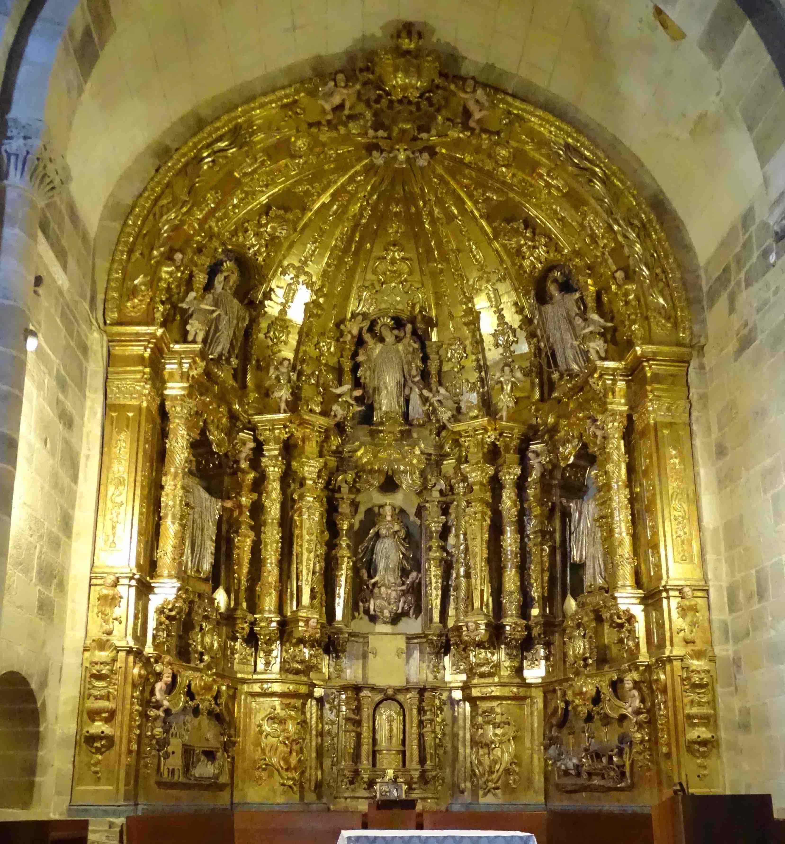
Santa María, retablo mayor.

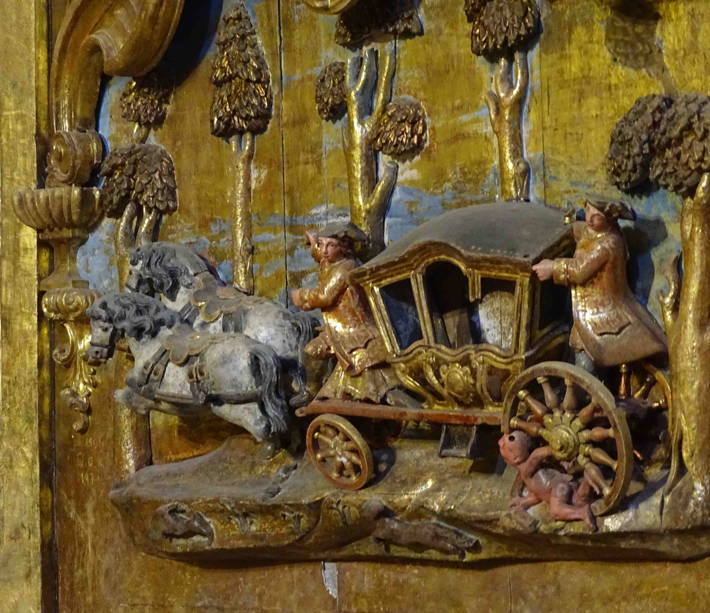
Santa María, detail of retablo mayor.

The glories of its pre-Romanesque, Romanesque, and Baroque ecclesiastical art aside, one of the most astonishing elements of the Santa María complex are the four painted wooden statues that are currently stashed in a side aisle of the monastery cloisters. Sculpted by Francisco de Nava between 1763 and 1767, these representations of King Alfonso IX (founder of the Santa María church) and his son King Fernando III, and of San Raimundo de Fitero and Don Diego de Velázquez (founders of the 12th-century military Order of Calatrava), were originally placed in the four corners of the basilica’s transept. Before his departure in 2009, Prior Jorge Gibert Tarruell had judged that these statues of mounted warrior kings and religious knights trampling their Moorish enemies underfoot were politically insensitive and inappropriate for his church, and he thus removed them to their current obscure location.

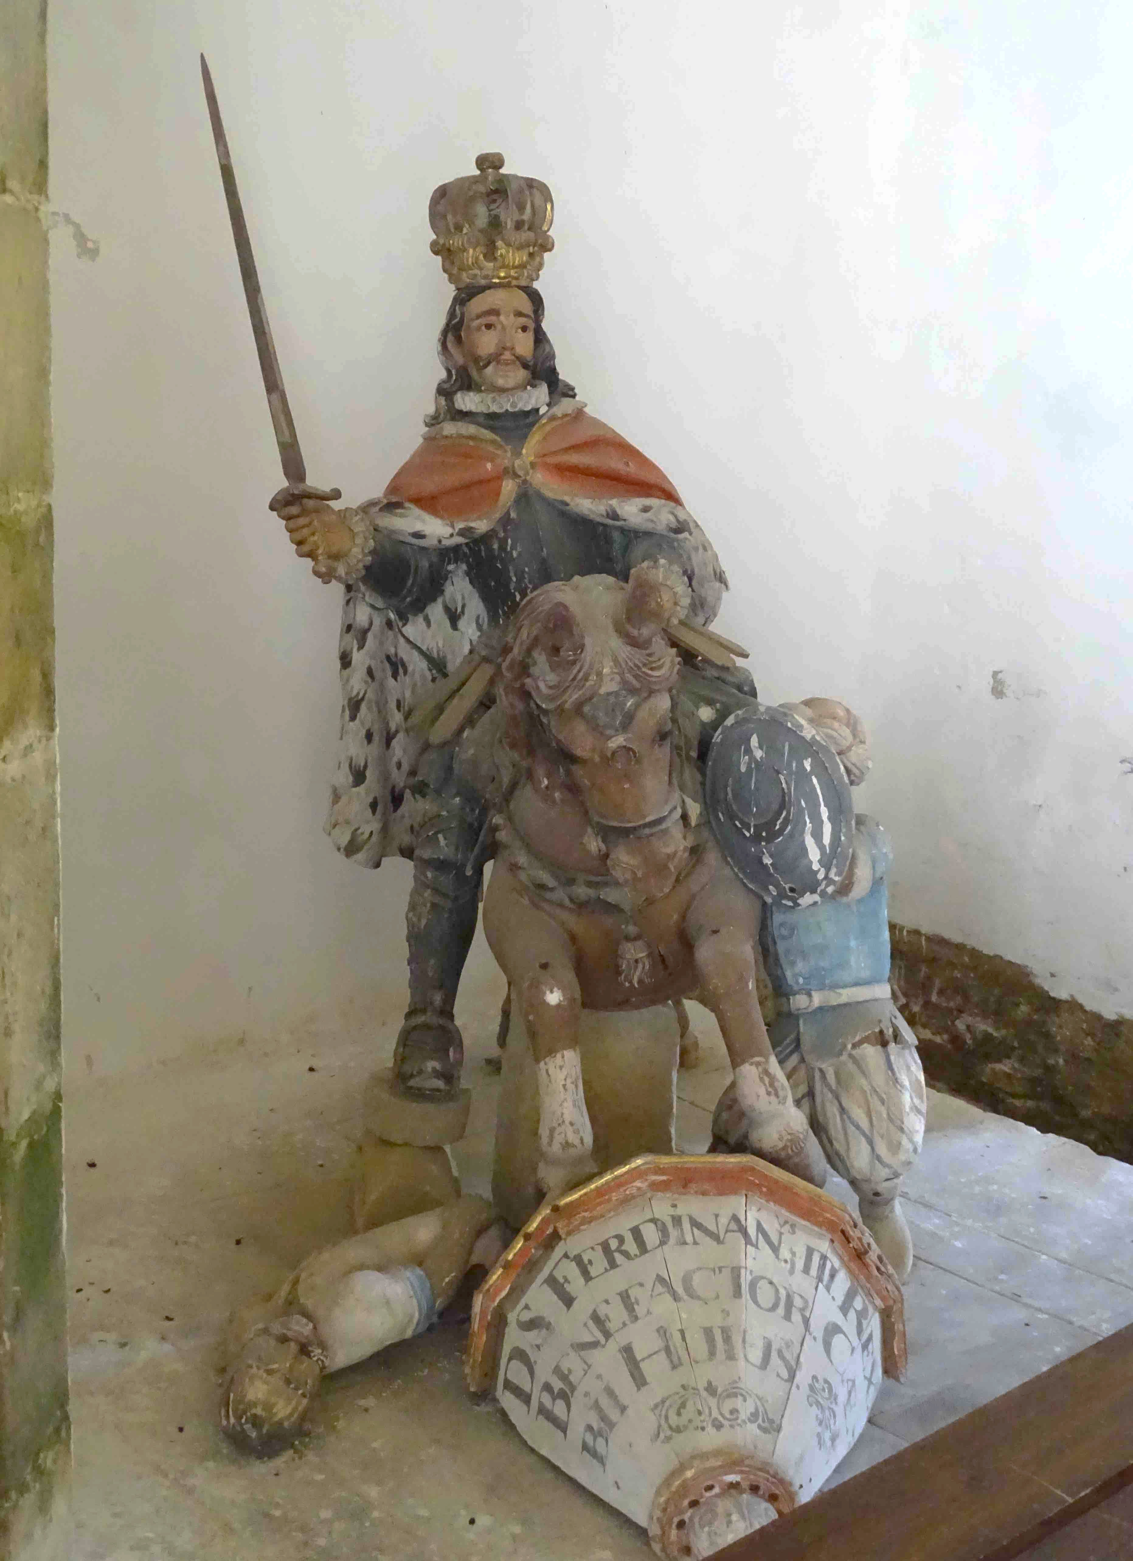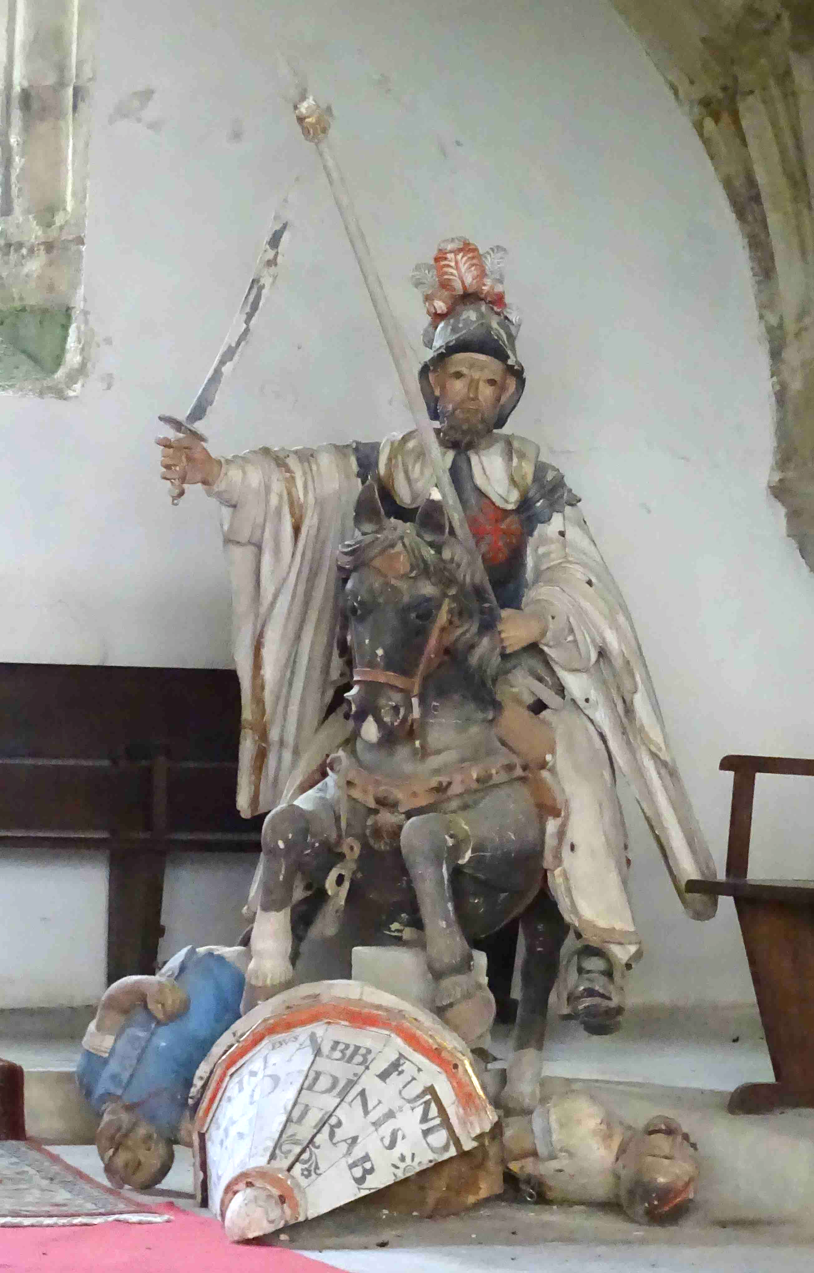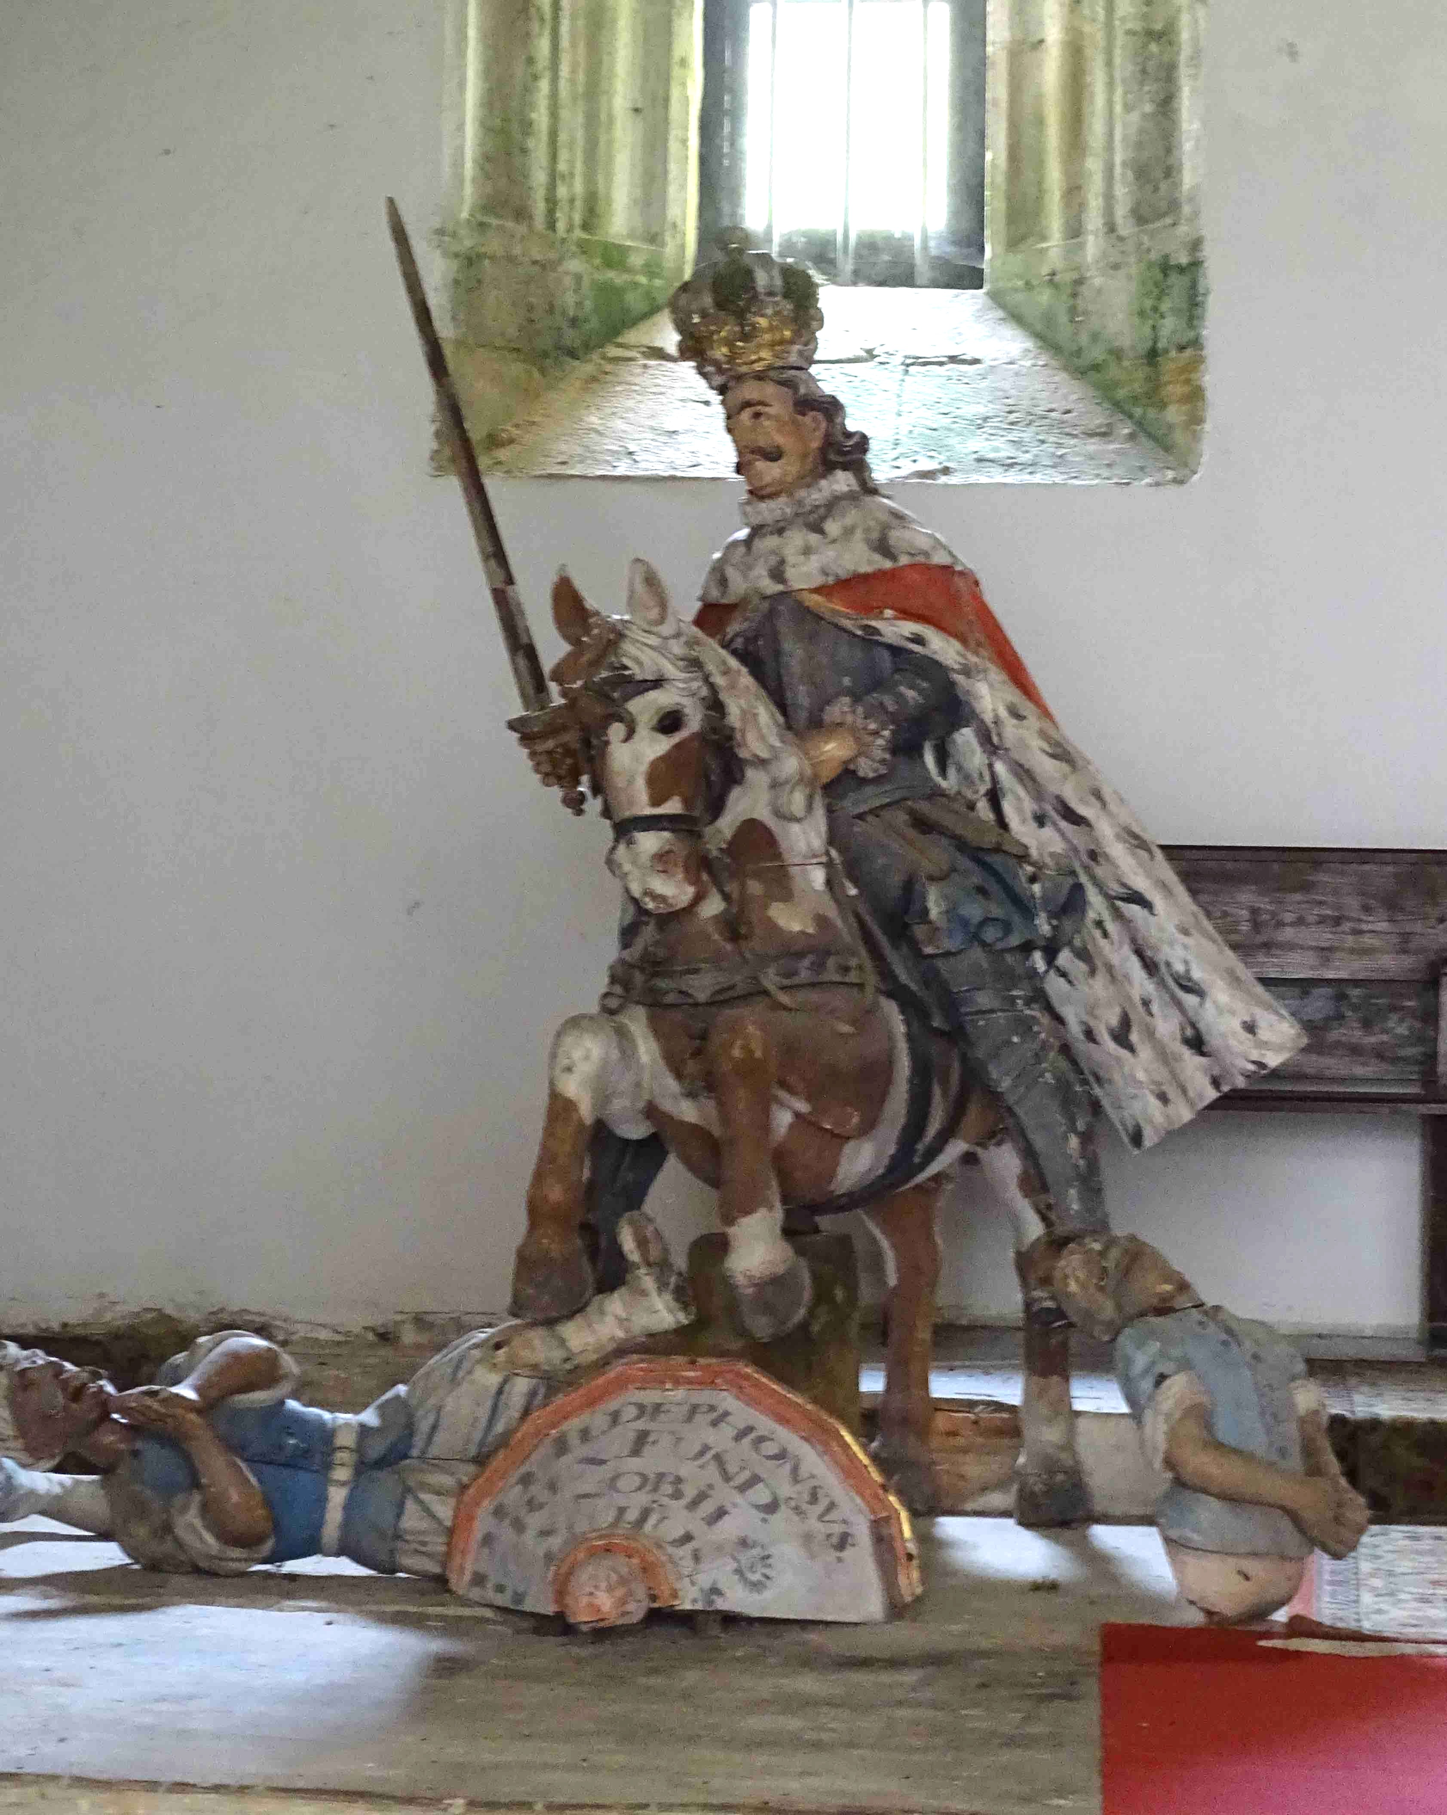
Statues of Fernando III (right), San Raimundo de Fitero (middle), and Alfonso IX (left), now in side chambers of the cloisters at Santa María de Valdediós.

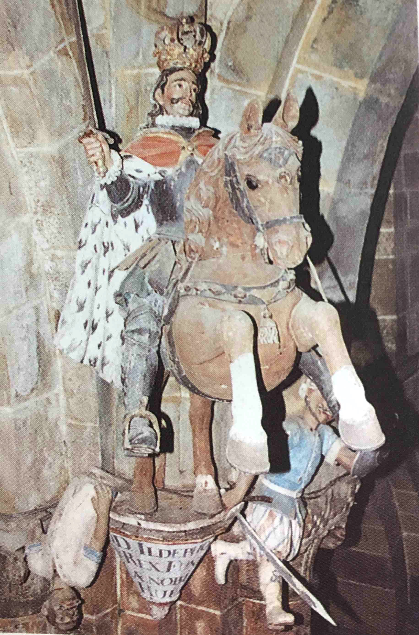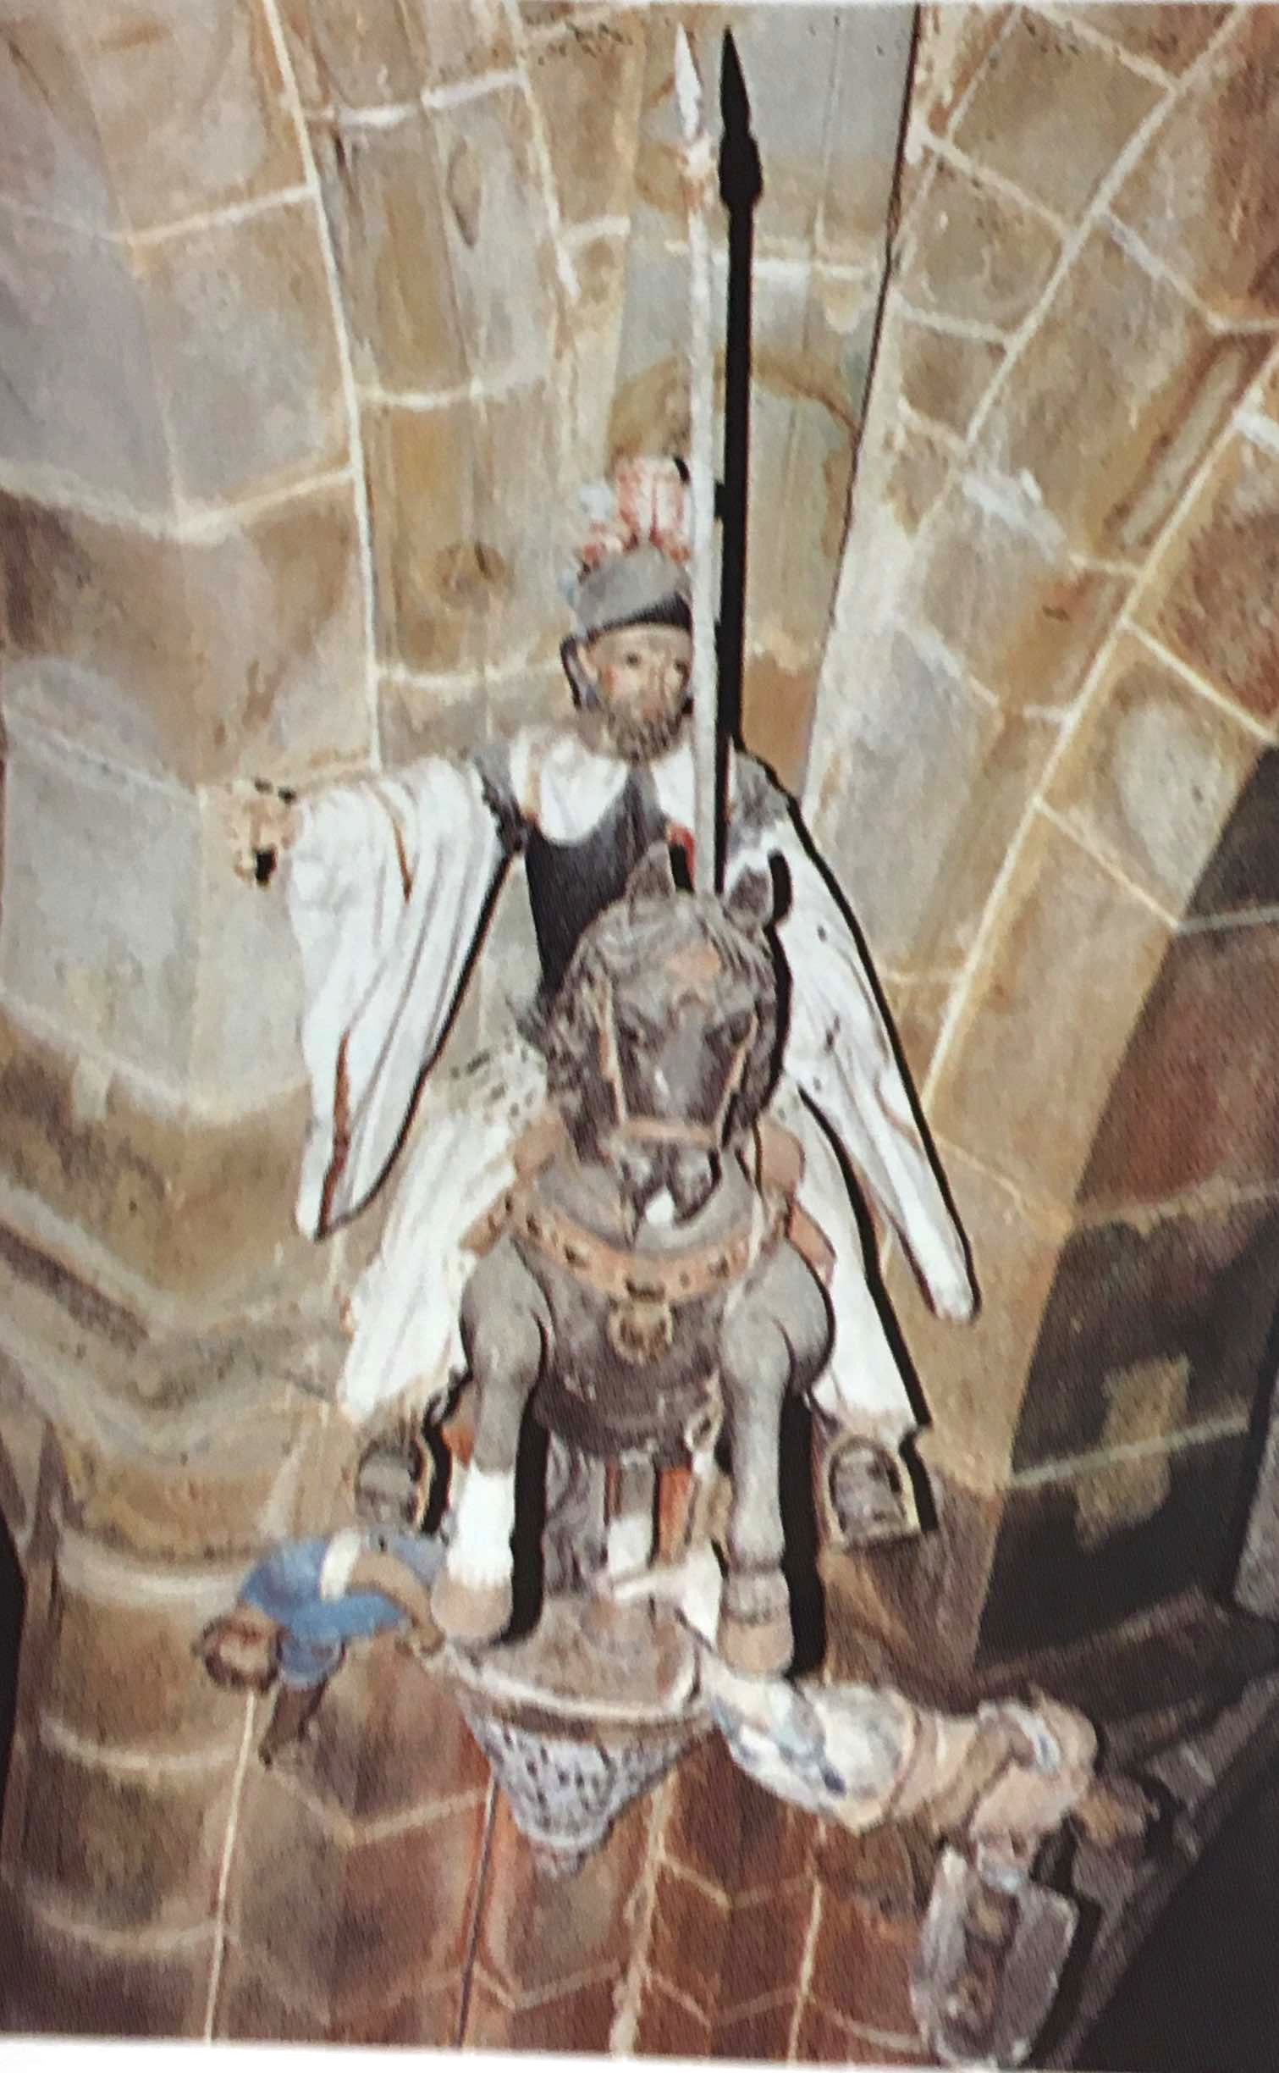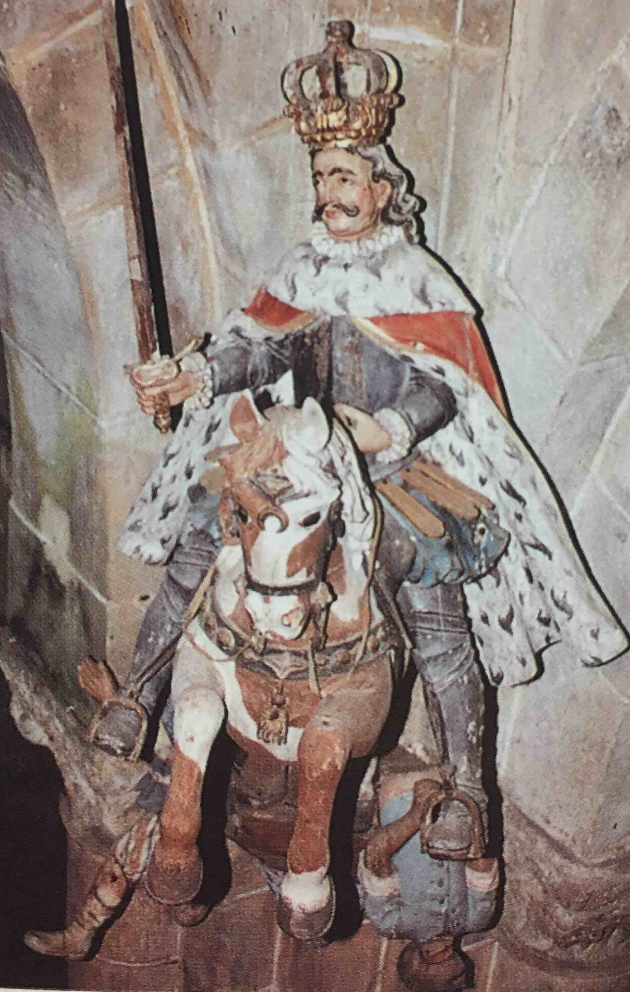
Original position in the transept of the statues of Fernando III (right), San Raimundo de Fitero (middle), and Alfonso IX (left), after Abella Vilar (1993).
In order to evaluate Gibert Tarruell’s decision to take down Santa María’s 18th-century statues of 12th-century Spanish kings and knights slaying Moors, one must view his action within the larger contexts of Spanish history and of contemporary debates about political correctness and religion.
The iconography of Santa María’s mounted Spanish warriors slaying infidels is clearly derived from the very common Baroque image of the Santiago Matamoros—St. James the Moor-slayer. In fact, a small 18th-century shrine to Santiago Matamoros can be found in the north aisle of the Santa María church, close to where the offending statues were originally located.
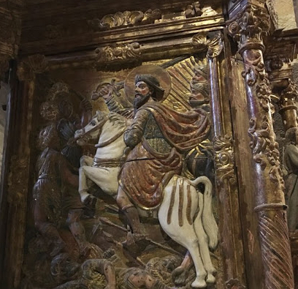
Santa María, 18th-century shrine of Santiago Matamoros.

St. James, the patron saint of Spain, had been associated with the Iberian peninsula as early as 814, when his tomb was miraculously “discovered” and the Asturian king Alfonso II established the church of Santiago de Compostela—which was to become the third most holy site of Christendom and the focus of the famous Camino de Santiago pilgrimage. The Spanish St. James, however, did not take on a military character before the 12th century, when the tradition emerged that the Apostle had appeared on a white horse at the mythical 9th-century battle of Clavijo, urging on the Christian soldiers of Ramiro I to fight against the invading Moorish army. The earliest works of art showing a mounted Santiago also belong to this period, the oldest known being on a mid-12th-century relief sculpture in the Cathedral of Santiago de Compostela; these early depictions, however, only show the saint on horseback exhorting the troops and not as an actual fighter with slain enemies under his mount’s feet. The earliest representations of the saint as an actual Matamoros in fact only date to the very end of the 15th century, that is after the 1492 conquest of the Emirate of Granada and the end of Moorish rule in Spain. The subsequent proliferation of paintings and statues of Santiago Matamoros in the 16th, 17th, and 18th centuries (to which one should add Santa María’s statues of Moor-slaying Reconquistadors) must thus be seen as ahistorical re-imaginings designed to serve contemporaneous motives—most notably as assertions of Spanish hegemony in its colonization of the New World and the Philippines, and as political statements during the controversy in the 1620’s over whether St. Teresa should replace St. James as the patron of the nation.
The ideological imagery of one age does not always align with the needs of subsequent ages. In 2004, following the 11 March Madrid train bombing—the deadliest terrorist attack in Spain history—calls were made to remove Joseph Gambino’s 18th-century Santiago Matamoros statue prominently displayed in the Cathedral of Santiago de Compostela, a call made on the grounds that this sculpture of a Christian saint killing Islamic foes might further inflame tensions in the country. Although church officials were initially inclined to substitute the Matamoros with a less offensive statue of Santiago Peregrino (St. James as a pilgrim), a political backlash ensued, and, as a compromise, Gambino’s sculpture remains in the Compostela church but with the slain Moors at his feet now being covered up by flowers.
As is the case with many developed Western nations, modern Spain is faced with wrenching social adjustments as it moves beyond entrenched attitudes towards women and immigrants and as it grapples with the thorny issues of racism, freedom of speech, and the role of religion in politics. Eliminating traditional Christmas carols (“villancicos”) from public schools, or attempting to remove politically charged statues from prominent sites has elicited reactionary attacks on “political correctness” in the press and on social media. For now, however, Prior Gibert Tarruell’s quiet purification of anti-Islamic militarism in the church of Santa María de Valdediós seems to have gone under the radar.
Addendum:
The removal of the Moor-slaying statues from the church of Santa María is not the only politically charged event to have taken place at Valdediós. When the city of Oviedo fell to Franco’s troops in 1936 during the Spanish Civil War, the Republican forces moved the city’s psychiatric hospital into the Valdediós complex. In October 1937, just days after the last Republican stronghold in Asturias, Gijón, fell to the Nationalists, a detachment of Franco’s troops—presumably part of the VI Brigada de Navarra—came to the Valdediós monastery and shot seventeen hospital employees, burying them in a hastily dug trench nearby. Like so many of those killed by Franco’s forces during the Civil War and its aftermath, the victims of the Valdediós massacre remained in their unmarked grave for more than a half a century. Finally, in 2003, the remains of these victims were exhumed and a monument commemorating the massacre was erected in 2005. This long-delayed recognition of the 1937 Valdediós tragedy is but one element in Spain’s on-going struggle to cope with the legacy of the violence perpetrated by the Franco dictatorship, a reconciliation process that was retarded by the 1977 Amnesty Law which attempted to impose a pact of forgetfulness as Spain was developing its new democracy. While the exhumations of mass graves such as the one at Valdediós mark an important step towards reconciliation, the Spanish nation has still not fully come to terms with its Franco heritage. The average visitor to Valdediós, for instance, is unaware that such abhorrent violence had been visited upon this serene, sacred valley.
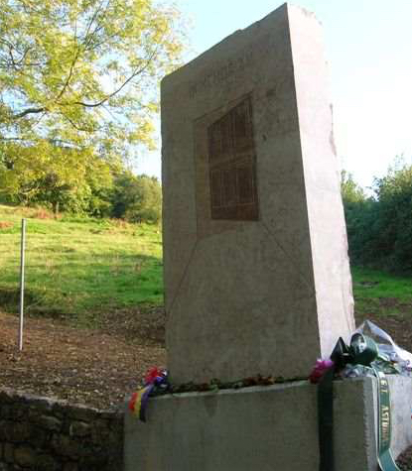
Joaquín Rubio Camón, Homenaje a las víctimas de la fosa común de Valdediós. Dedicated Oct. 10, 2005. On the simple stone block is a representation of a "ventana abierta a la esperanza" (“window open to hope”).

Further Reading:

Beatriz Abella Villar, Arte y tiempo: catálogo de bienes de interés historico-artistico del Monasterio de Santa María de Valdediós, Oviedo: Agencia Regional de Empleo, D.L, 1993.

Francisco Ferrándiz, “The Intimacy of Defeat: Exhumations in Contemporary Spain,” Unearthing Franco's Legacy: Mass Graves and the Recuperation of Historical Memory in Spain, edd. Carlos Jerez-Farran and Sam Amago, South Bend: University of Notre Dame Press, 2010, pp. 304 – 325. Web. Accessed 25 May, 2018.

Eduardo García, “Santa María de Valdediós, una iglesia entre dos mundos,” La Nueva España, 14 de agosto, 2011. Web. Accessed 29 April, 2018.
Javier Domínguez García, “St. James the Moor-slayer, a new challenge to Spanish national discourse in the twenty-first century,” International Journal of Iberian Studies. 2009, Vol. 22:1, pp. 69 – 78.
“Iglesia de San Salvador de Valdediós,” Lugares con Encanto en España, arteguias.com. Web. Accessed 29 April, 2018.

“Monasterio de Santa María de Valdediós,” Monasterios de España, arteguias.com. Web. Accessed 29 April, 2018.

Rebecca C. Quinn, "Santiago As Matamoros: Race, Class, And LIMPIEZA DE SANGRE In A Sixteenth- Century Spanish Manuscript," The Larrie and Bobbi Weil Undergraduate Research Award Documents. 1, 2011. Web. Accessed 25 May, 2018.

Stephen B. Raulston, “The Harmony of Staff and Sword: How Medieval Thinkers Saw Santiago Peregrino & Matamoros,”La corónica: A Journal of Medieval Hispanic Languages, Literatures, and Cultures, Volume 36, Number 2, Spring 2008, pp. 345 – 367.
UNESCO, World Heritage Centre, “The Church of San Salvador de Valdedíos,” Jan. 27, 2017. Web. Accessed 25 May, 2018.
Isambard Wilkinson, “Public outcry forces church to keep Moor Slayer's statue,” The Telegraph, 22 July, 2004. Web. Accessed 25 May, 2018.

