The Pamela J. Russell Collection of
Art & Archaeology
COMIC STRIPS

Charles Schulz, Peanuts.

By
Murray C McClellan

Table of Contents

Introduction 3
Part I: Funny Art 9
Marjorie’s Cartoons 9
Art Humor 101 14
Making Fun of Making Art 22
Poking Fun at Painters 22
Sculpting Humor 32
Kidding Art 38
Madcap Museums 44
Mocking Modern Art 53
Meming the Masters 59
Silly Sistine Chapel 66
Comic Crossing the Delaware 68
Silly Thinker 69
The Silly Scream 70
Dalí Dillies 71
Escher Absurdities 72
Joking Pollock 73
Zanny Zippy 74
Droll Doonesbury Art 76
Part II: Funny Archaeology 81
Digging-up Jokes 82
Ascent of Foolish Man 85
Nutty Stone Age 87
Comic Cave Painting 88
Campy Cavemen 93
Wacky Stonehenge 99
Ancient Egyptian Antics 101
Poking Fun at Pyramids 102
Mummy Mirth 107
Biblical Boffos 109
Classical Comics 111
Medieval Minoans? 112
Goofy Greeks 113
Amusing Atlas and Silly Sisyphus 116
Acropolis Absurdities 118
Ridiculous Romans 120
Loony Easter Island 121
Amusing Americas 124
Conclusion 125
Index of Comic Strip Artists 127

Introduction

Garry Trudeau, Doonesbury.

One day in March 2011, Pam Russell went to her doctor’s office and saw in the waiting room a loose-leaf notebook containing a set of comic strips with medical themes that the doctor and her staff had collected over the years. This inspired Pam, an archaeologist and museum professional, to start her own collection of comic strips with art or archaeology subjects. She began her collection quite methodically, clipping out all the comic strips about art or archaeology that she could find in our daily New Hampshire local paper, the Keene Sentinel, or in the Sunday Boston Globe. By June 2015, the notebook into which Pam was pasting her collection was completely filled; at this point in time, it was already evident that certain topics—such as Paleolithic cave painting, the Egyptian pyramids, Easter Island, and the Sistine Chapel—were favorite subjects for comic strip artists. After dropping her project for almost a year, Pam—this time with my sporadic help—renewed her collection of art- and archaeology-themed comic strips, filling up half of another notebook before we packed up and moved out of our New Hampshire home in November, 2017.
I have scanned and arranged Pam’s collection into more-or-less meaningful categories, but—more through laziness than any particular aesthetic principle—I have otherwise not altered the comic strips as they appeared in her notebooks: imperfectly cut out, sometimes a bit aslant and crumpled, and with the lined paper to which the comic strips were scotch-taped peaking out from the background. This current study of Pam’s collection thus preserves something of the charm of her original scrapbooking.

Although this collection makes no claim to be a complete record of art- and archaeology-themed comic strips published in the United States from March 2011 through November 2017, the two-hundred-plus examples presented here are nonetheless a representative sample of how some major syndicated comic strip artists treated these themes during this period. While more granular observations about different categories of art- and archaeology-themed comics appear in the individual sections below, a few general comments about overall trends may be in order here.
A comic strip is a visualized joke, often the product of a symbiotic collaboration of a writer and a graphic artist. At times, the joke is clearly verbal (a pun, for instance) while at other times the joke is more visual (a parody of a famous work of art, for instance); ideally, the comic strip joke is a clever combination of the two. Although there are obvious overlaps in the genres, a comic strip is quite distinct in this regard from a political cartoon or from a serialized comic adventure story or soap opera. In narrating its joke, a comic can either consist of a series of inter-related cartoon panels or of a single panel; for the purpose of this study, the generic term “comic strip” will be used to refer to both forms.
It is scarcely surprising that comic strips often address the subject of art. For comic strip artists, sitting day after day with pencils and pens at their drafting tables, it is quite natural that visions of painters at their easels would come to mind. In spite of the fact that some comic strip artists did indeed begin as that stereotypical dweebie adolescent who sat doodling at the back of the classroom, comic strip artists as a group tend to be serious students of art. As the examples in this collection demonstrate, comic strips abound in allusions to the challenges of creating works of art, to the major figures in the history of art, or to the experience of visiting an art museum. One might even wonder if some of these allusions often go over the heads of many comic-strip readers.
In contrast to the sophistication of the references to art in comic strips, those with archaeological themes demonstrate a rather outdated view of the past. While our understanding of human evolution and the nature of Neanderthal and other early Homo sapiens has undergone dramatic realignments in the last half century, the ever-popular comic strip caveman remains the same primitive beast he was conceived to be in the 19th century. Crackpot ideas about the extra-terrestrial origins of the Egyptian pyramids or about the mysteries of the moai of Easter Island—ideas which were never accepted by mainstream archaeologists—continue to be perpetuated in contemporary comic strips. To be sure, the role of the comic strip is to elicit a chuckle and not to educate; still, the discrepancy between the way that this collection of comic strips conceives of art history and archaeology is striking.
Some comic strip artists represented in this collection seem to be especially drawn to art and archaeology subjects (pardon the pun!). Of particular note are:
- Robert Thaves (1924 – 2006). Thaves, who received a BA and MA in psychology from the University of Minnesota, began his Frank and Ernest strip in the 1960’s; his son Tom has continued it since his father’s death. A hallmark of the Thaves’ art and archaeology comics is a reliance on some rather atrocious puns.

- Mike Peters (b. 1943). A graduate of Washington University in fine arts, Peters began his Mother Goose & Grimm strip in 1984. In addition to the strips featuring the dogs Grimm and Ralph making silly art gags, Peters also has produced a number of panel cartoons with much more sophisticated jokes about art and antiquity.

- Wiley Miller (b. 1951). An art student at Virginia Commonwealth University and now a resident of Maine, Wiley Miller has been creating his satirical Non Sequitur cartoon since 1991. Characters in Miller’s comics—especially Danae, the youngest daughter of the Maine-based Pyle family—often take art and archaeology subjects to absurd lengths. In this collection, of special note are Miller’s many jokes about cavemen and cave painting.

- Dan Piraro (b. 1958). Dan Piraro, who dropped out of Washington University, has been creating the cartoon panel Bizarro since 1985. Piraro’s richly inked art and archaeology comics in this collection often entail a subtle visual pun that takes a while to sink in.

- Jim Meddick (b. 1961). Like Mike Peters (who he credits as his mentor), Jim Meddick is a graduate of Washington University. The main character in Meddick’s comic strip Monty, which has been in syndication since 2000, frequently tries his hand at painting, always to humorous effect; Monty also features a hilariously unorthodox museum guard.

- Hilary B. Price (b. 1969). A graduate of Stanford University in English, Hilary Price started her innovative panel comic Rhymes with Orange in 1995 and became, at age 25, the youngest cartoonist to be nationally syndicated. Price humorously pokes fun at a wide variety of art and archaeology subjects, from artists, to museum-goers, to modern interpretations of ancient classics.

- Mikael Wulff (b. 1972) and Anders Morgenthaler (b. 1972). Mikael Wulff and Anders Morgenthaler are a Danish team who began their comic strip Wulffmorgenthaler in 2001. Renamed Wumo in 2014, this quirky panel comic is now widely distributed in the United States. Wulff and Morgenthaler’s work satirizes contemporary attitudes about artists and ancient cultures.

Two comic strip artists, Bill Griffith (b. 1944) and Garry Trudeau (b. 1948), have been singled out in this study for the special series about art that each has created. Bill Griffith, a pioneer of the underground comix scene in San Francisco in the early 1970’s, first created his pinhead character Zippy in 1971, and the comic strip Zippy has been syndicated and widely distributed since 1986. Griffin’s comic strips about art in this collection are of two types: the autobiographical “Random Memories” and those strips in which Zippy engages with art in his characteristically non-linear way of thinking. Garry Trudeau began his comic strip Doonesbury in 1970 while he was an undergraduate at Yale University, where he went on to earn a BA and a MA degree in fine arts and graphic design. Trudeau produced his often highly politicized daily strip until 2014, when it went into rerun mode as “Classic Doonesbury”; Trudeau continues to publish original new Doonesbury strips for Sunday newspapers. Two Doonesbury storylines about art are represented in this collection: the career of the artist J. J. Caucus, Michael Doonesbury’s first wife; and the story of Michael’s goofy friend Zonker owning an original Monet. Because of the order in which the Doonesbury re-runs have been issued, both of these storylines are only partially represented in this study.

˜˜˜˜˜˜˜˜˜

Of course, cut-and-paste scrapbooking from physical newspapers is old fashioned. Long before Pam began her project, print journalism had already largely been digitized and put online. These days, only a few people—mostly diehard baby-boomers like us—still go out to the driveway every morning to retrieve the newspaper; the joy we experienced in opening our paper and unexpectedly finding a comic strip about art or archaeology is quickly becoming a thing of the past. To be sure, comic strips continue to be published in many digital newspapers, and virtual cut-and-paste scrapbooking of art- and archaeology-themed comic is possible. Many new comic strip artists, however, are opting to publish their work as independent webcomics rather than rely on the old major comic strip syndications, and one would have to peruse the entire corpora of these webcomics to find strips about art or archaeology. Similarly, online depositories—most notably the British-based CartoonStock, which has purchased the rights to over half a million comics, and GoComics, which has the largest catalog of online syndicated comic strips—contain thousands of examples of comic strips about art or archaeology, but these sites are not easily searchable by subject categories and thus are difficult to use in a meta-analysis of art and archaeology comic strips.
And the art of scrapbooking itself is quickly disappearing. Although there was a spurt of scrapbooking in the first decade of this century—mostly fueled by downsizing baby-boomers who wanted to preserve family memories—this trend has gone into steep decline in the past decade, being largely replaced by online equivalents, most notably by the phenomenon that is Pinterest. To be sure, like CartoonStock and GoComics, Pinterest is a useful depository of comic strips about art or archaeology, but the way Pinterest is structured, however, limits it usefulness for a study like the present one. Individual images (“Pins”) are presented on Pinterest boards in the order by which they were added, and there is no mechanism for rearranging these images into meaningful subcategories.

The proliferation of online images of copyrighted art is a challenge for the concept of fair use, especially when copies of these images appear on for-profit websites. While a case might be made that the manipulation of the comic strips that appear in this study—the cutting-and pasting, scanning, and categorizing—might constitute a legitimate “transformation” of the original copyrighted work, the matter is moot here as this compendium is presented solely for the enjoyment of the viewer. I do urge everyone to feel free to share this work with others, but only on a non-commercial basis.

Part I: Funny Art

Are comic strip artists real artists? This is a question that seems to parallel the one of whether graphic novels are real literature. The answer is that some are, and some aren’t. Some are masters of drawing and design, while others use childish scribbles to illustrate their jokes. But the real art in making a comic strip, like that of a graphic novel, is in the combination of the visual with the verbal. And this art is especially brought to the fore when the subject of the cartoon is art itself.

Marjorie’s Cartoons

Charles Addams, New Yorker, Aug. 1979

As we were processing many dozens of boxes of old family archives in preparation for our move, we discovered scattered among the files of Marjorie Russell—Pam’s mother—several clipped-out cartoons and comic strips about art. While this discovery was not surprising, as Marjorie had worked in museum education for much of her adult life, it was interesting that Pam had been unaware her mother had been saving art comic strips many decades before she started her own project. The apple doesn’t fall far!
It is also interesting that the ten comic strips we found in Marjorie’s files all fall within categories that can be identified in Pam’s much larger collection: Art Humor; Making Fun of Making Art; Mocking Modern Art; and Miming the Masters. Apparently, the early 21st-century comic sensibilities about art stretch back well into the 20th century. Plus ça change.

Robert Thaves, Frank & Ernest,1980.

Garry Trudeau, Doonesbury, 1985

Stanley and Janice Bernstain, date? | Wiley Miller, 1981.  Stanley and Janic Bernstain, Calvin and Hobbes, 1988.

Duck Edwing, Tribune Toon, 1995

Jim Berry, Berry’s World 1974. 1981?

Berke Breathed, Bloom County, 1985.

Art Humor 101

Weingartens & Clark, Barney and Clyde.

It seems that contemporary comic strip artists assume that their viewers took an Art History 101 class—and that they remember more of it than they have forgotten. The silly puns that Mike Peters and Brookins & MacNelley serve up, Lynn Johnston’s and Marciuliano & Keefe’s allusions to Rubens and Cezanne, and Jimmy Johnson’s and Wulff & Morgenthaler’s erudite jokes about “selfies” would be hard for an average school child to get. Similarly, Marciuliano & Keefe’s take on performance art in the third of the beautifully drawn Sally Forth strips in this section, Wiley Miller’s quirky views of art appreciation, and Wulff & Morgenthaler’s jokes about bohemian artists all require some sophistication to find funny.

Mike Peters, Mother Goose & Grimm.

Mike Peters, Mother Goose & Grimm.

Gary Brookins & Susie MacNelly, Jeff MacNelly’s Shoe.

Lynn Johnston, For Better or for Worse.

Francesco Marciuliano & Jim Keefe, Sally Forth.

Francesco Marciuliano & Jim Keefe, Sally Forth.

Jimmy Johnson, Arlo and Janis.

Mikael Wulff & Anders Morgenthaler, Wumo.

Wiley Miller, Non Sequitur.

Hilary B. Price, Rhymes with Orange.

Dean Young and John Marshall, Blondie.
Jim Meddick, Monty.

Mikael Wulff & Anders Morgenthaler, Wumo.

Making Fun of Making Art
You want to create a work of art? Is that so funny? What could possibly go wrong? These comic strips show that the possibilities for humor are endless.

Poking Fun at Painters
Painting is by far the most popular medium of the fine arts that comic strip artists like to make fun of. Cartoon artists, who daily sit in front of a blank piece of paper at their drafting tables, know what it is like to stand in front of a blank easel. There is a special self-reflective quality to works of visual artists who depict other visual artists at their work, even when they do so in jest.

Jim Meddick, Monty.

Jim Meddick, Monty.

Scott Pilburn, The Argyle Sweater.

Lincoln Peirce, Big Nate.

Brian Crane, Pickles.

Brian Crane, Pickles.

Mike Peters, Mother Goose & Grimm.

Russell Myers, Broom-Hilda.

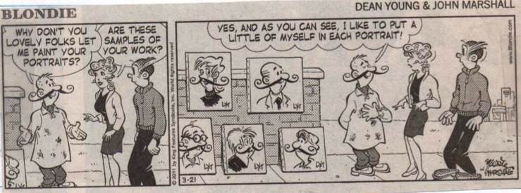
Dean Youn & John Marshall, Blondie.

Patrick McDonnell, Mutts.

Jim Davis, Garfield.

Mikael Wulff & Anders Morgenthaler, Wumo.

Wiley Miller, Non Sequitur.

Hilary B. Price, Rhymes with Orange.

Dan Piraro, Bizaro.

Sculpting Humor
Comic strip artists often make fun of iconic paintings and sculptures (see the “Mocking Modern Art” and “Meming the Masters” sections below), but they rarely lampoon paintings qua paintings. They seem to find sculpture, on the other hand, intrinsically funny.

Parker and Hart, The Wizard of Id.

Hilary B. Price, Rhymes with Orange.

Darby Conley, Get Fuzzy.

Paul Jon, Fort Knox.

Jerry Scoot and Jim Borgman, Zits.

Hank Ketcham, Dennis the Menace.

Tony Carrillo, F Minus.

Bill Amend, FoxTrot.

Jimmy Johnson, Arlo and Janis.

Mike Peters, Mother Goose & Grimm

Dan Piraro, Bizarro.

Kidding Art

Kids are funny. Kids making art are even funnier. Lincoln Peirce, with his mischievous Nate, and Paul Trap, with his artistic prodigy baby, are especially fond of the genre of kiddie cartoon artists.

Tony Carrillo, F Minus.

Chris Cassatt, Gary Brookins, and Susie MackNelly, Jeff MacNelly’s Shoe.

Lincoln Peirce, Big Nate.

Robb Armstrong, Jump Start.

Paul Trap, Thatababy.

Paul Trap, Thatababy.

Paul Trap, Thatababy.

Paul Trap, Thatababy.

Madcap Museums

Charles Barsotti

Quite a few of us can remember being dragged to an art museum as a child, an experience that many comic strip artists find as rich source of humor. Other cartoonists, such as Hilary Price, Michael Wulff & Anders Morgenthaler, and Dan Piraro, take great glee in spearing the contemporary art museum itself. Special note in this section should be made of Jim Meddick’s humorous series on the museum guard “Dirty” Harry; we have all wondered what really goes on behind-the-scenes at the art museum—these Monty vignettes suggest that it is worse than we could have imagined!

Weingartens & Clark, Barney and Clyde.
Brian and Greg Walker, Hi and Lois.

Pat Brady and Don Wimmer, Rose is Rose.

Robb Armstrong, Jump Start.

Paul Gilligan, Pooch Café.

Mike Peters, Mother Goose & Grimm.

Hilary B. Price, Rhymes with Orange.

Mikael Wulff & Anders Morgenthaler, Wumo.

Weingartens & Clark, Barney & Clyde.

Darby Conley, Get Fuzzy.

Dan Piraro, Bizarro.

Jim Meddick, Monty.

Jim Meddick, Monty.

Jim Meddick, Monty.

Mocking Modern Art

Gary Brookins & Susie MacNelley, Jeff MacNelley’s Shoe.

“My child could do that.” This dismissive attitude towards modern art is, as we have seen in the cartoons in Marjorie’s collection, a long-standing and common theme in comic strips—one that has especially been used by Bunny Hoest and John Reiner, whose strip The Lockhorns repeatedly dips into this particular comic well. While Hoest and Reiner, like many cartoonists who mock abstract expressionism, portray that art in their strips as unappealing blobs of color, the Brookins and MacNelley strip above actually gives us a carefully rendered work reminiscent of a Helen Frankenthaler, suggesting that these two might not fully agree with their cartoon characters. Other comic strip artists, such as Wiley Miller, the Wulff and Morgenthaler team, Mike Peters, Lincoln Peirce, and Bill Amend, have furthered this approach to poking fun at modern art; rather than critiquing the supposed incomprehensiveness of modern art, these cartoonists ironically mock both the ignorance of its detractors as well as the pretentiousness of its adherents.

Bunny Hoest and John Reiner, The Lockhorns.

Bunny Hoest and John Reiner, The Lockhorns.

Hank Ketcham, Dennis the Menace.

Jim Toomey, Sherman’s Lagoon.

Wiley Miller, Non Sequitur.

Mikael Wulff & Anders Morgenthaler, Wumo.

Mike Peters, Mother Goose & Grimm.

Lincoln Peirce, Big Nate.

Bill Amend, Foxtrot.

Meming the Masters

Norman Rockwell, The Connoisseur, 1961. Oil on canvas, 96 x 80 cm. Cover illustration for The Saturday Evening Post, January 13, 1962. Private Collection.

As we the viewers of Norman Rockwell’s The Connoisseur look at the well-dressed older gentleman looking at what appears to be a Jackson Pollock painting, we might think that we know what he is thinking—namely that he is perplexed by abstract expressionism. But this is not what Rockwell intended for us to think. Rockwell was a great admirer of the work of Pollock, and, in preparing for this 1961 picture, he actually painted a real Pollock-esque canvas to use as a model. Although by this point in his career Rockwell’s realistic style was taken to be—as many continue to take it—the epitome of populous kitsch and thus the antithesis of modern art, The Connoisseur must in fact be seen as an homage to abstract expressionism. The title is not ironic.
A panel from Garry Trudeau, Doonesbury.

The impulse to pay homage to other works of art is especially evident in the output of comic strip artists. Strips that quote well-known works of art are the second-most common type in this collection of art-related comic strips, only being surpassed by those about the making of art. One notable feature about this type of comic strip is that the artists, like Rockwell, tend to take great care in rending their replicas, often in stark contrast to way they depict their cartoon characters. One suspects that this discrepancy in the quality of rendering underlies a tension that comic strip artists feel about not being “real” artists.
But paying homage is not the main point of those comic strips that quote famous works of art. The raison d’être of a comic strip is to tell a joke, and many of the quotations of famous works of art in comic strips function as memes—units of cultural ideas that spread from person to person—to which the comic strip artist adds a humorous twist. Thus, when the Red Rascal—the fictional freedom fighter created by the Doonesbury character Jeff Redfern—is depicted falling asleep from exhaustion in his bathtub, the quotation of Jacques-Louis David’s The Death of Marat becomes humorous when the viewer realizes that the letter in the idealized French revolutionary’s hand of the original has been replaced by a laptop.
In this section, Tom Thaves is by far the most prolific of the comic strip artists who mimic famous works of art. In his continuation of his father’s Frank and Ernest strip, Thaves comes back to the great masters time and time again as sources for his atrocious puns—a bad habit that Dan Piraro also seems to have picked up.
Although this collection of art-related comic strips is probably too small to make any statistically significant conclusions about which famous works of art most commonly serve as subjects for jokes, a few general trends are evident. Counting the panels in the Frank and Ernest and Bizarro comics, the artist most frequently quoted is Michelangelo (Sistine Chapel eight times; David once), followed by Jackson Pollock (four times), Leonardo da Vinci (Mona Lisa twice, Vitruvian Man once), Auguste Rodin (The Thinker three times), Edvard Munch (The Scream three times), Vincent van Gogh (three times), Salvador Dalí (The Persistence of Memory three times), M.C. Escher (three times), Emanuel Leutze (Washington Crossing the Delaware twice), and one allusion each to Vermeer, Gainsborough, David, Whistler, Picasso, and Lichtenstein.
Comic strips are not only miners of fine-art memes, but they are also one of the main mechanisms by which the cultural ideas these memes represent have been propagated. Especially before the age of the internet meme, comic strips were a major venue for the popularization of the Western art canon. Together with print advertising as well as book and music album covers, comic strips have served both to prop up the hegemony of that canon as well as to subvert it by reducing works of art to simplistic “sight-bites.”
Tom Thaves, Frank and Ernest.

Tom Thaves, Frank and Ernest.

Tom Thaves, Frank and Ernest.

Tom Thaves, Frank and Ernest.

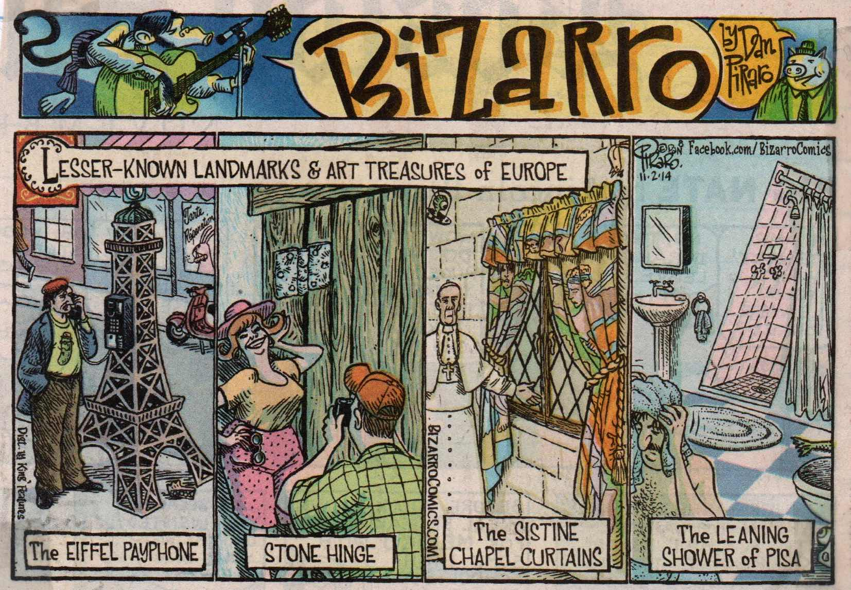
Dan Piraro, Bizarro.

Silly Sistine Chapel

What is it about that pregnant space between the fingers of God and Adam in Michelangelo’s The Creation of Adam that fascinates us, and that comics find such a rich source of humor?
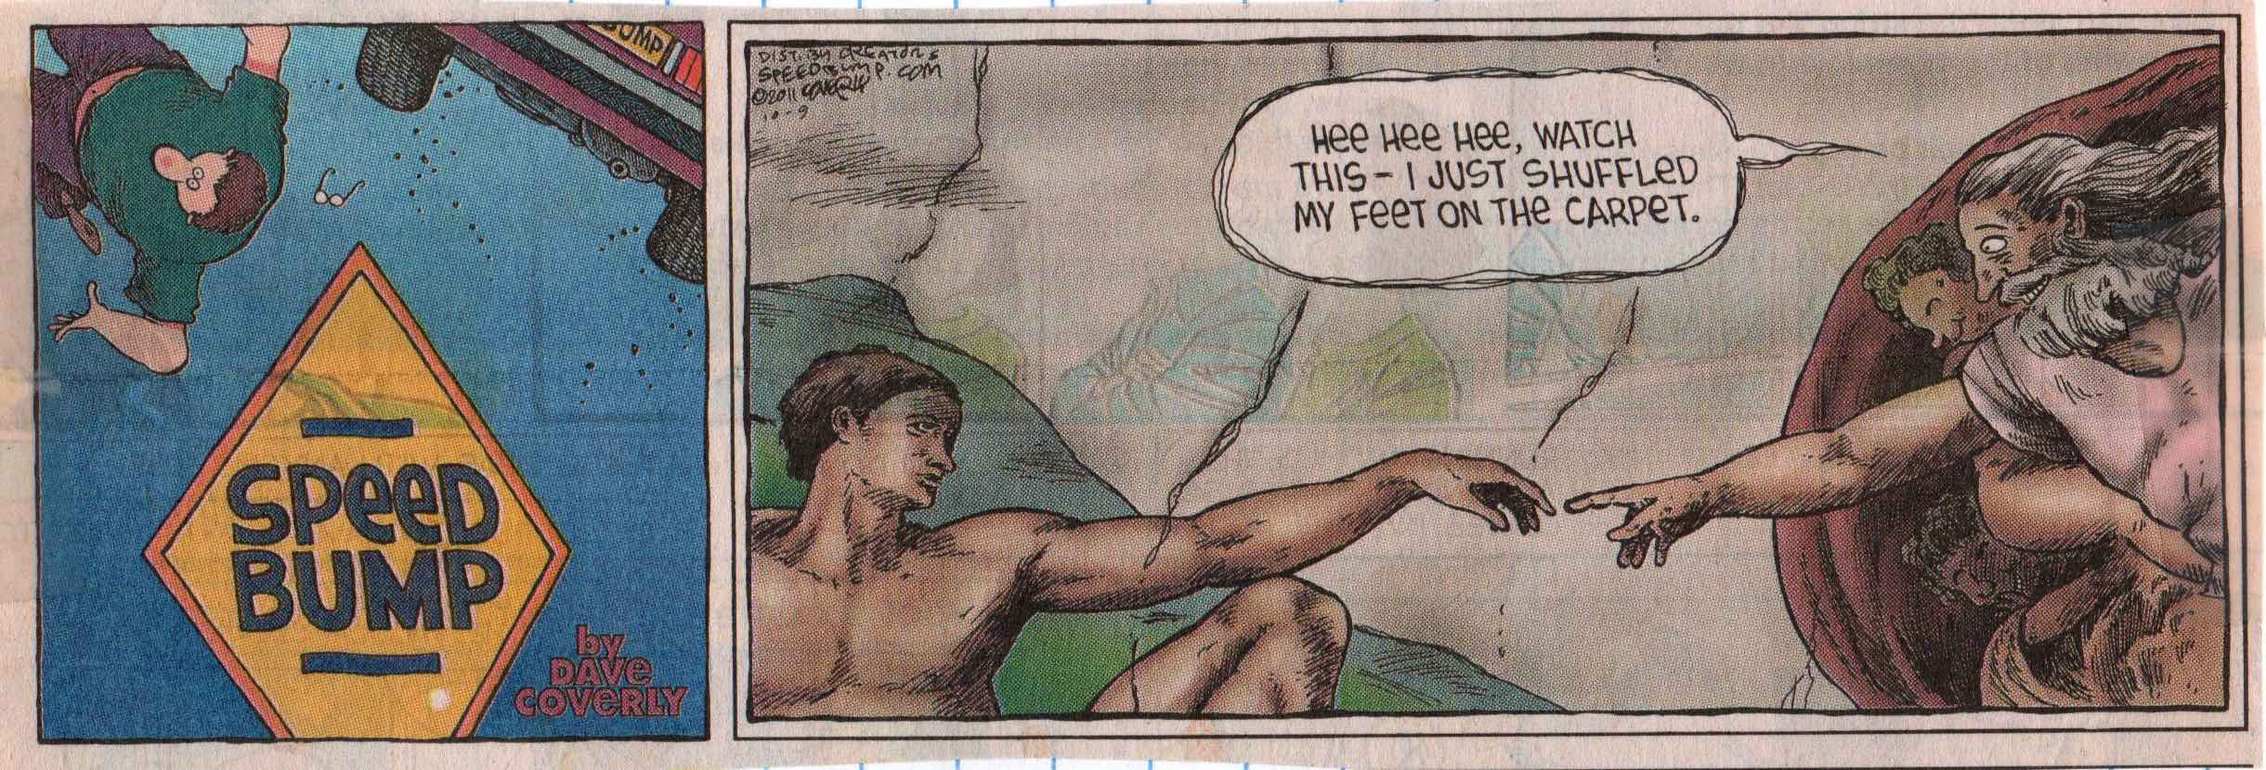
Dave Converly, Speed Bump.

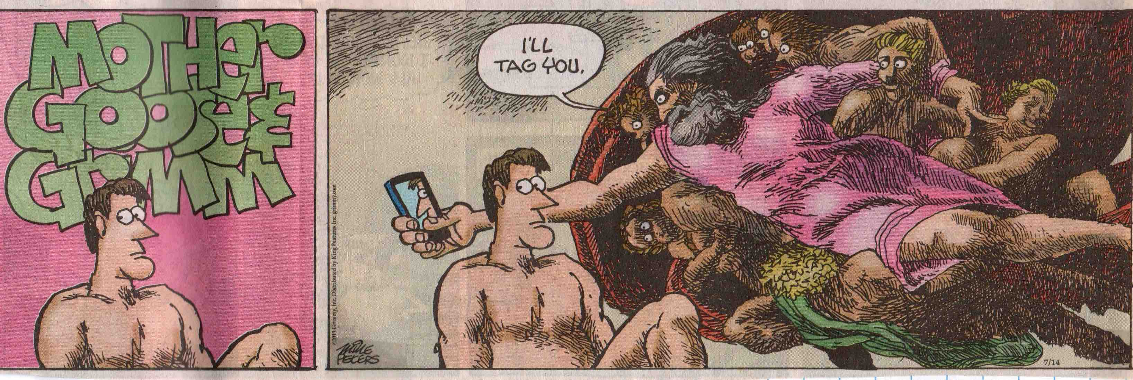
Mike Peters, Mother Goose & Grimm.

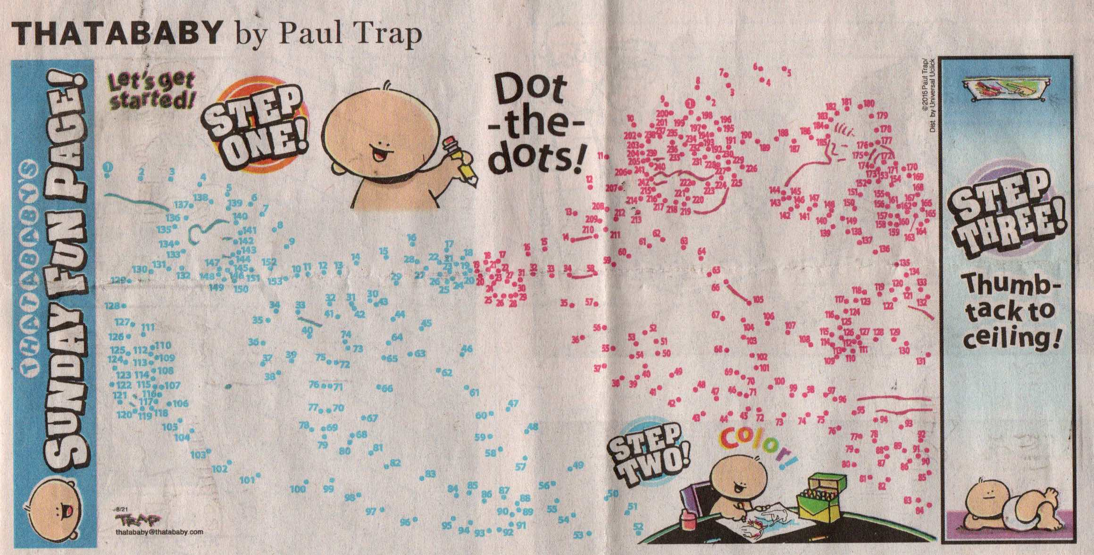
Paul Trap, Thatababy.

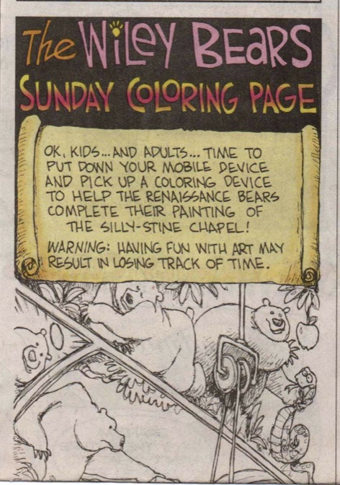  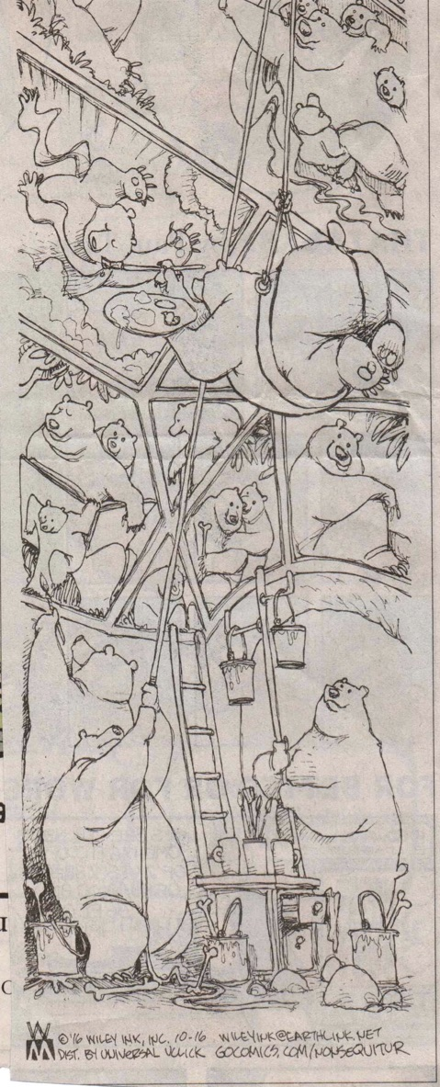 | 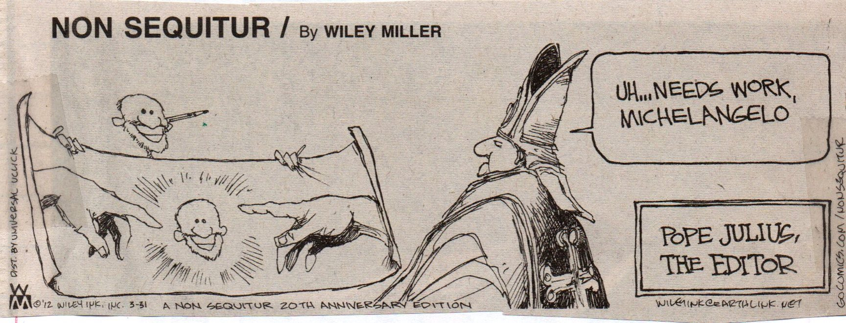
 | 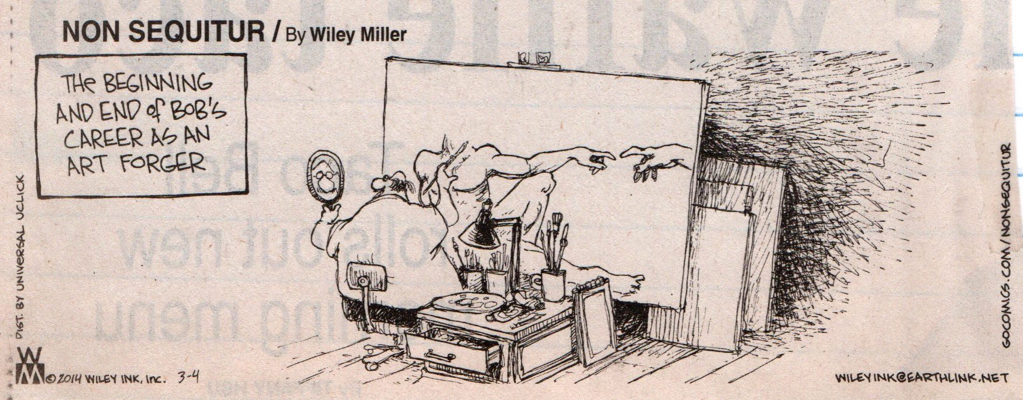
Wiley Miller, Non Sequitur.

Comic Crossing the Delaware

The German-American artist Emanuel Leutze painted Washington Crossing the Delaware in 1851 in Bremen, Germany, as an encouragement to European liberal reformers following the 1848 revolutions. The original was destroyed in an Allied bombing raid in World War II (a contemporaneous copy is now in the Metropolitan Museum of Art), just as the original internationalist context of the piece has been replaced by the purely American patriotism of the meme.

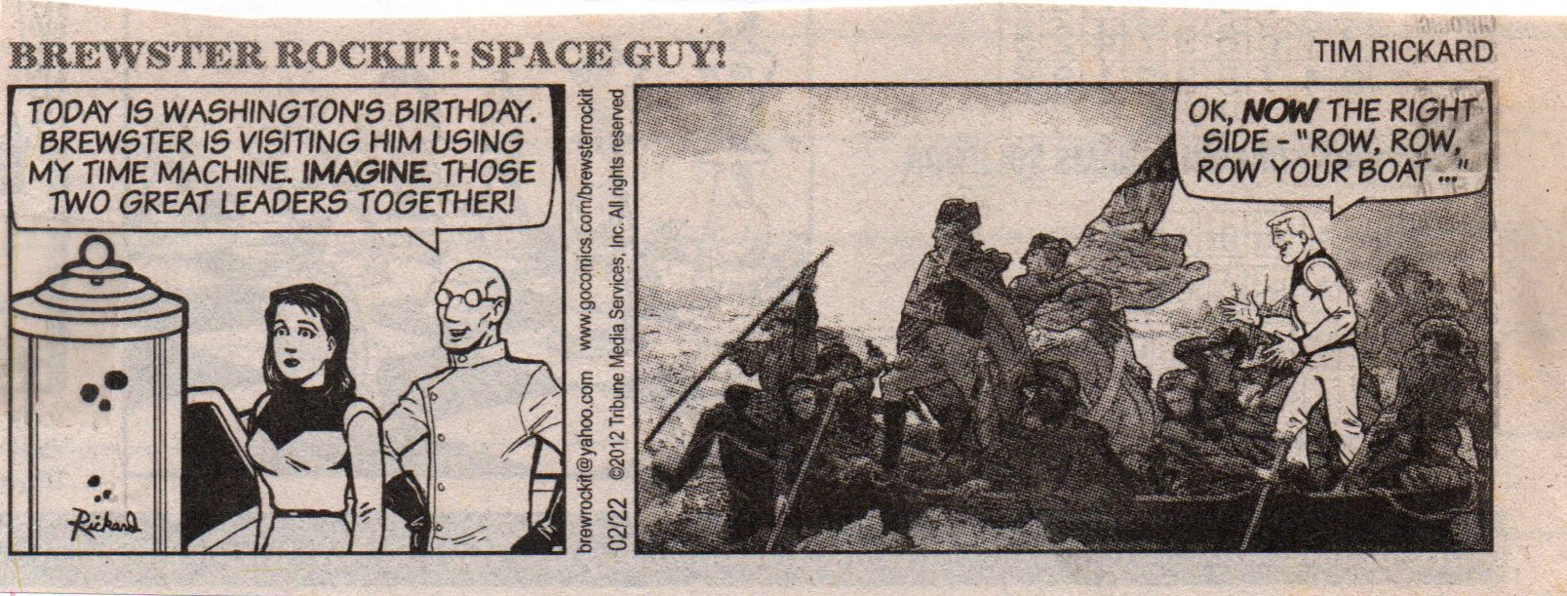
Tim Rickard, Brewster Rockit: Space Guy!

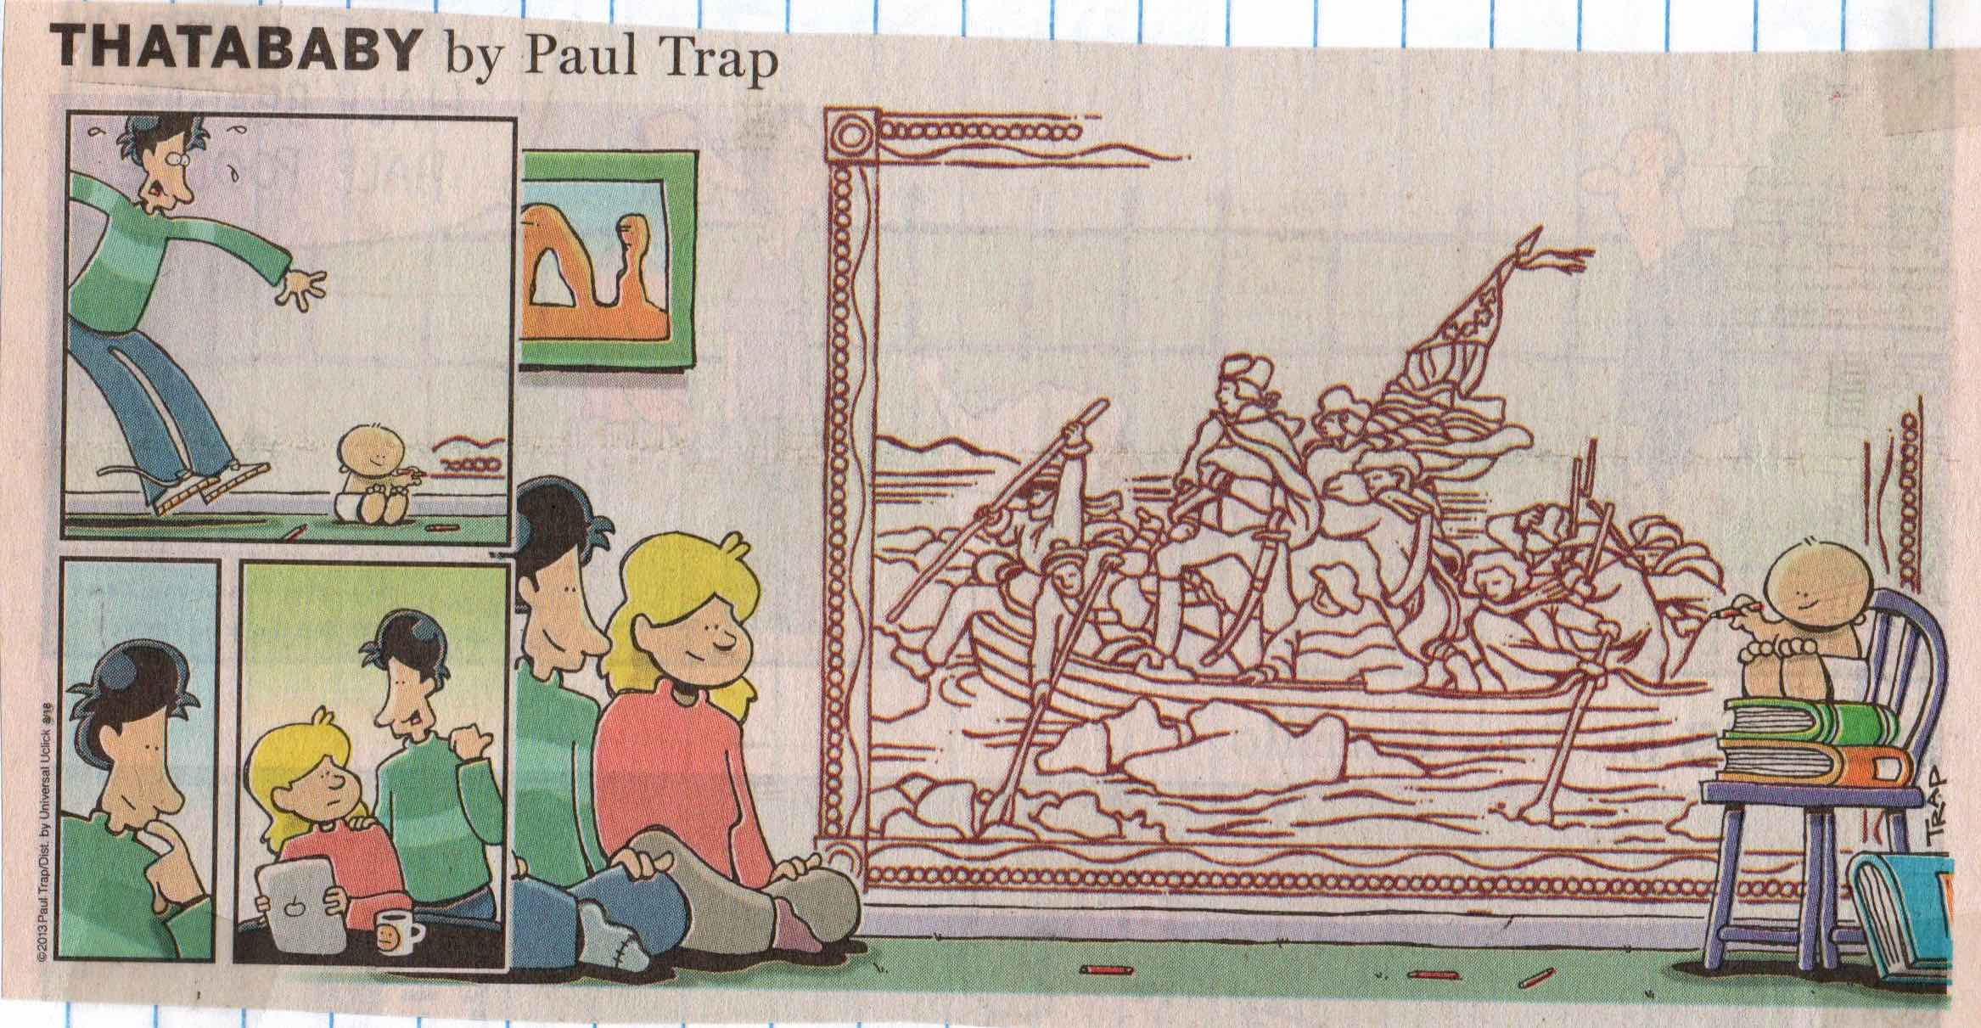
Paul Trap, Thatababy

Silly Thinker

One wonders what Auguste Rodin might have thought had he known that, of his entire corpus of innovative modernist sculpture, The Thinker emerged a meme of serious, passive, mental contemplation. The Thinker was originally entitled The Poet and began its life as an idealized representation of Dante in Rodin’s monumental work The Gates of Hell; for Rodin, the sculpture embodied active creation rather than quiescent meditation.

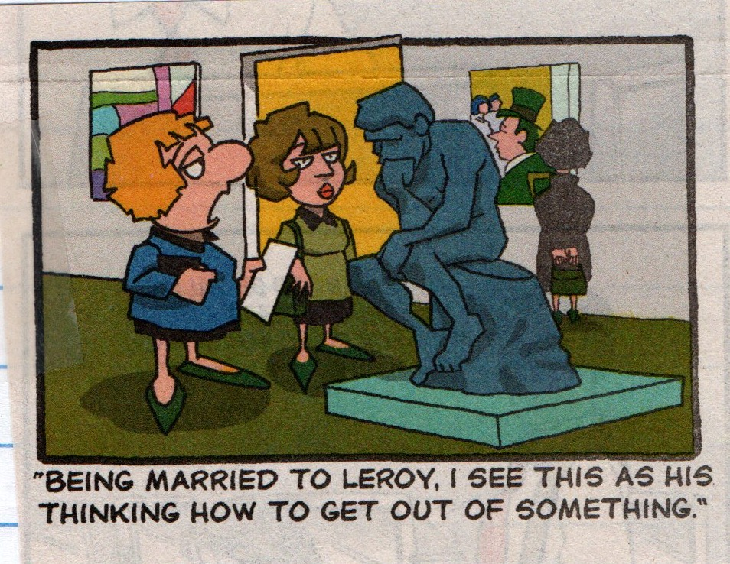
Bunny Hoest and John Reiner, The Lockhorns.

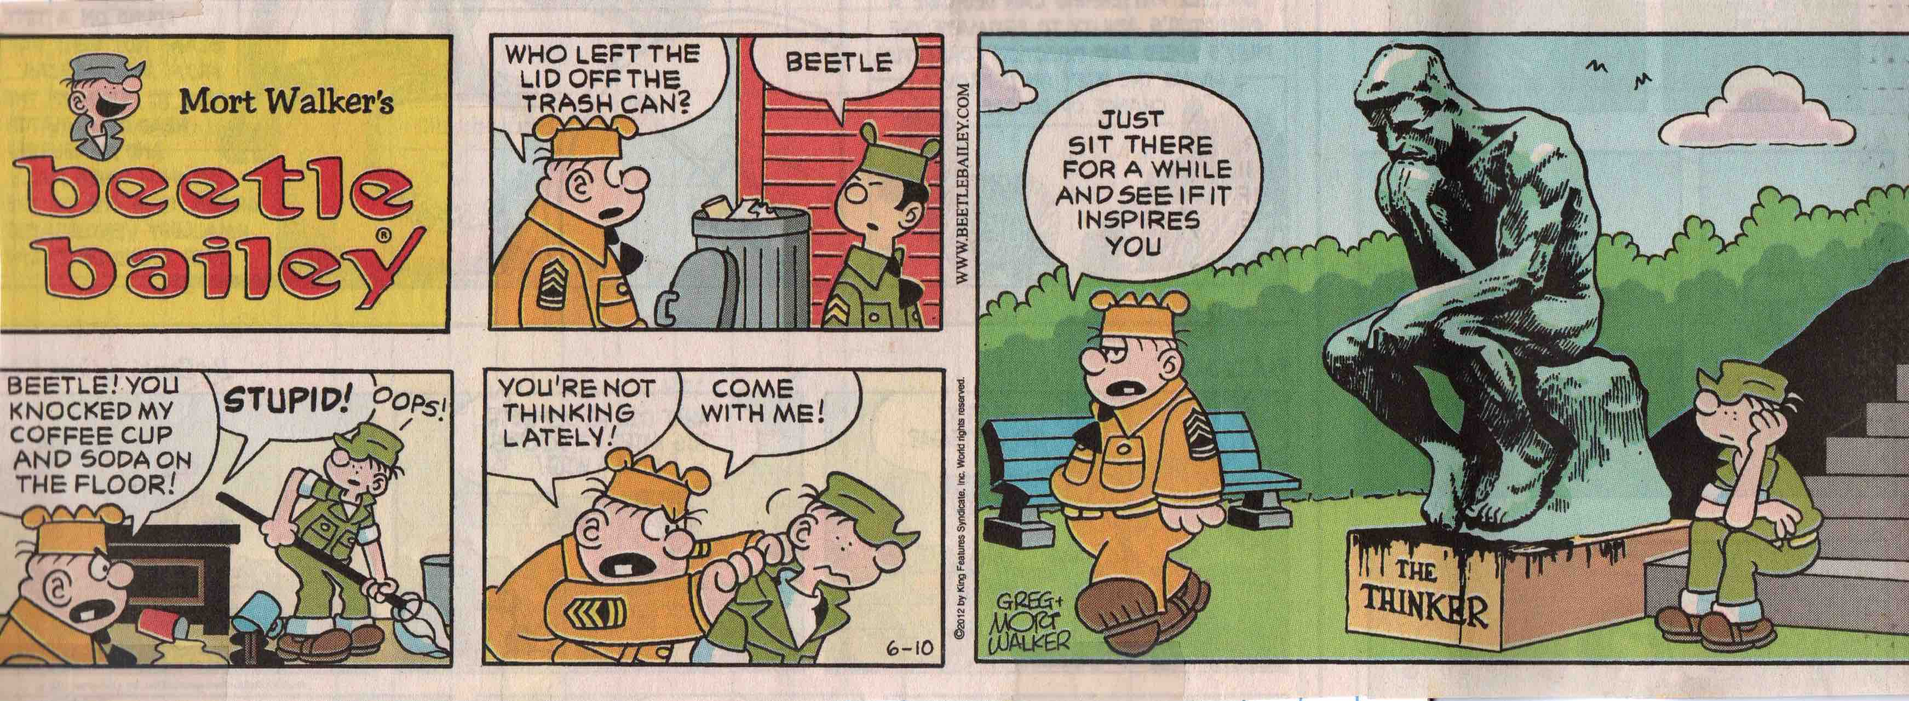
Mort Walker, Beetle Bailey.

The Silly Scream

Poor Edvard Munch! If this Norwegian knew that, of all of his Symbolist paintings exploring human psychology, only this meme of existentialist dread would emerge, he would probably, well, scream!

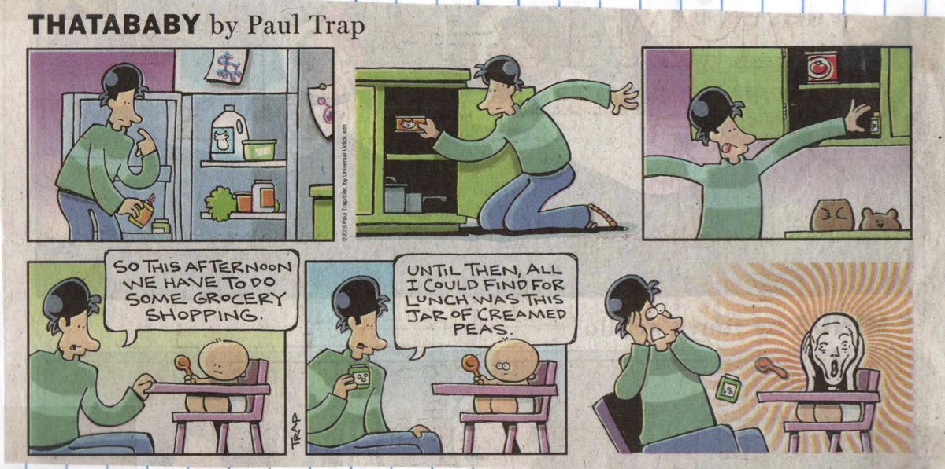
Paul Trap, Thatababy

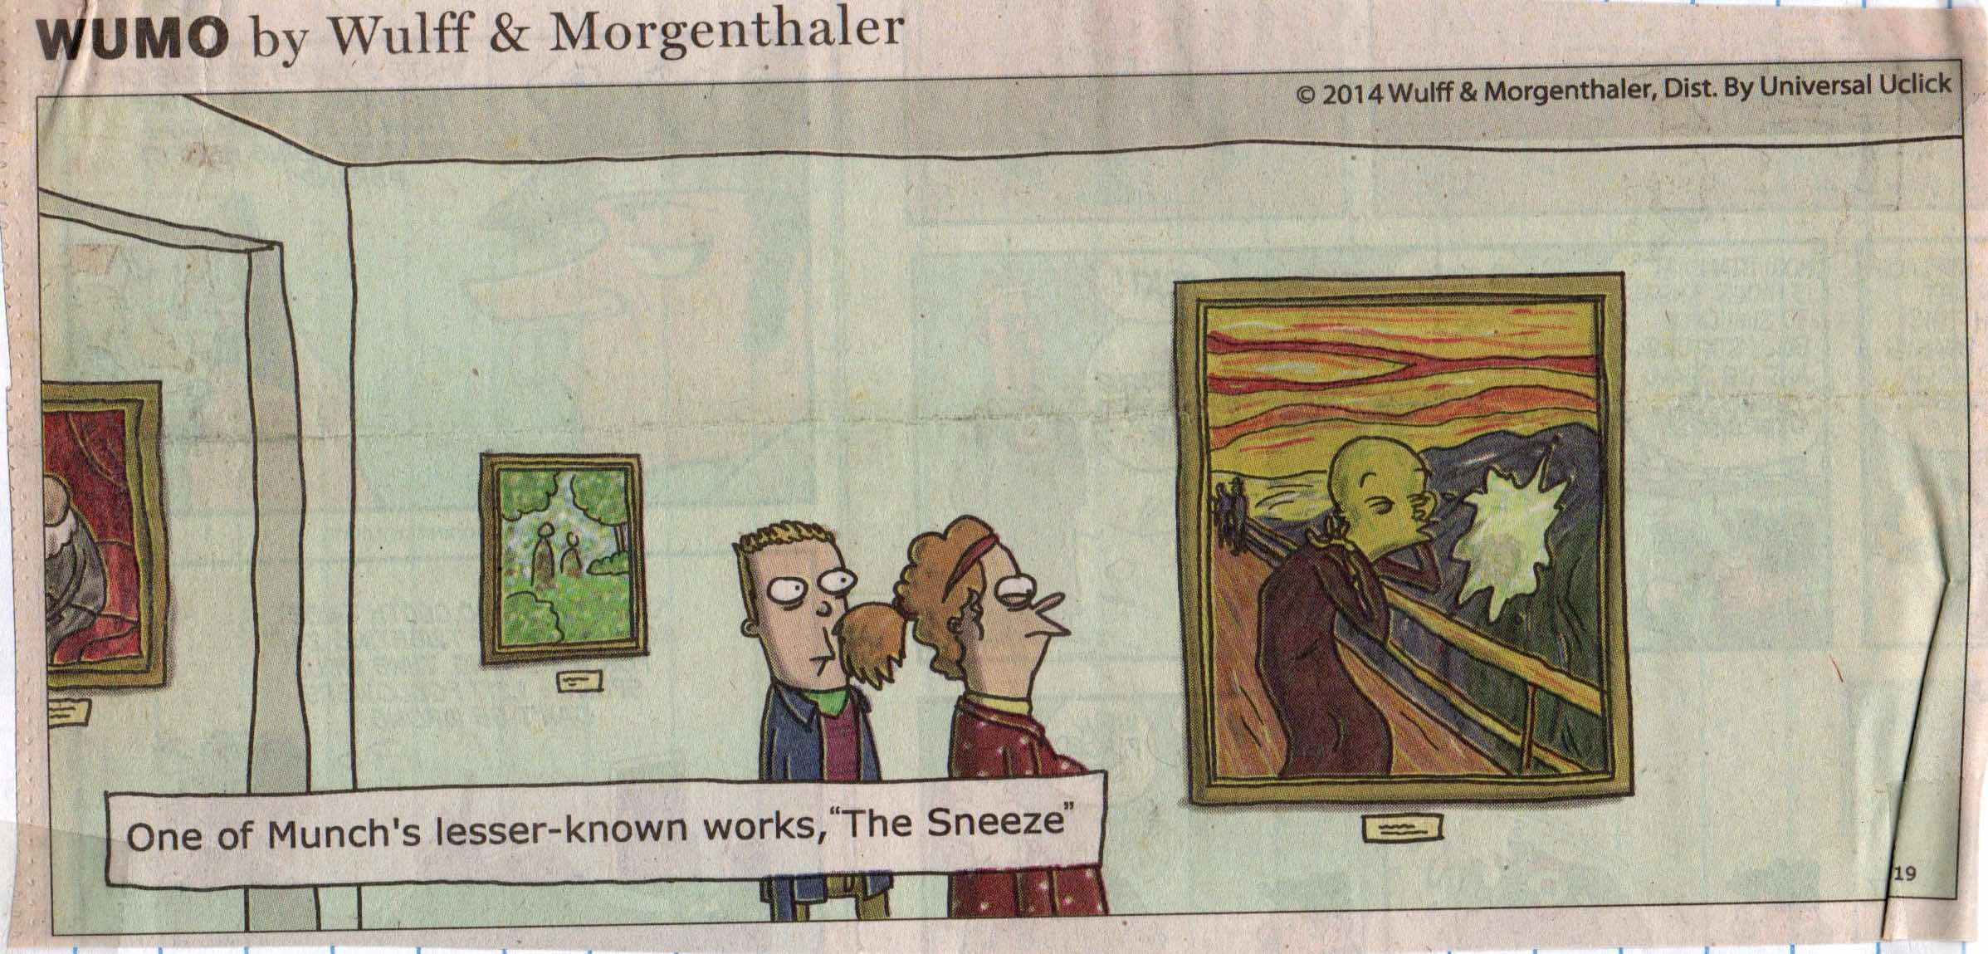
Mikael Wulff & Anders Morgenthaler, Wumo.

Dalí Dillies

While the compositional complexities of Savador Dalí’s 1931 surrealistic masterpiece, The Persistence of Memory, may have faded over time, the melting watch meme does continue as an absurdist vision of a collapsing world order—a vision that is comic in its own right.

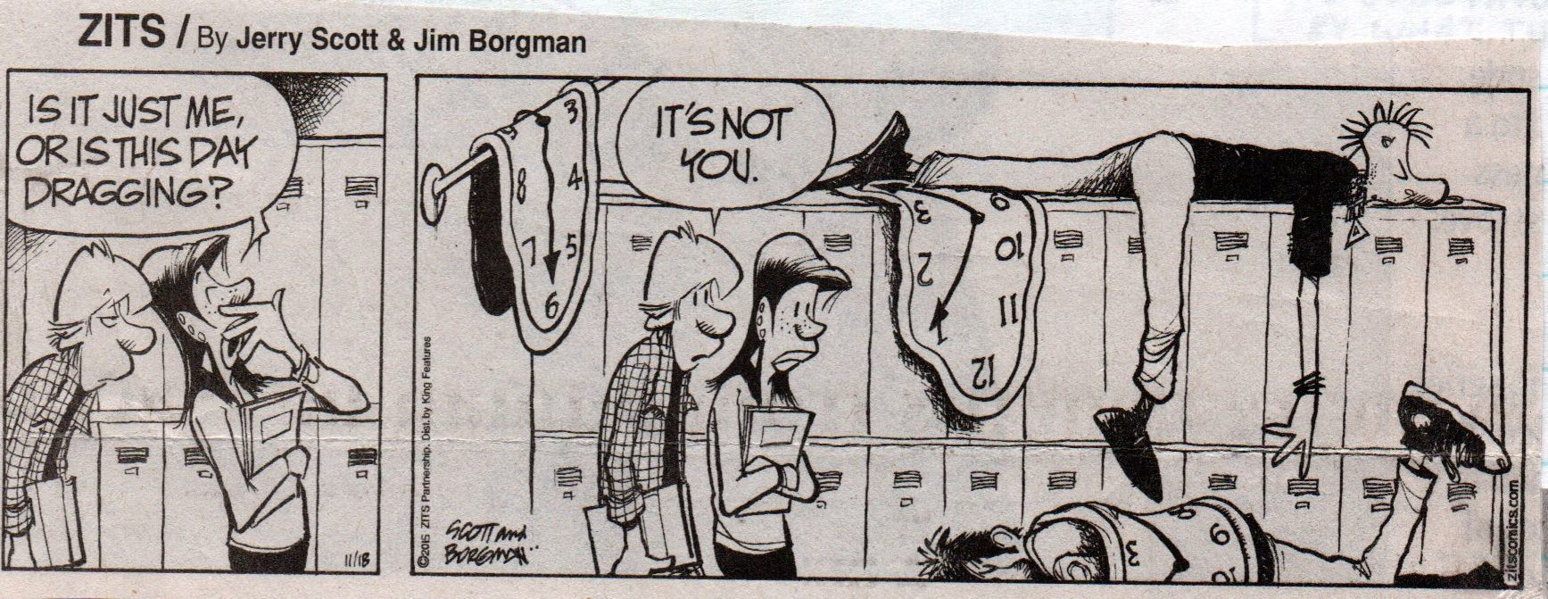
Jerry Scott & Jim Borgman, Zits.

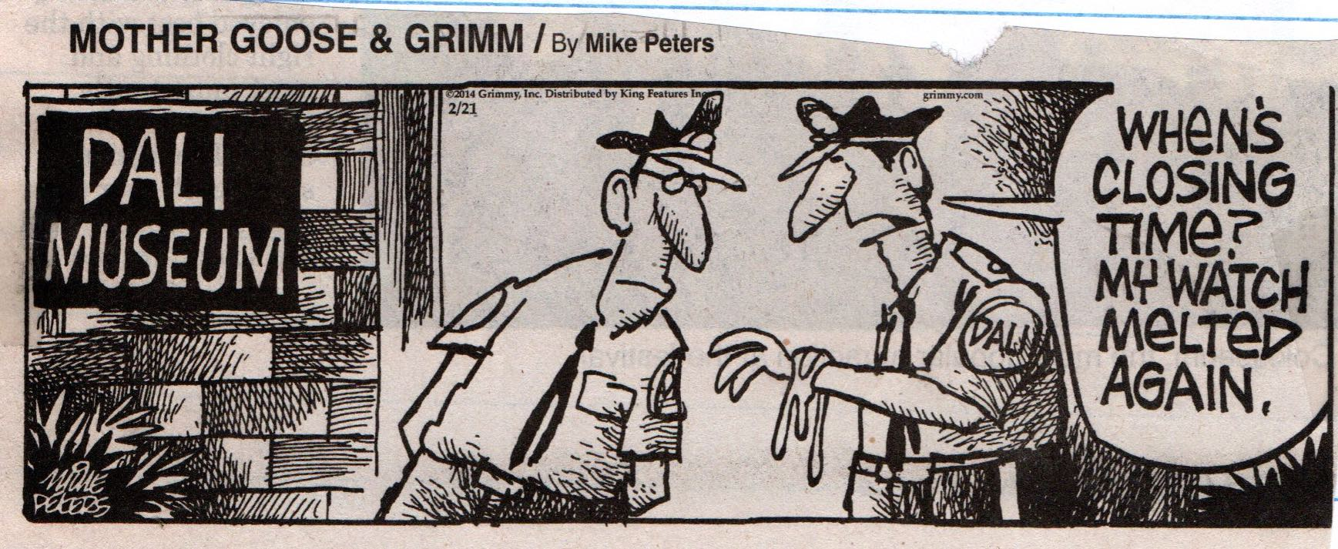
Mike Peters, Mother Goose & Grimm.

Escher Absurdities

For many comic strip artists, M.C. Escher’s impossible geometries are too enticing to pass up as they explore the absurdities of the human condition.

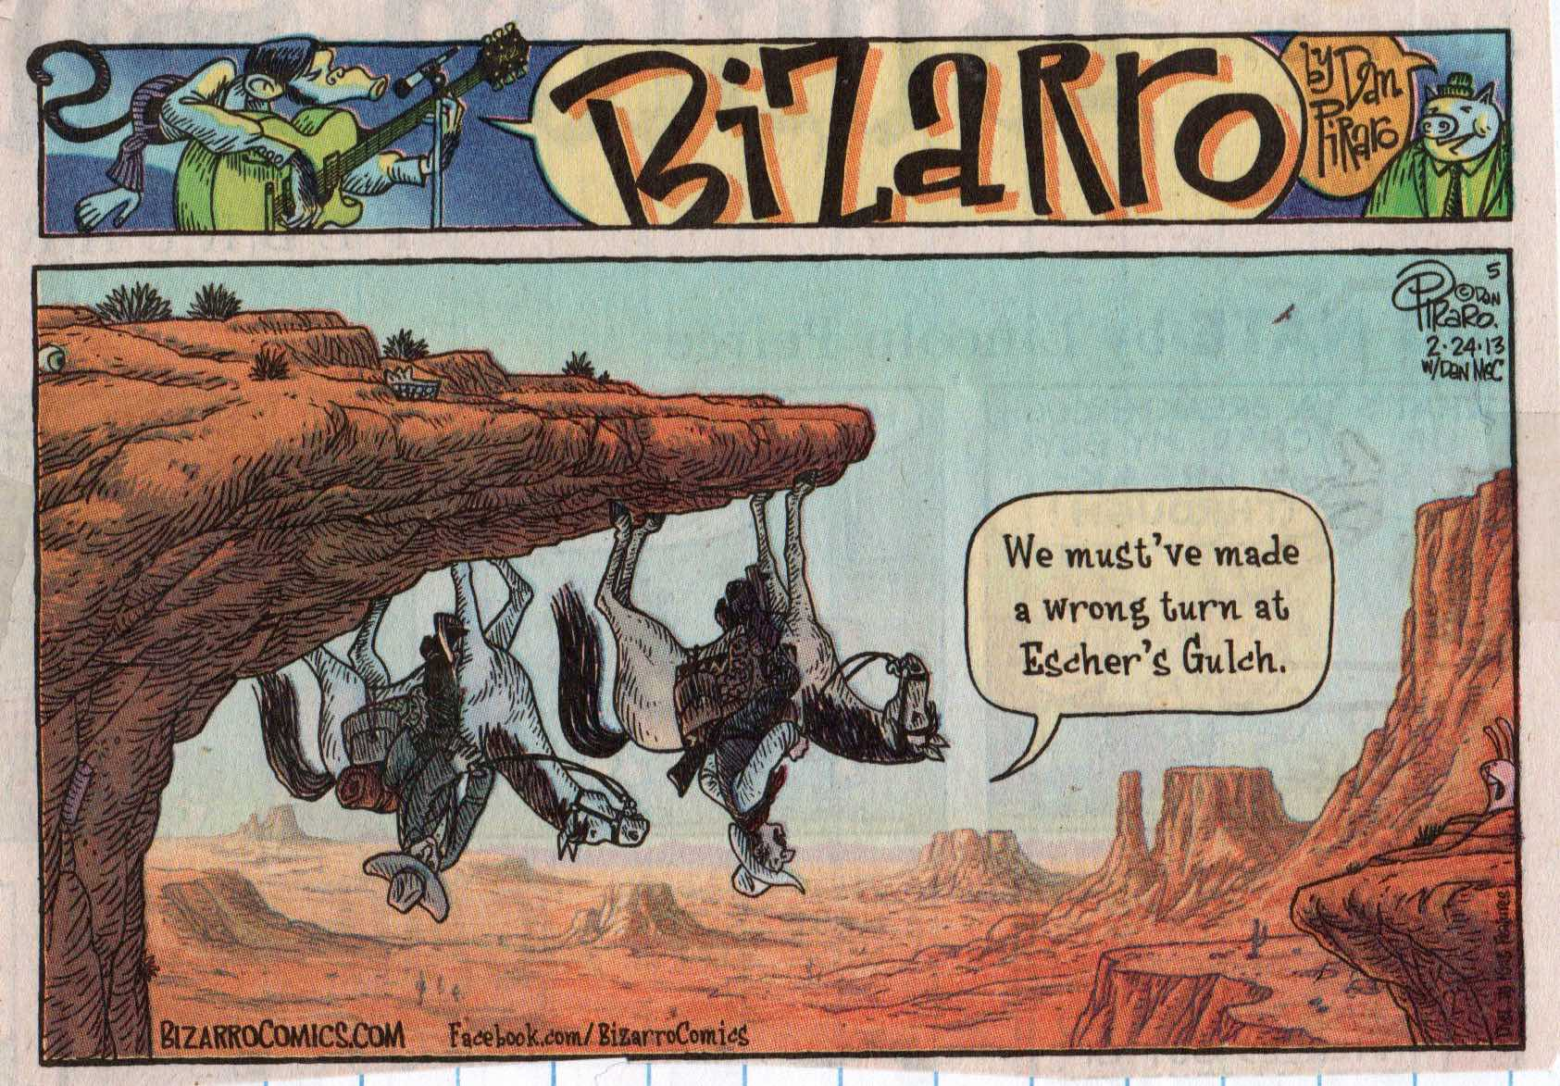
Dan Piraro, Bizarro.

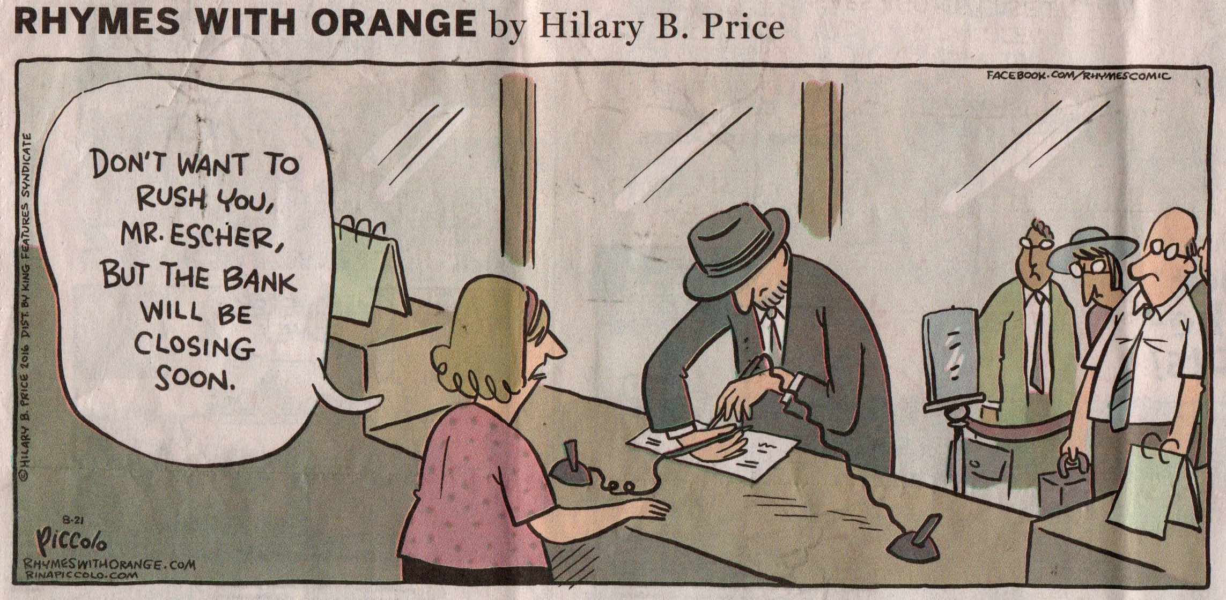
Hilary B. Price, Rhymes with Orange.

Joking Pollock

Pollock’s style itself, rather than any one particular work, has become the quintessential meme for abstract expressionism.

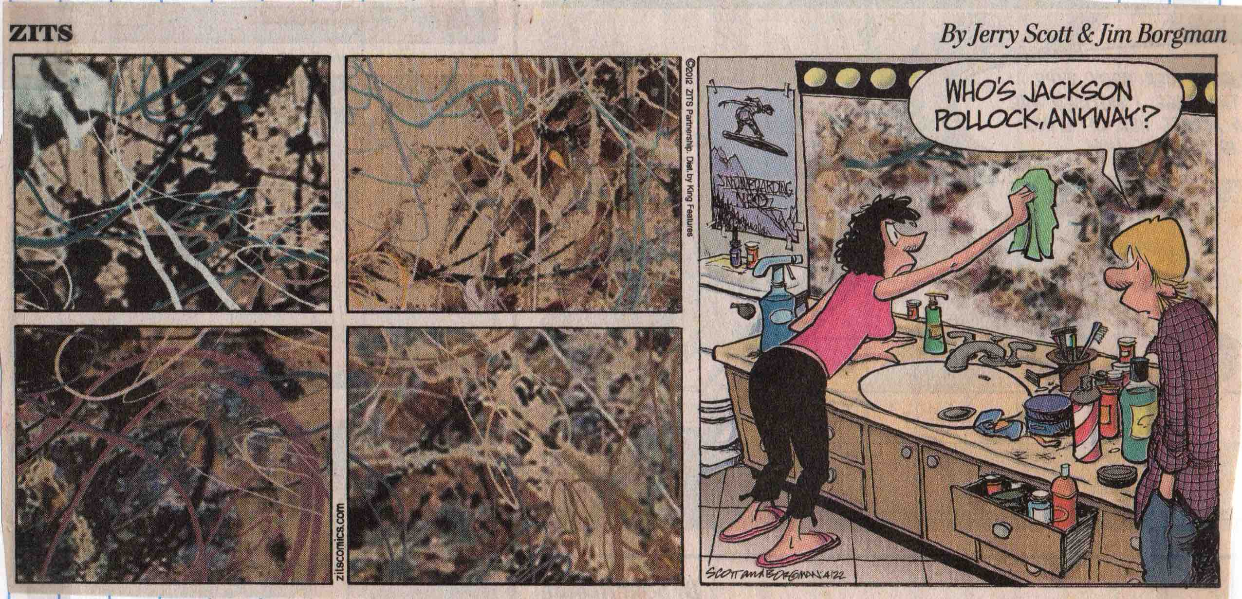
Jerry Scott & Jim Borgman, Zits.

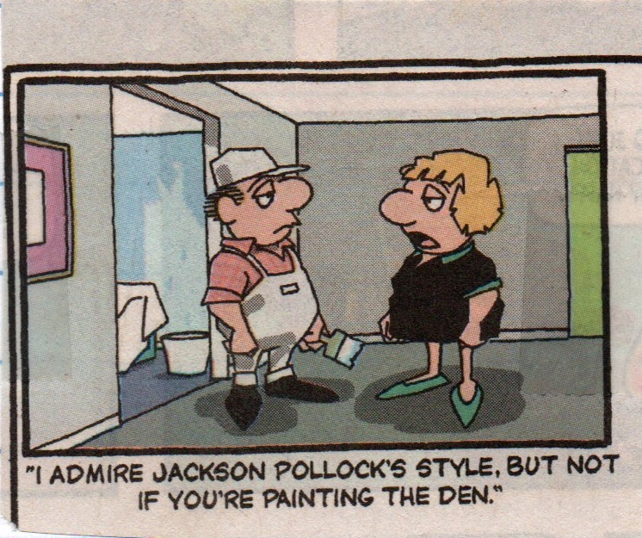
Bunny Hoest and John Reiner, The Lockhorns.

Zanny Zippy

Bill Griffith has spent his life at the vanguard of comic art. After growing up in the cultural conformity that was post-WWII Levittown, Long Island, Griffith went to art school in 1962 and then moved to San Francisco in 1970, where he quickly became a leading figure in the underground comix movement.
Griffith’s occasional “Random Memories” in his comic strip Zippy are autobiographical reflections on aspects of his life, such as the influence that his Levittown neighbor, the science-fiction illustrator and filmmaker Ed Emshwiller, had on his becoming an artist, or the pride he feels about his great grandfather, the pioneering photographer William Henry Jackson.

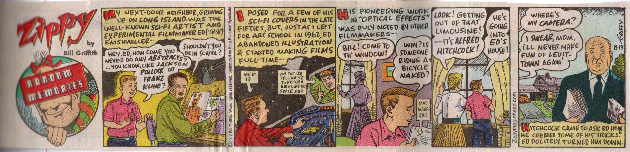

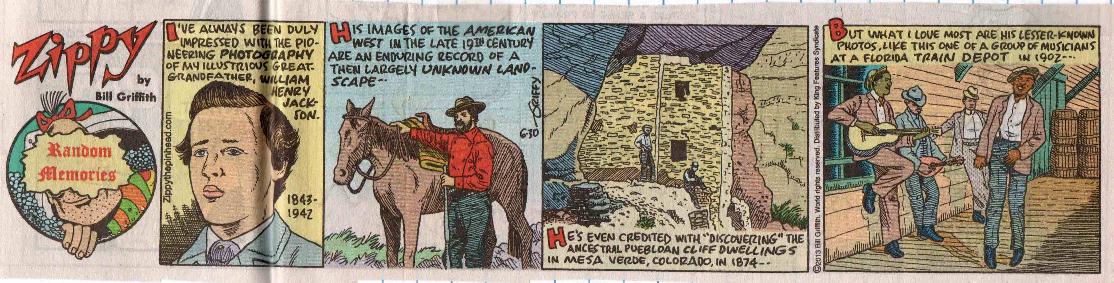
Bill Griffith, Zippy: Random Memories.

Zippy focuses on Griffith’s neurotic alter ego Griffy and the pinhead, muu-muu-clad Zippy, the two main characters at opposite ends of rationality and irrationality. Recently, Griffith has set many of his strips in the bizarre town of Dingburg where Zippy and his fellow pinheads live in a world of non-linear thinking. The strips in this section explore the whimsical role of art in Dingburg, where allusions to Diane Arbus and René Magritte seem quite natural.

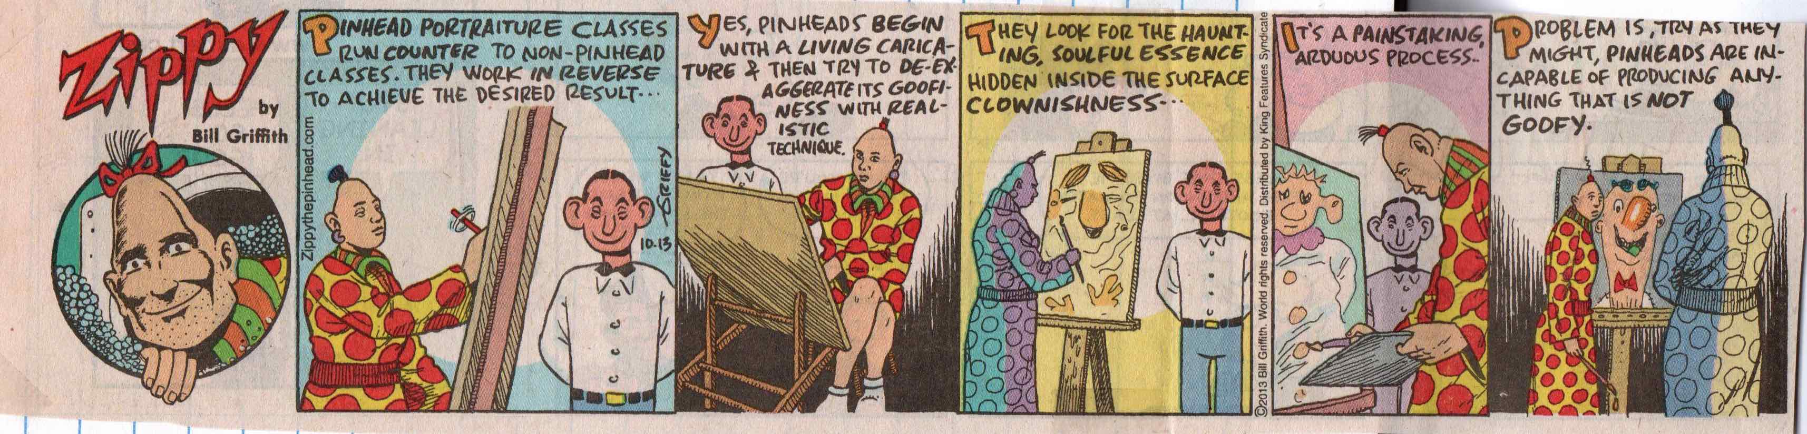

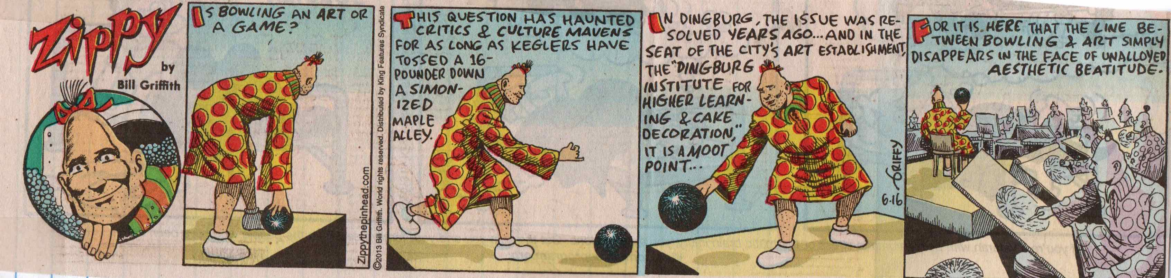

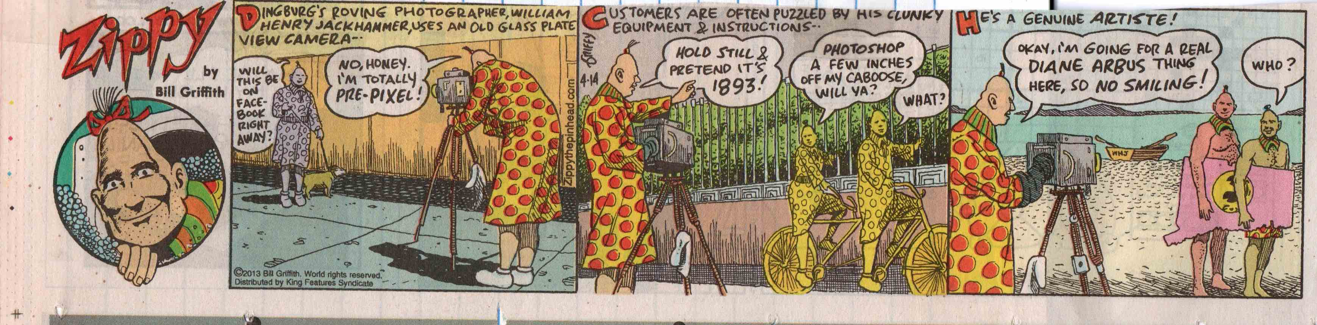

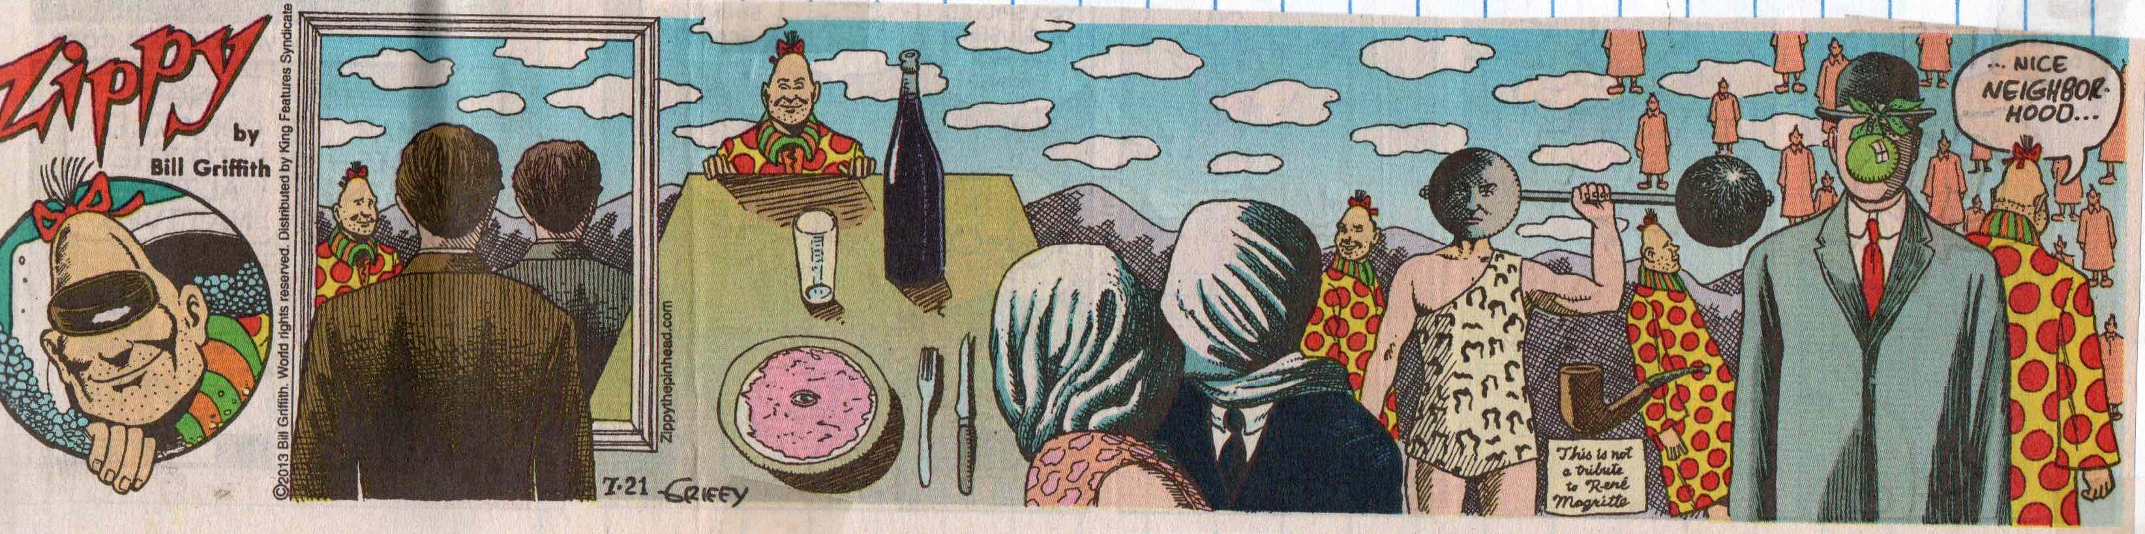
Bill Griffith, Zippy.

Droll Doonesbury Art

One of the hallmarks of Garry Trudeau’s long-running comic strip Doonesbury is how the main characters have evolved over time, from college life through adulthood—a feature that has allowed Trudeau to stay current with his trenchant social commentaries along the way. In 2014 Trudeau ceased publishing his daily strip and started reissuing highlights of old strips as Doonesbury Classics, although he continues to publish original Doonesbury strips on Sundays. The collection of Doonesbury here represents both some original strips and reissued comics.
One of the main Doonesbury storylines related to art revolves around the character J.J. Caucus, who was Mike Doonesbury first wife. J. J.’s career as an avant garde artist was first featured in 1985, when she and Mike were newlyweds. [Note: see “Marjorie’s Cartoons”, above, for another strip belonging to this series.]

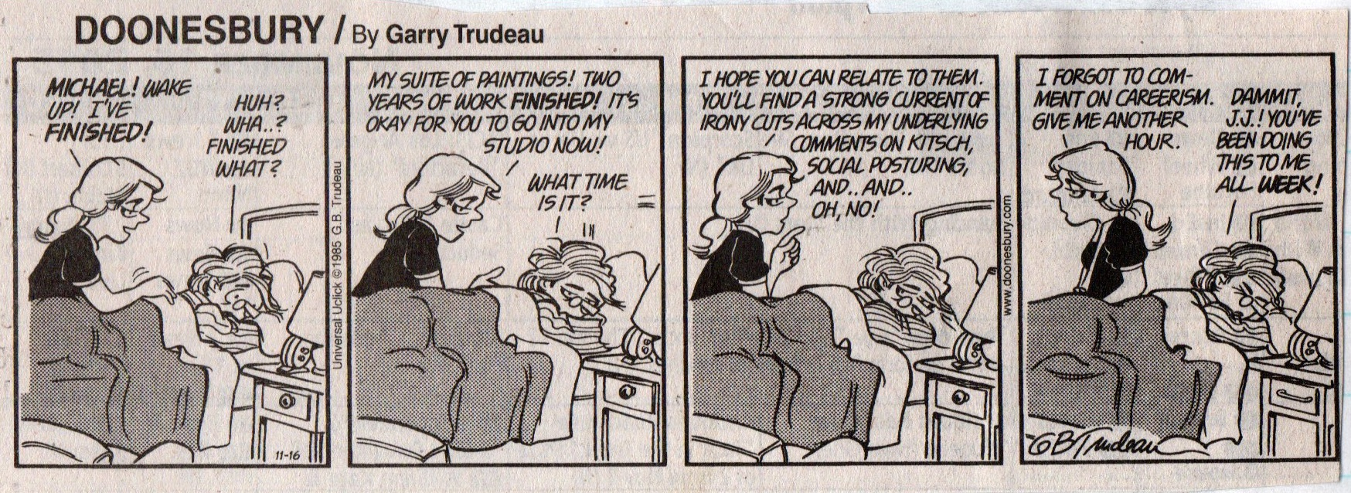

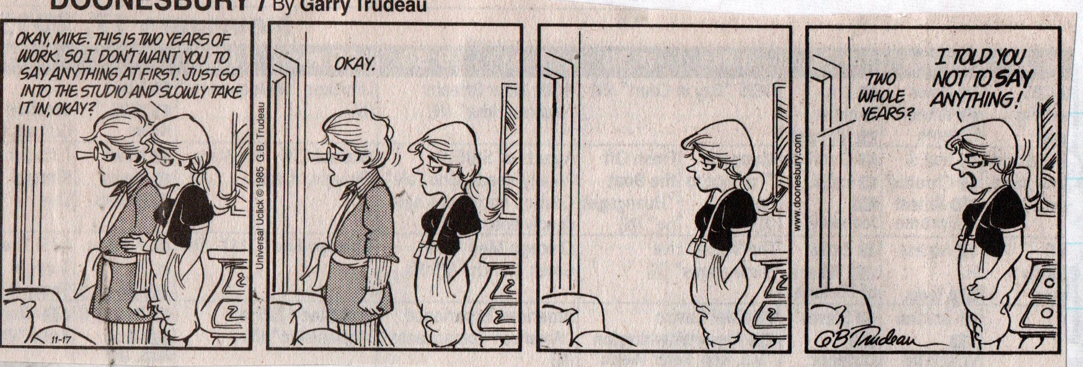
Garry Trudeau, Doonesbury, 1985
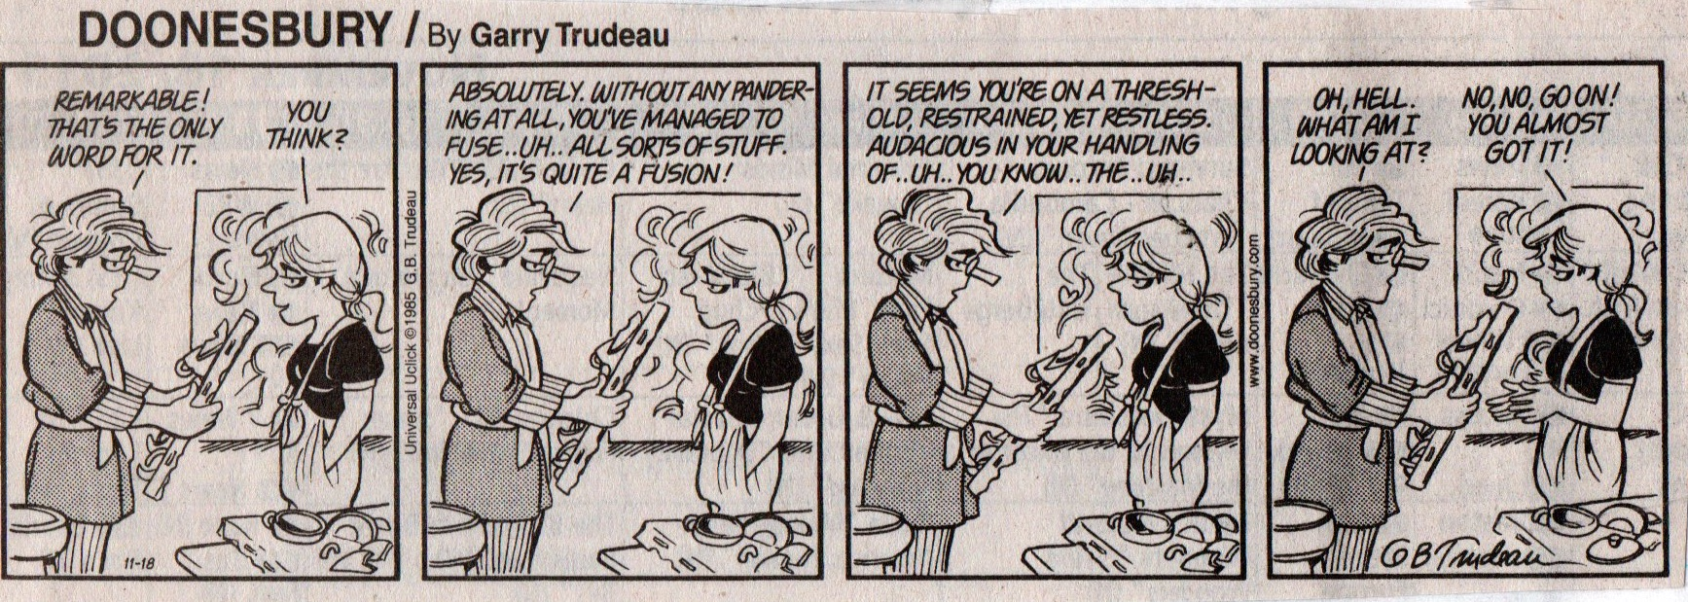
Garry Trudeau, Doonesbury, 1985

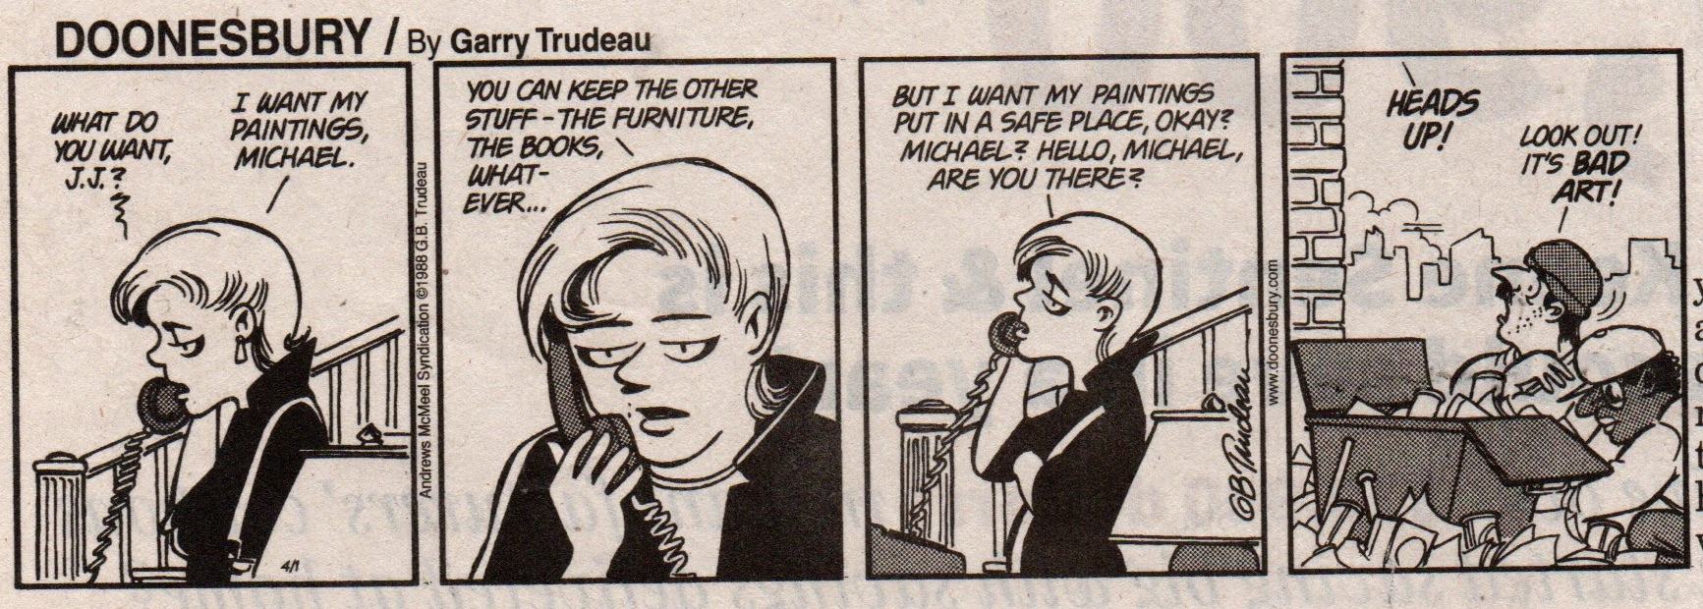
Garry Trudeau, Doonesbury, 1986.

In 1989 Trudeau returned to J.J.’s career with a series of comic strips where, after her divorce from Mike, the avant garde J.J. was forced to prostitute her art by working for Donald Trump, at that time mocked as a gaudy artistic philistine. When this prescient series was repeated in Doonesbury Classics after Trump ran for president in 2016, what had originally been a comic strip with a social commentary had crossed the line into being a satirical political cartoon.

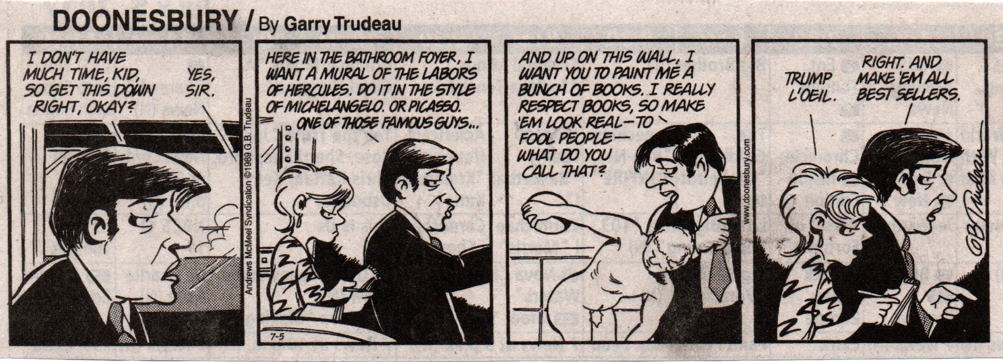
Garry Trudeau, Doonesbury, 1989.
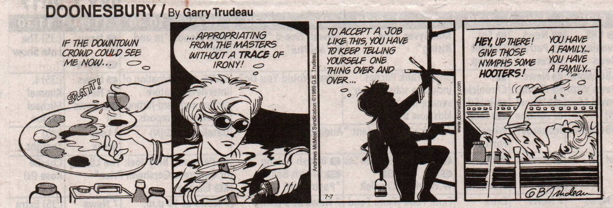
Garry Trudeau, Doonesbury, 1989.

Another Doonesbury art-related storyline is the running gag, which originally ran in 1986, about Mike’s zanny’s friend Zonker, who had won $23 million in the lottery but lost most of it in buying his Uncle Duke out of slavery and purchasing a British nobility title. That this ne’er-do-well would end up owning a $3 million Monet is reminiscent of Charles Schulz’s Peanuts, where Snoopy’s doghouse is home to a vast number of improbable items, including a van Gogh and an Andrew Wyeth

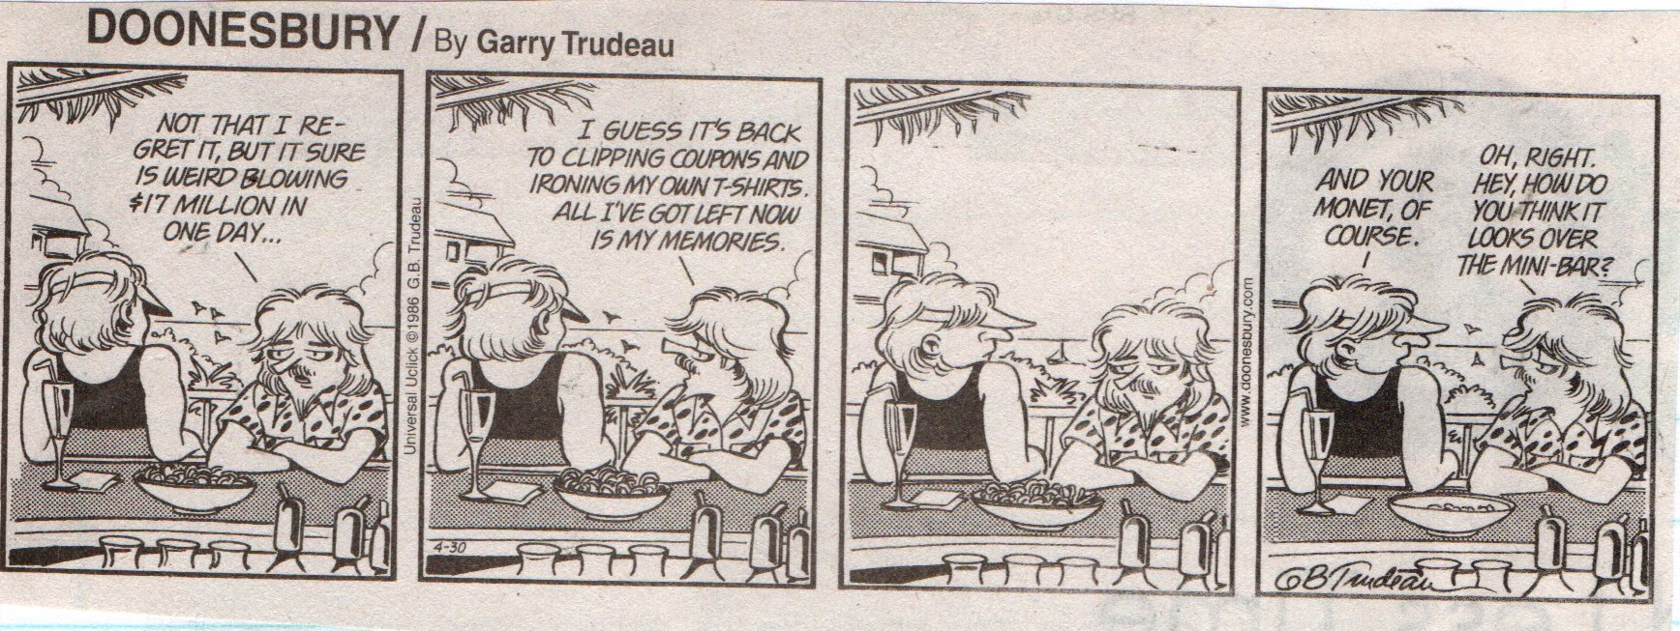

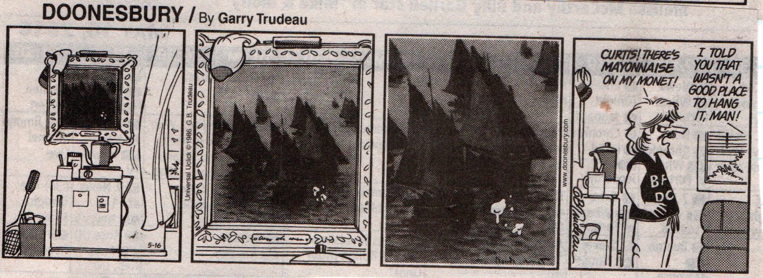
Garry Trudeau, Doonesbury, 1986.

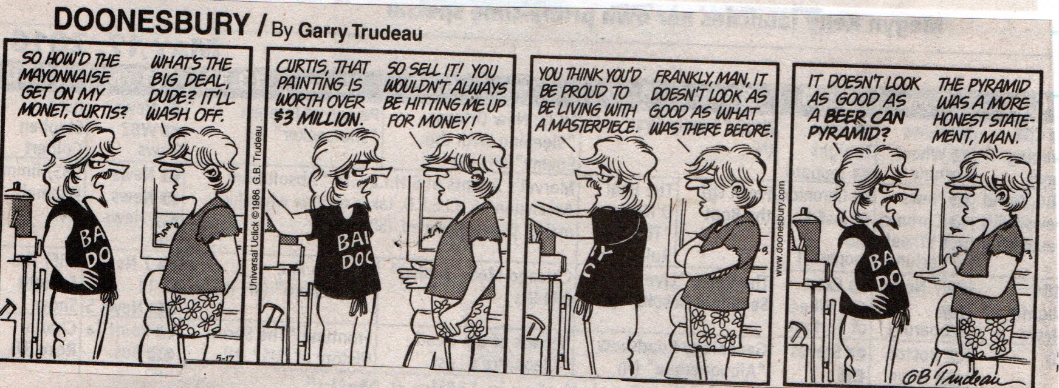

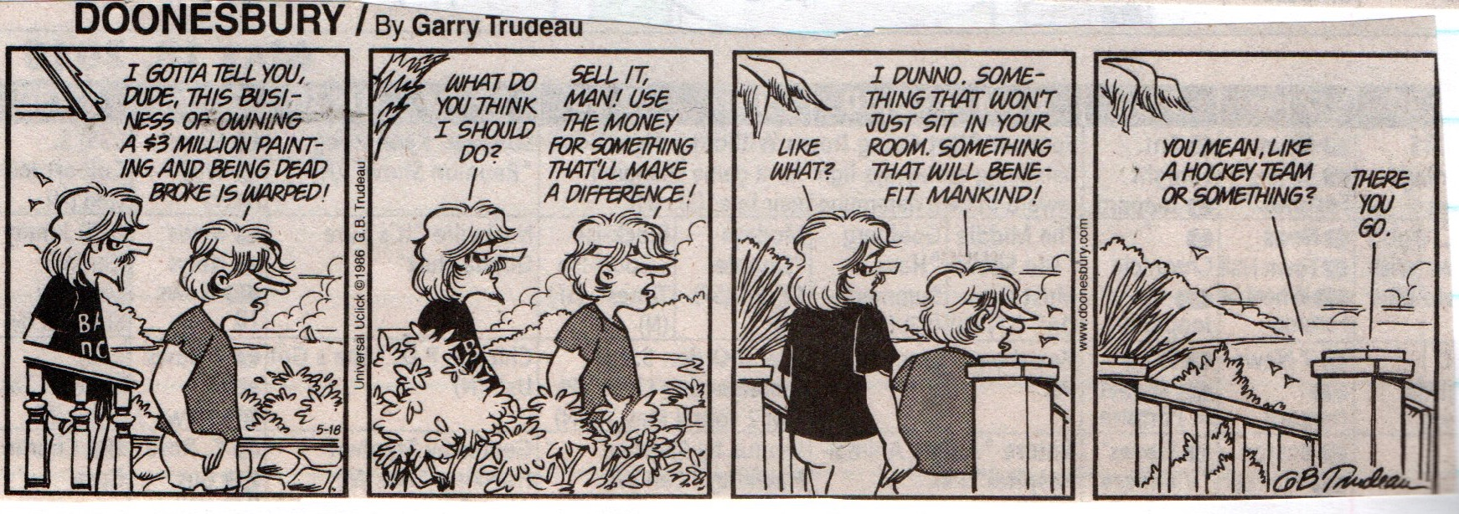
Garry Trudeau, Doonesbury, 1986.

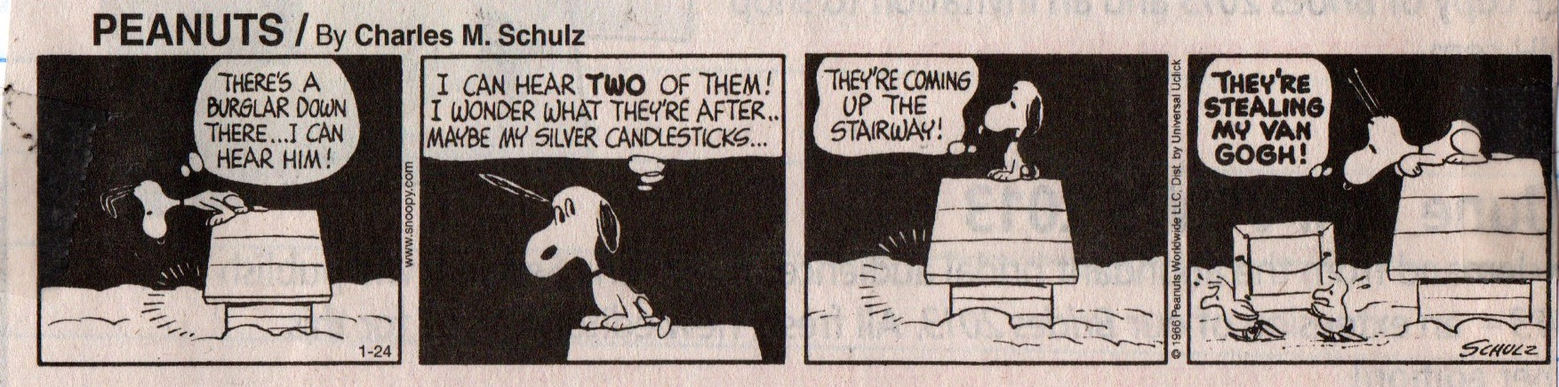

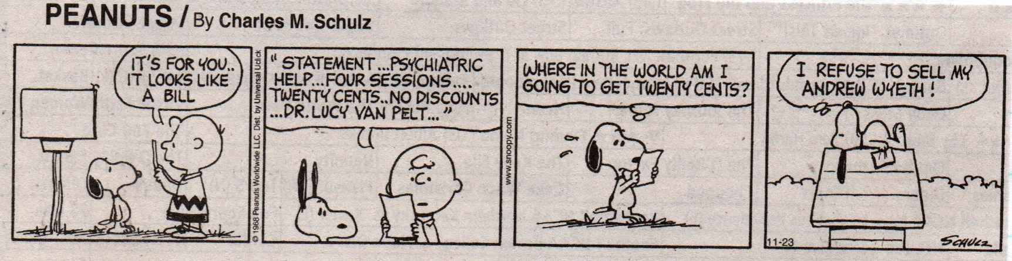
Charles Schulz, Peanuts.

Trudeau has continued the J.J. artist storyline in his current series of Sunday comics, now including Mike’s new wife Kim and J.J.’s and Mike’s daughter Alex.

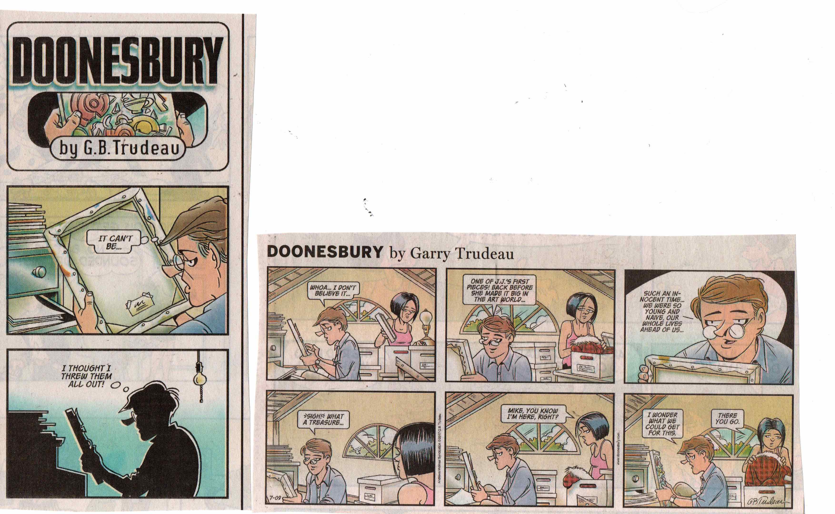

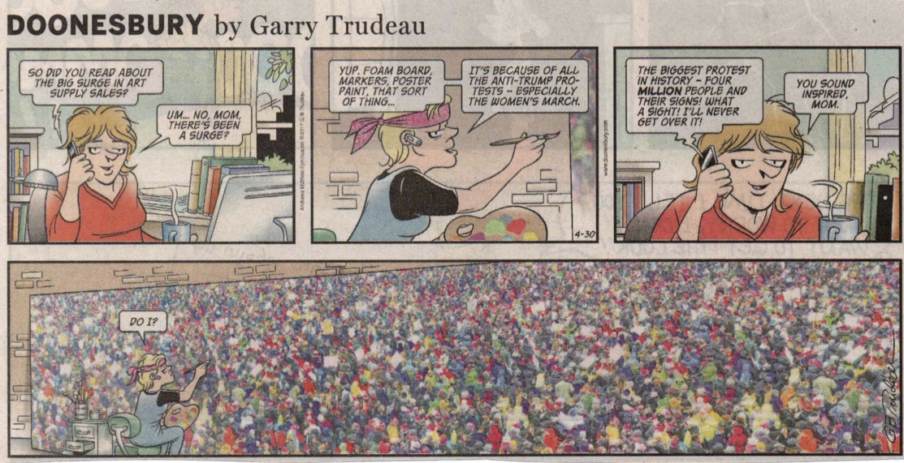
Garry Trudeau, Doonesbury, 2017.

Part II: Funny Archaeology

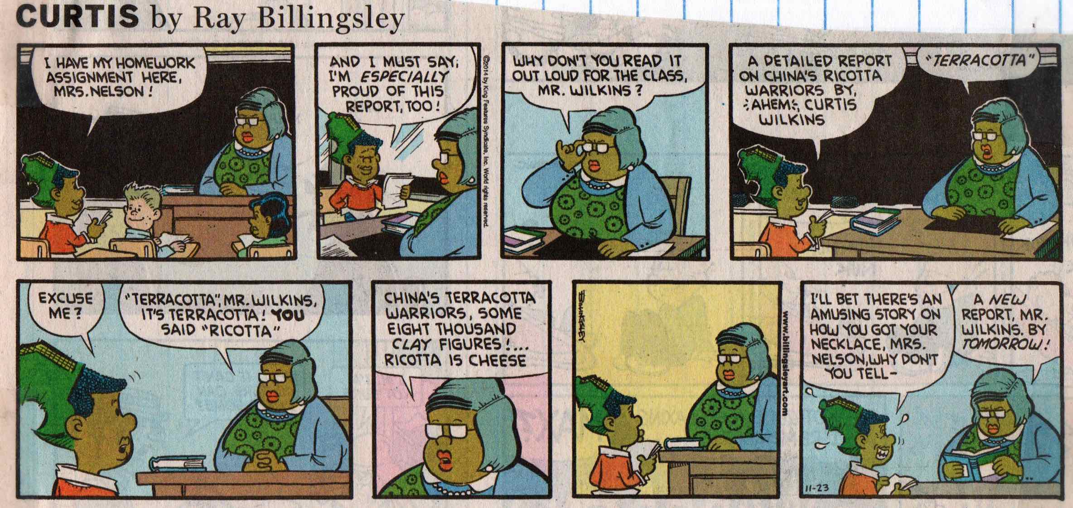
Ray Billingsley, Curtis.

Just as art-themed comic strips play a role in the codification of the established Western art canon, so too do comic strips about archaeology and ancient cultures function to reinforce preconceived notions about the past. However, if the art-themed comic strips in this collection suggest that the cartoon artists assumed that their viewers had at least an Art-History-101 level of knowledge, it would seem that the archaeology-themed comic strip artists represented here had themselves never taken an Archaeology 101 or Ancient Cultures course.
Although, as with the art-related comic strips, the sample size of the archaeology-related comic strips in this collection is too small to make definitive statements about the popularity of individual categories of archaeology humor, here too general trends are plainly evident. The most popular category of comic strips about archaeology in this collection is the Stone Age, with twelve examples on Cave Painting and fifteen examples on Cave Men. Almost as popular are strips about ancient Greece and Rome (twenty-two examples) and ancient Egypt (seventeen examples). The next most popular categories are jokes about excavations (six examples), Easter Island (seven examples), and Stonehenge (four examples). Given the Western-culture bias of comic strips distributed in the United States, it is not entirely surprising that this collection contains only two examples of strips about Pre-Columbian America and only one of ancient China. It is more difficult to understand why our Biblical heritage is so scantily represented, with only a three examples.

Digging-up Jokes

It has been thirty-seven years since the first Indiana Jones movie was released and a decade since the last in the franchise was aired. Still, the meme of the intrepid, pith-helmeted archaeologist lives on.
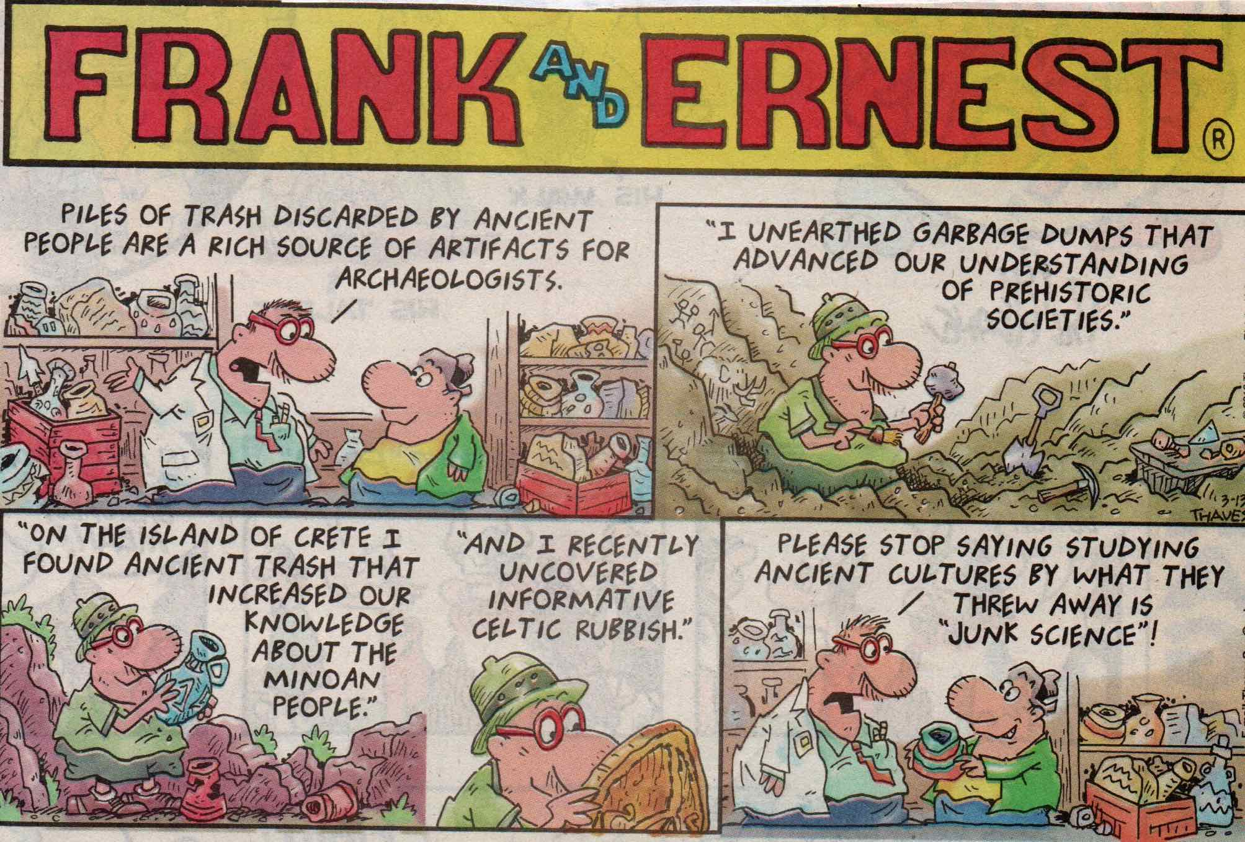
Thaves, Frank and Ernest.

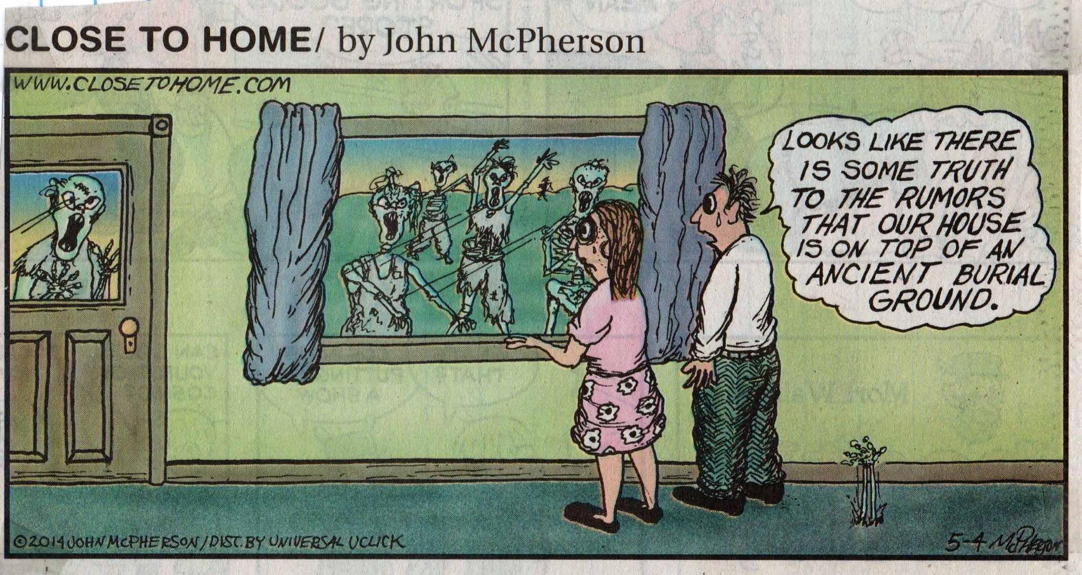
John McPherson, Close to Home.

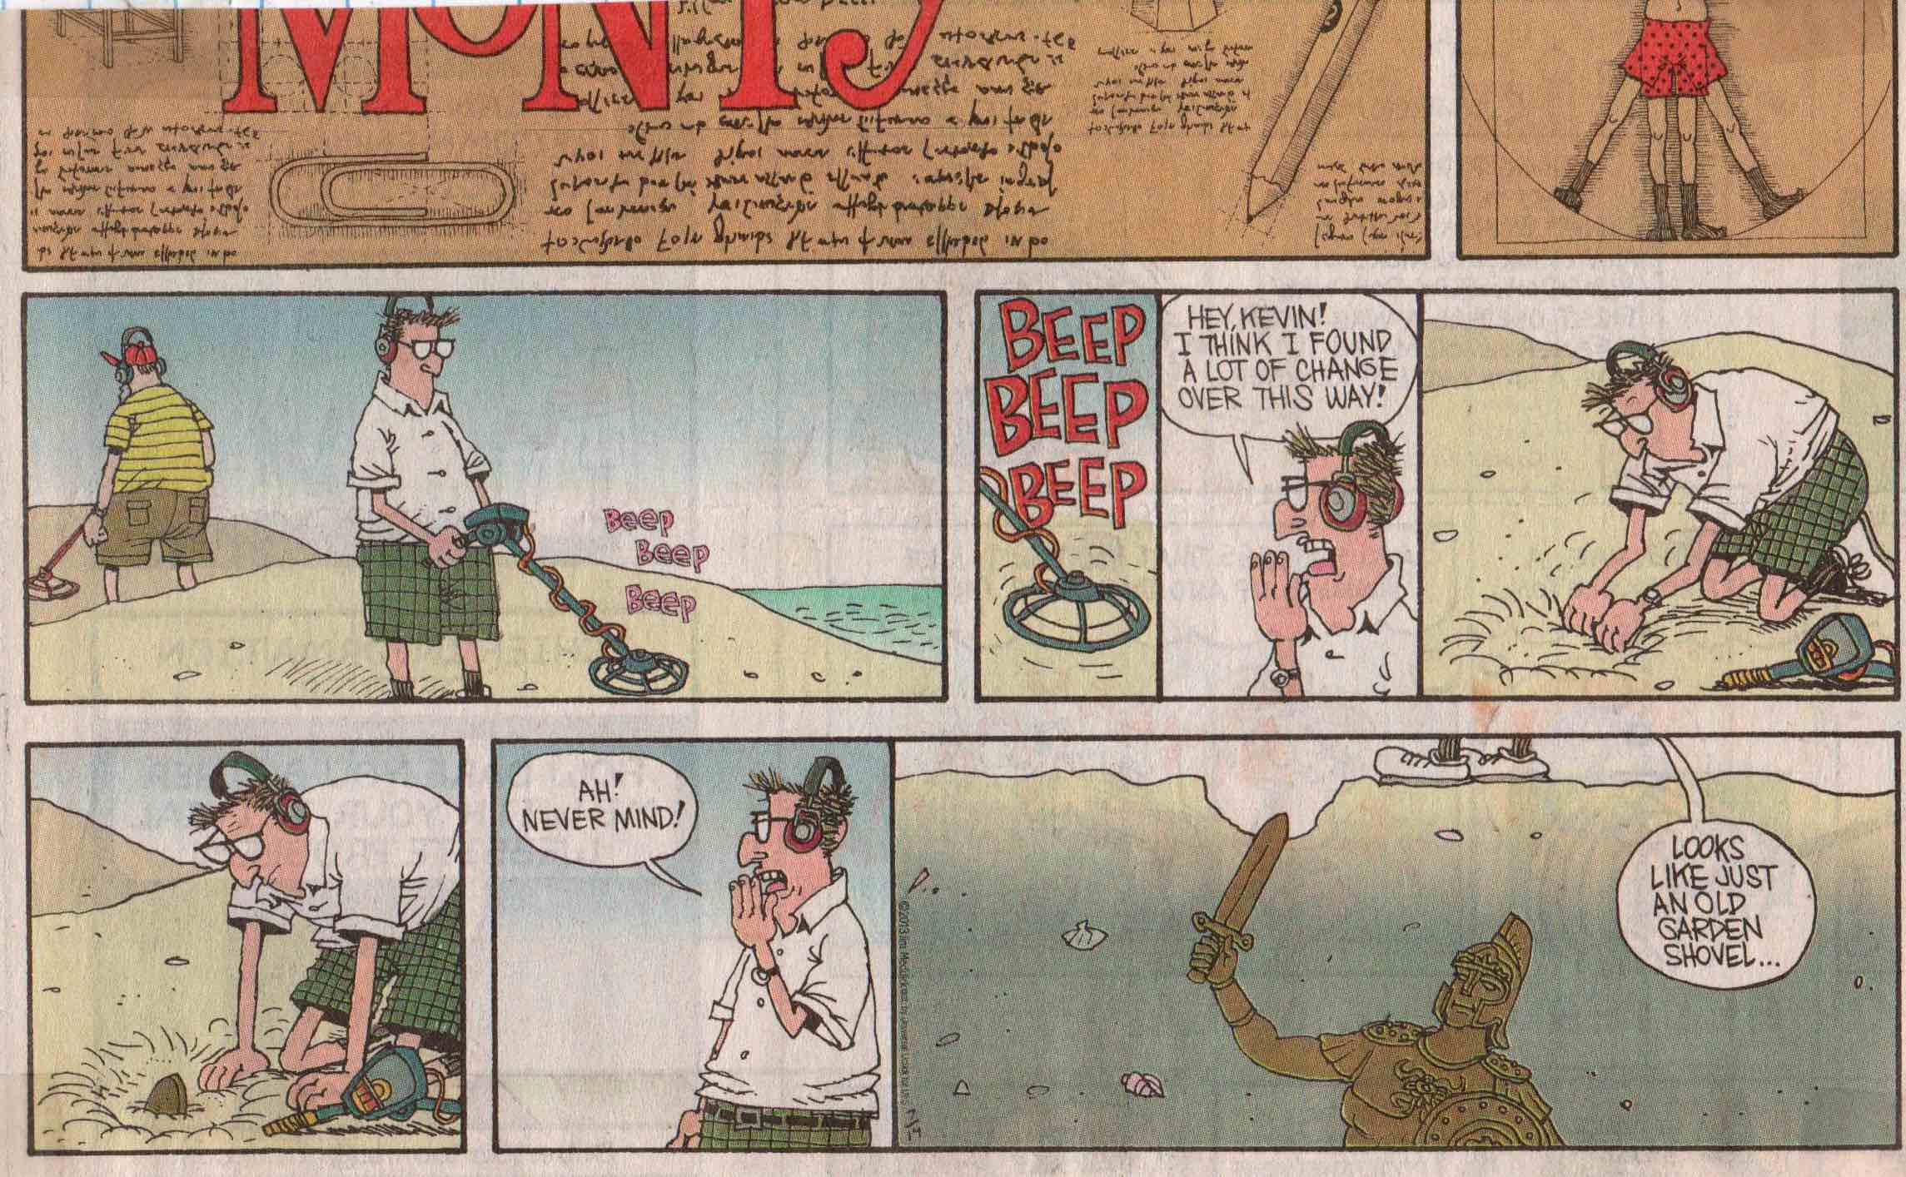
Jim Meddick, Monty.

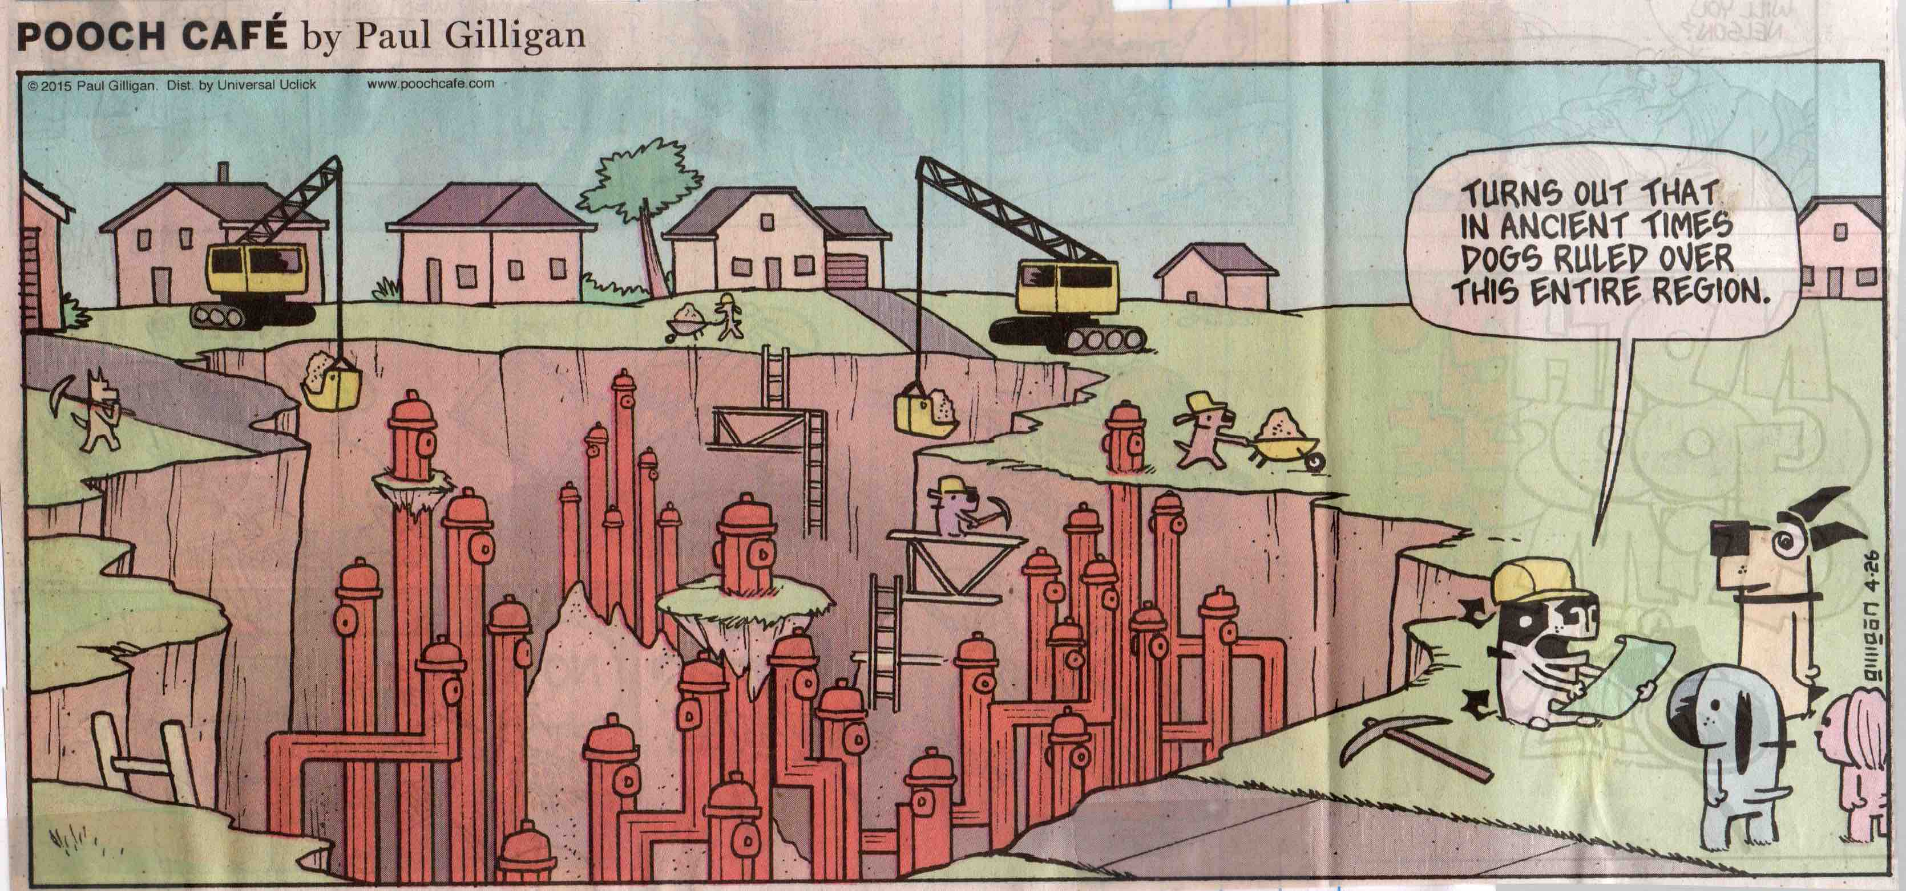
Paul Gilligan, Pooch Café.

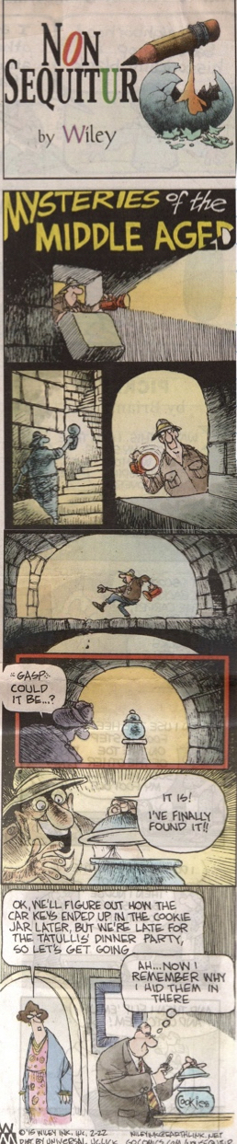
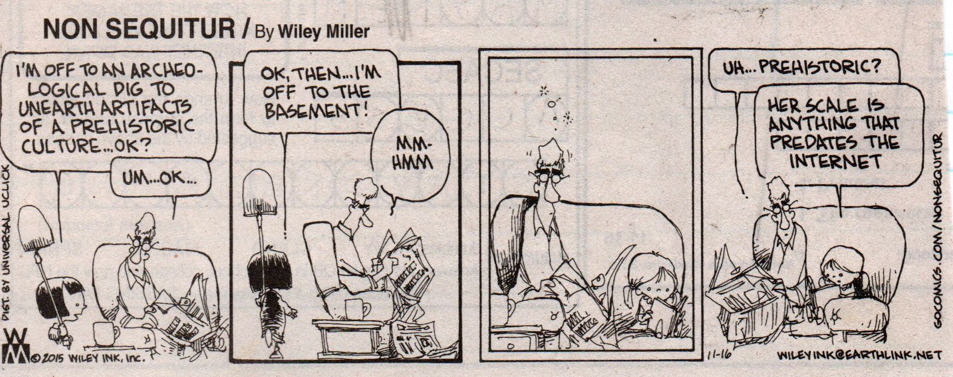
Wiley Miller, Non Sequitur.

Ascent of Foolish Man

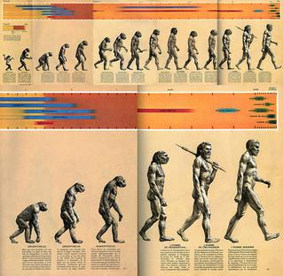

When Rudolph Zallinger created his “The Road to Homo Sapiens” illustration for F. Clark Howell’s Time-Life publication Early Man in 1965, the idea that evolution was a unilinear progression from the primitive to the advanced had already been long out of fashion among paleontologists and evolutionary scientists. Still, the great chain of being—which puts humans at the pinnacle of evolution—has remained a powerfully attractive idea, abetted by religious ideology and the self-centeredness of humanity. And besides, the image of the “March of Progress,” with vertebrates wading out of the primeval slime and gradually standing upright into Homo sapiens is intrinsically funnier than an evolutionarily more accurate cladistic branching tree!

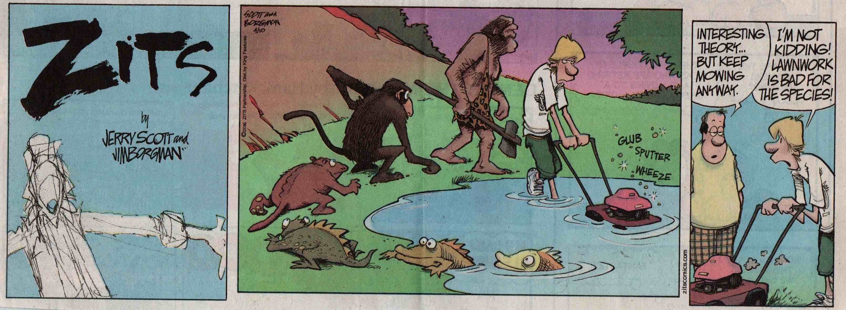 Jerry Scott and Jim Borgman, Zits.

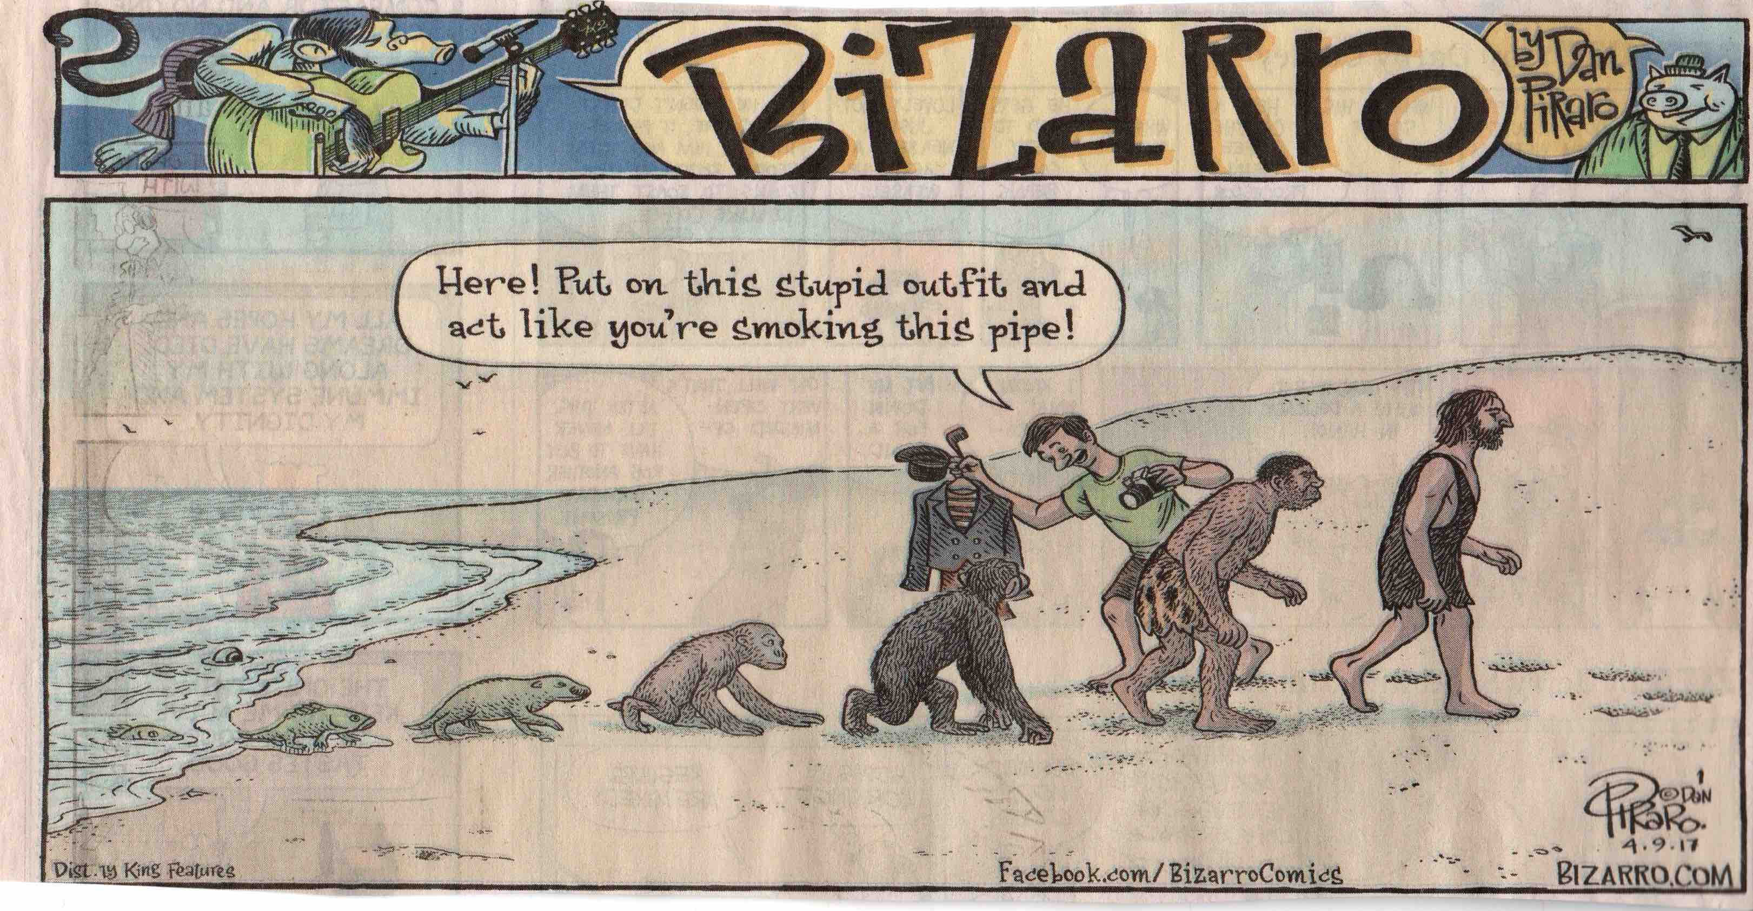

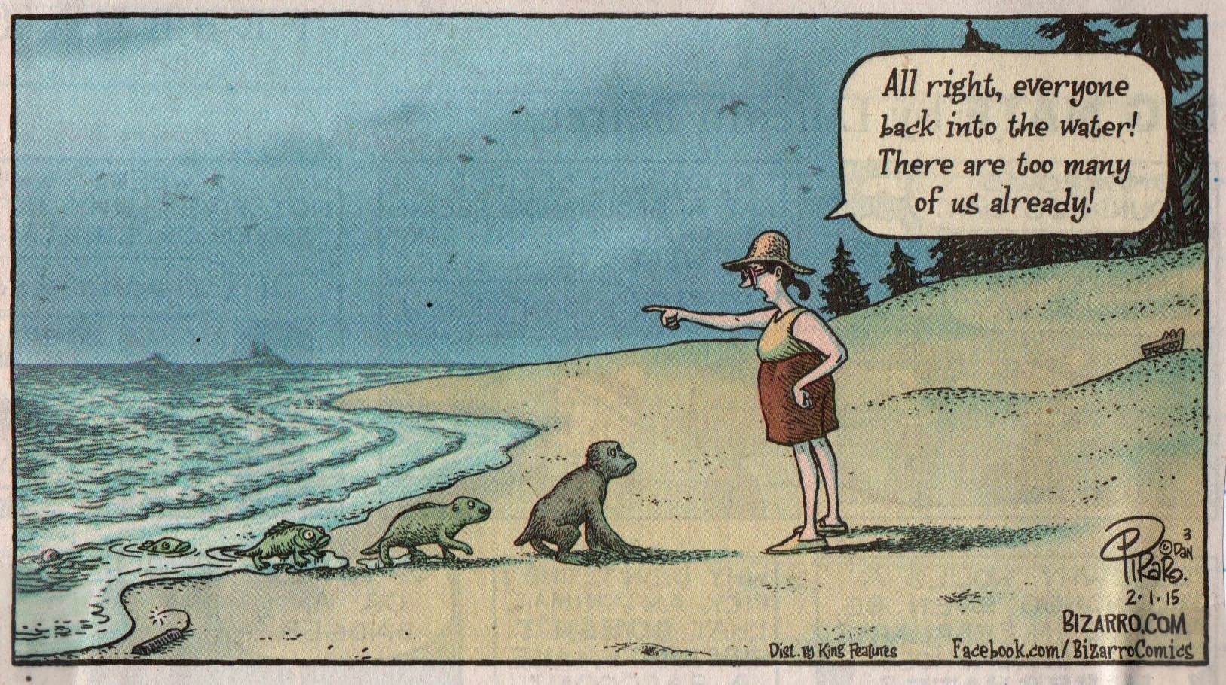
Dan Piraro, Bizarro.

Nutty Stone Age

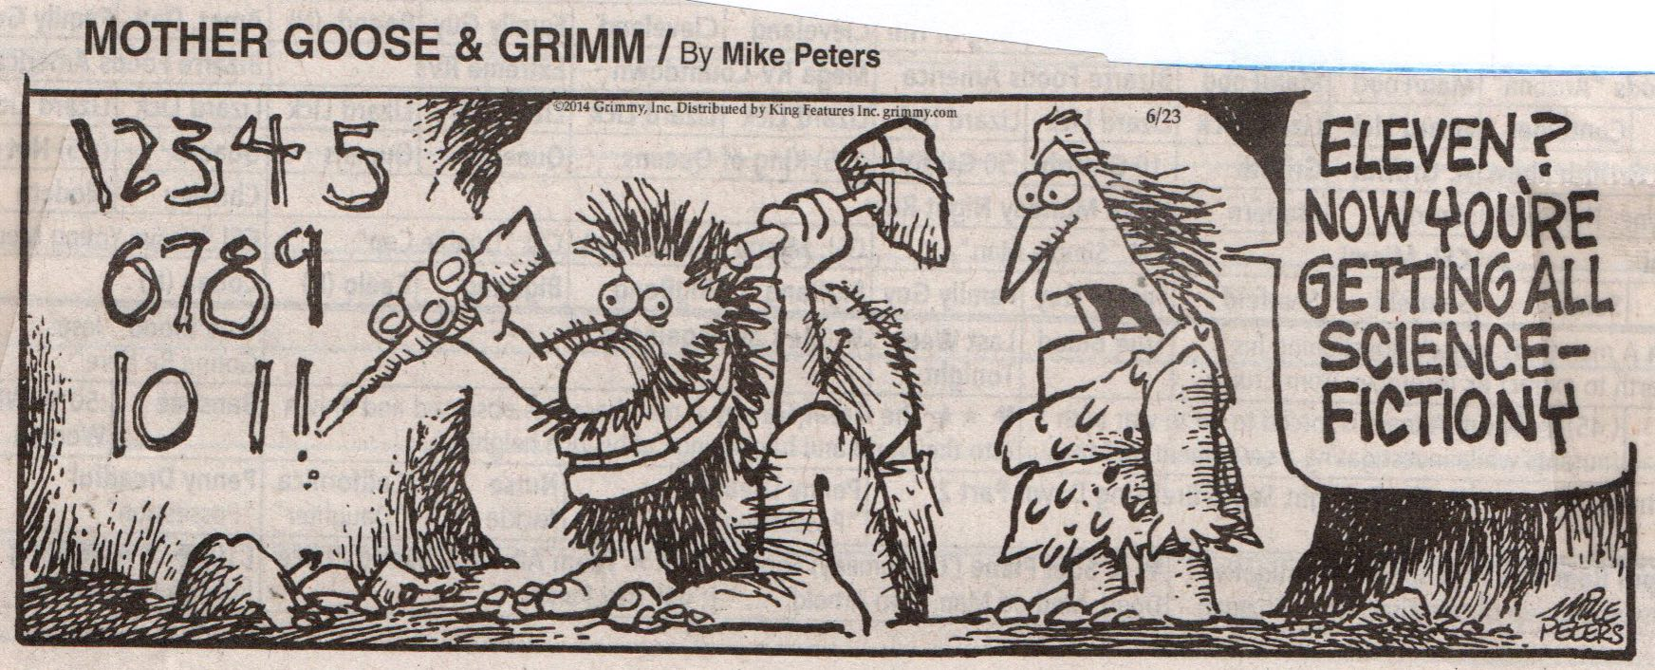
Mike Peters, Mother Goose & Grimm.

When, in 1911, Marcellin Boule reconstructed the Neanderthal skeleton of an old man discovered at La Chapelle-aux-Saints—the most complete Neanderthal remains known at that time—he failed to recognize the severe osteoarthritis of the bones and thus depicted Neanderthals as having forward-thrusting skulls, curving backs, and short bowed legs. This image of a brutish creature matched the view of what scientists of the time labeled Homo neanderthalensis—which they viewed as a dead-end side branch of the human evolutionary tree. (One scholar had even suggested the designation Homo stupidus for the earliest discovered Neanderthal remains!) And now, more than a century later, this meme lives on, in spite of the fact that the paleontological record shows that Neanderthals—now designated Homo sapiens neanderthalensis—were essentially modern in appearance and in fact have contributed some 4% of the genome of the current population of Homo sapiens.
Perhaps because the emergence of modern humans in the Middle and Upper Paleolithic ages seems so long ago to most of us—although this 300,000-year span is but a geological and evolutionary blink of an eye—we tend to lump all of the various archaic humans together into a single image of the “Stone Age” and inaccurately portray anatomically modern Homo sapiens sapiens living in the last Ice Age (“Cro Magnons”) as brutish Neanderthals. For comic strip artists, however, such a portrayal is an irresistible opportunity to poke fun at our modern foibles by anachronistically attributing them to our early ancestors.

Comic Cave Painting

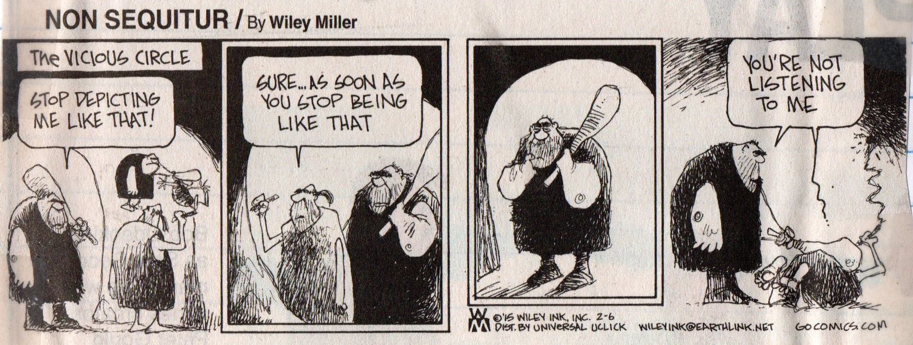
Wiley Miller, Non Sequitur.

One of the most exciting new developments in the study of the European Paleolithic is the discovery of Neanderthal cave paintings that date to some 20,000 years before the arrival of fully modern humans. Like the better known, and later, paintings of extinct bison and ancient animals at Lascaux, Altamira, and other French and Spanish caves, these enigmatic Neanderthal handprints and doodles were found deep within caverns where they could only have been made and seen with the aid of sputtering oil lamps. Ever since Upper Paleolithic paintings located in inaccessible regions of caves were first discovered in the late 19th century, their “meaning” has been a matter of speculation, with scholarly opinion currently moving away from seeing them as ritual hunting rites to favoring their being representations of shamanistic trances. While it may be a natural impulse to try to understand why Paleolithic peoples painted in caves, the fact of the matter is that their exact significance has been lost in the fog of time. Whatever various functions ancient cave paintings may have served, it is now clear that “art”—in the form of cave paintings, carvings on bone, and presumably designs made on perishable material—has been an intrinsic part of the human experience for much longer than we had originally imagined.
Comic strips about cave paintings are very popular, forming half of the Stone Age comics in this collection. While comic strip artists consistently err in presenting Paleolithic painting as taking at the mouth of caves, and while they tend to follow the out-of-date notion that these paintings were connected to hunting rituals, they are, perhaps unintentionally, quite avant garde in suggesting that the creation of art is a human trait that stretches back to our Neanderthal cousins.

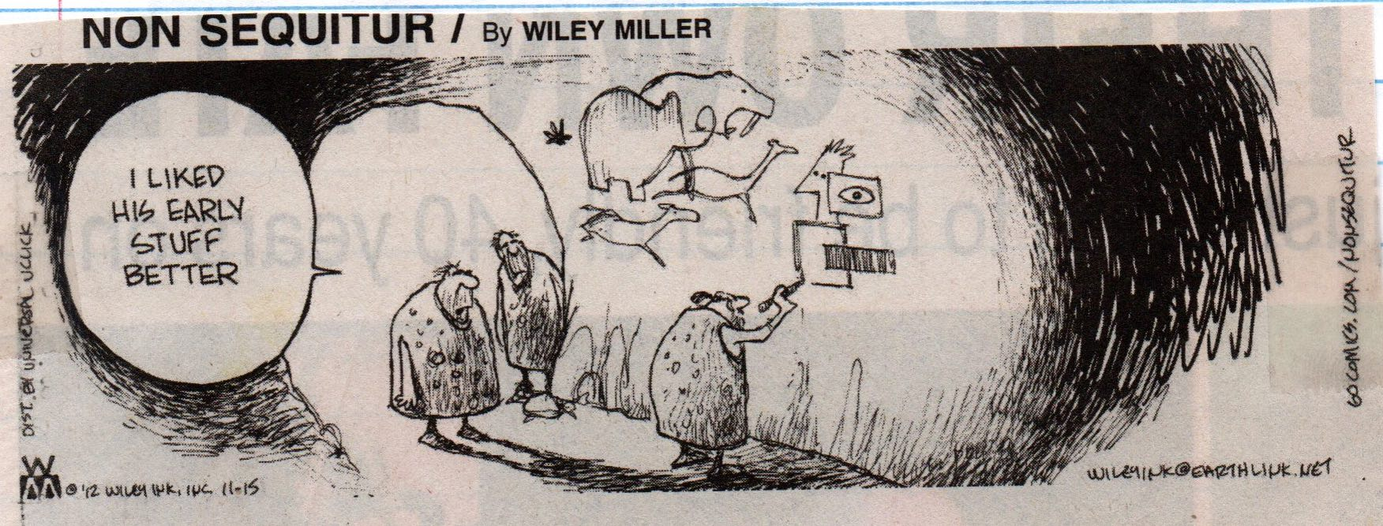

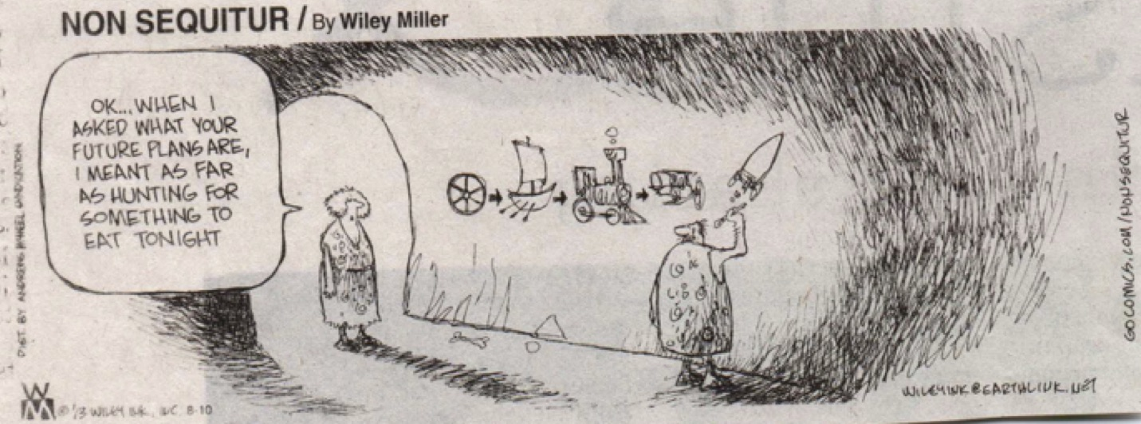
Wiley Miller, Non Sequitur.

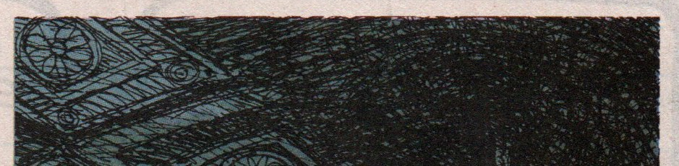  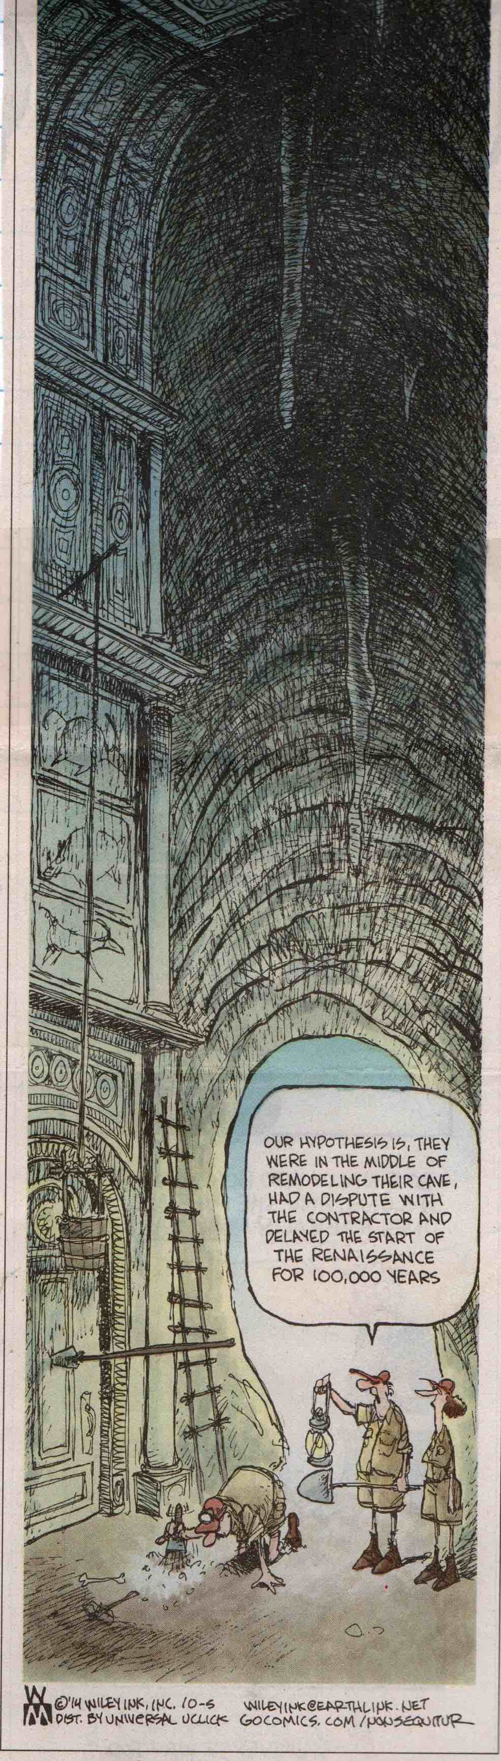 | 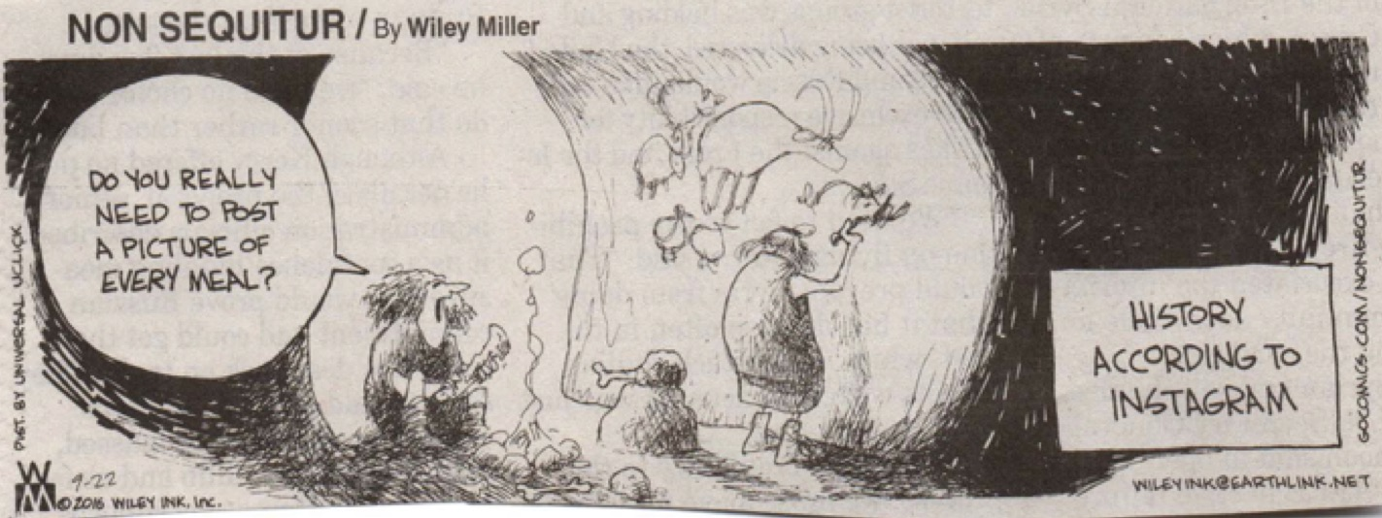  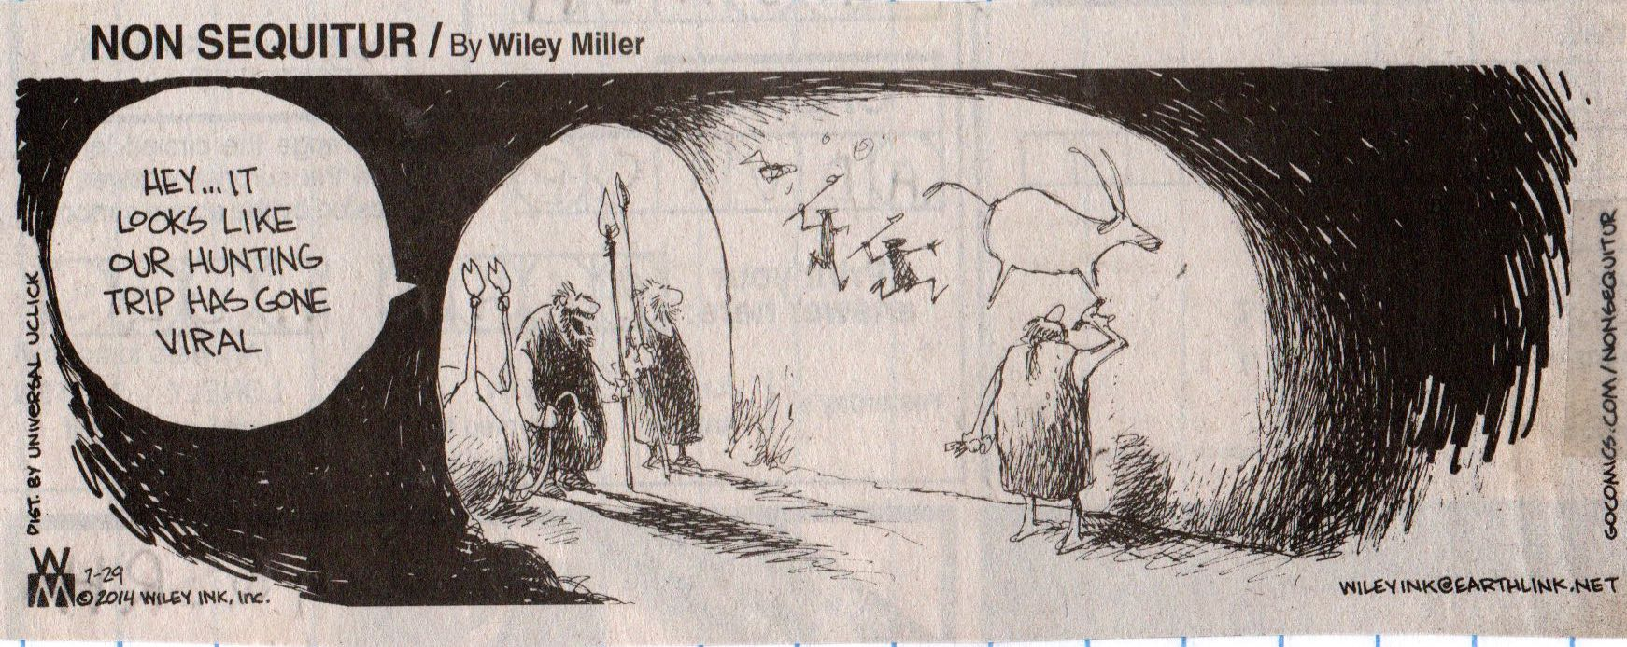
Wiley Miller, Non Sequitur.

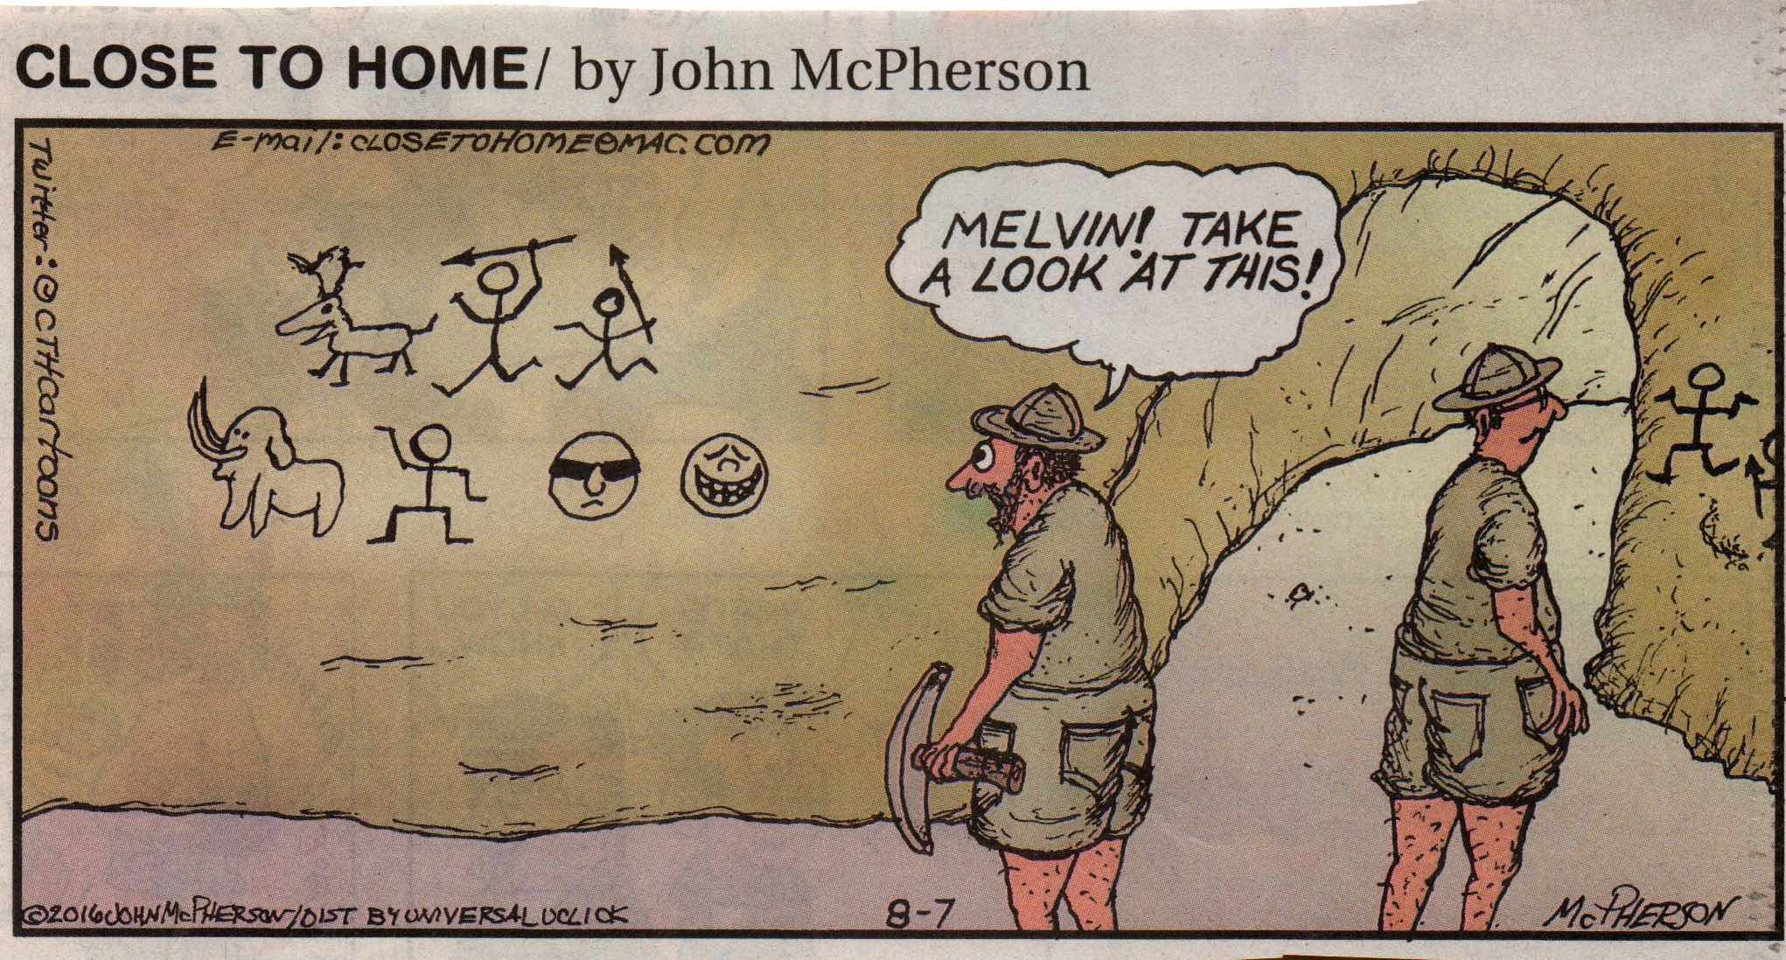
John McPherson, Close to Home.

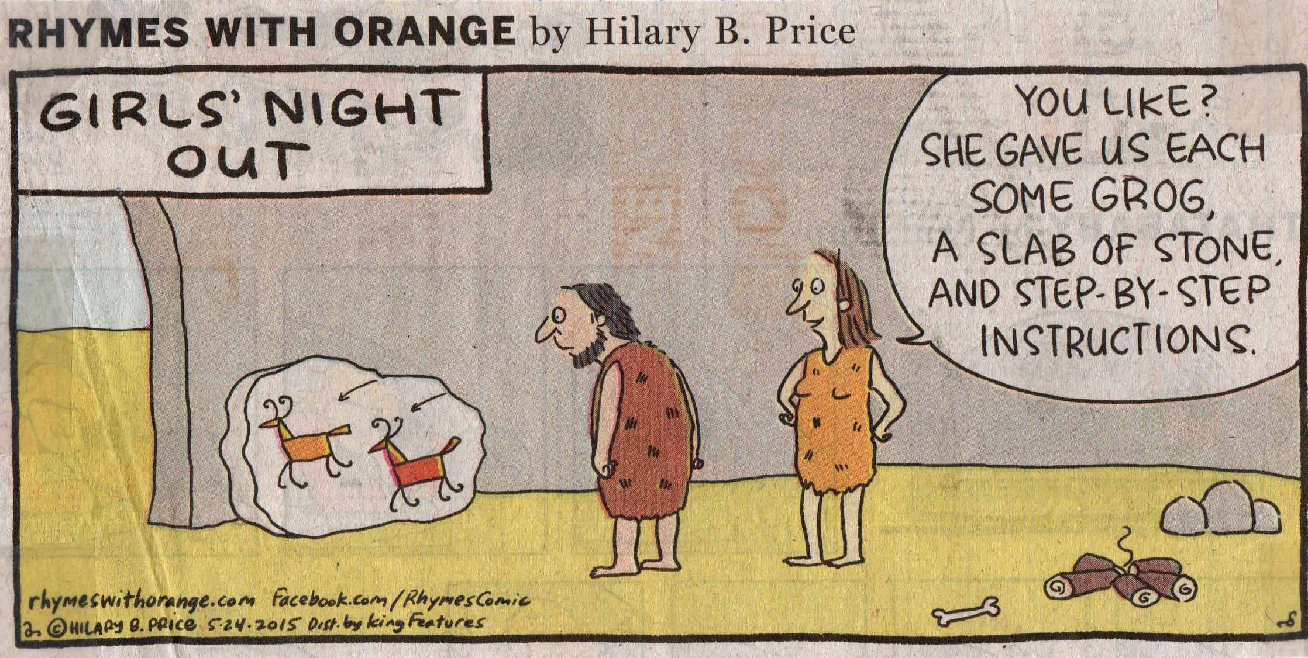
Hilary B. Price, Rhymes with Orange.

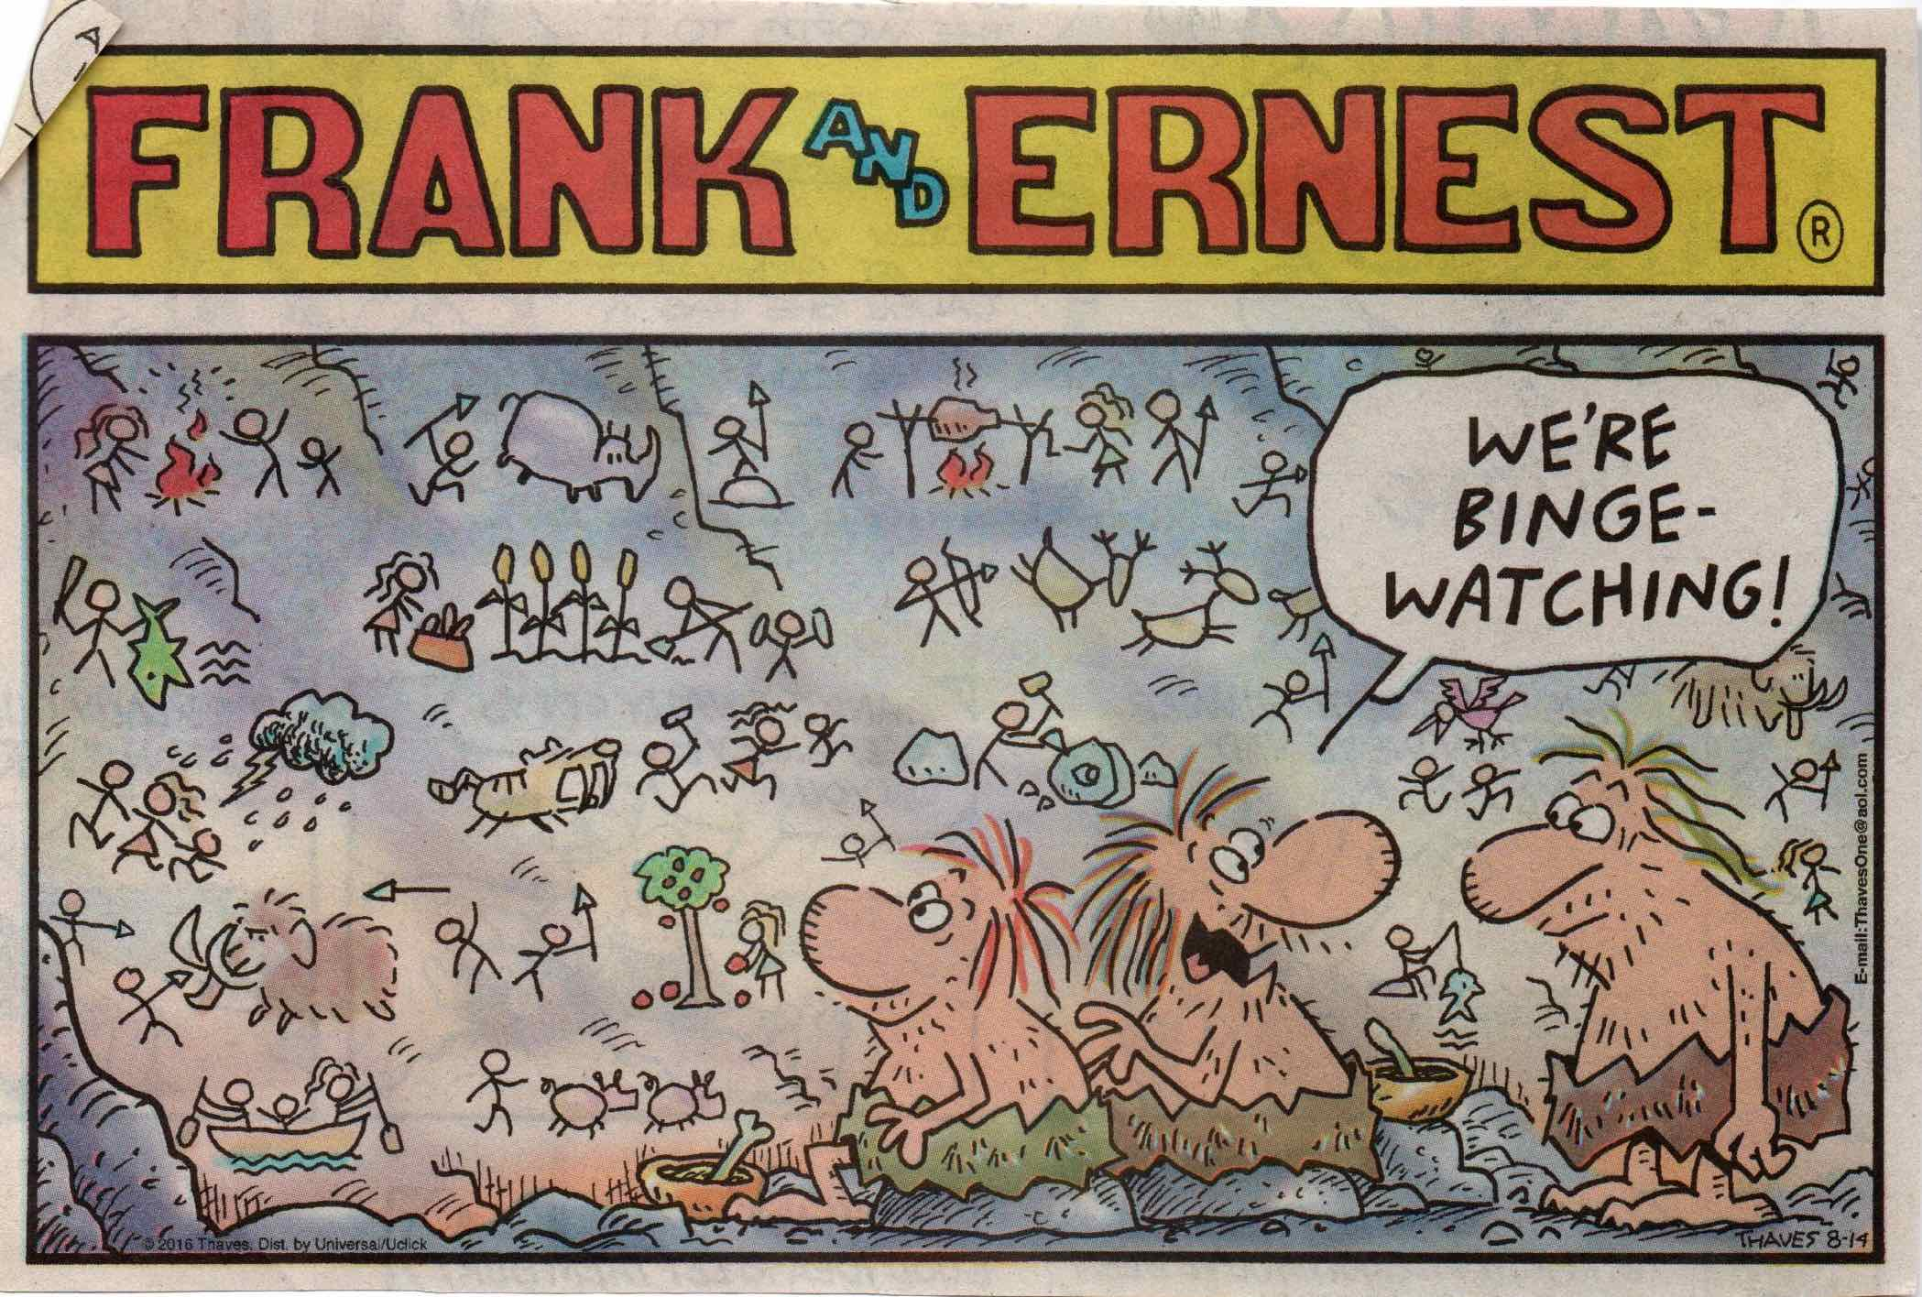

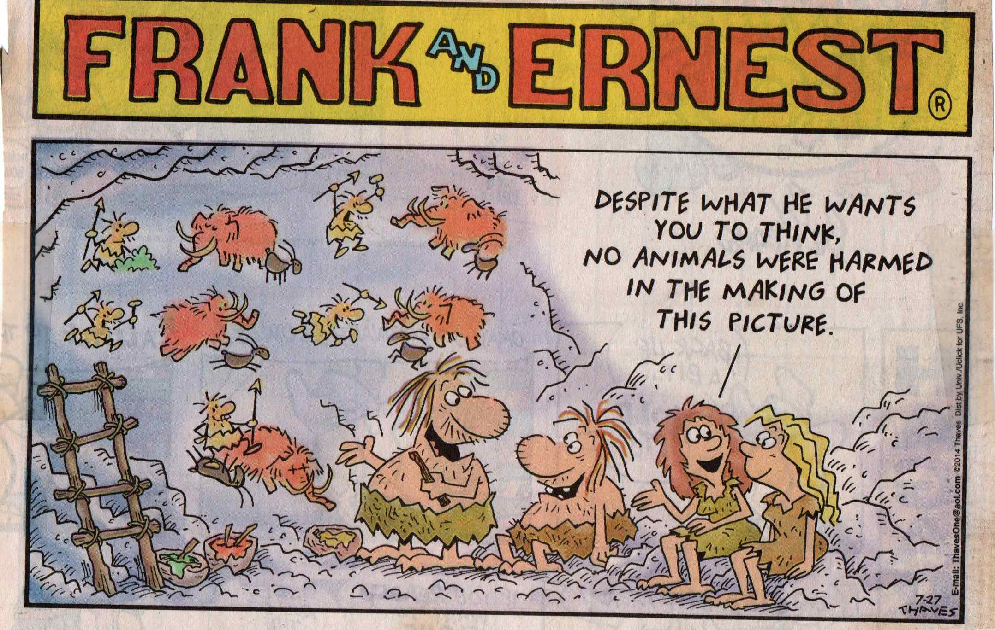
Thaves, Frank and Ernest.

Campy Cavemen

There is something about cave men and women that appeals to certain comic strip artists. In this collection, Wiley Miller, John McPherson, Tom Thaves, and Dan Piraro never seem to tire of them. Dumb cave men throwing rocks at each other, trying to invent the wheel, and generally being clueless compared to cave women are subjects that clearly resonate to comics who use these Stone Age memes to mock our modern condition.

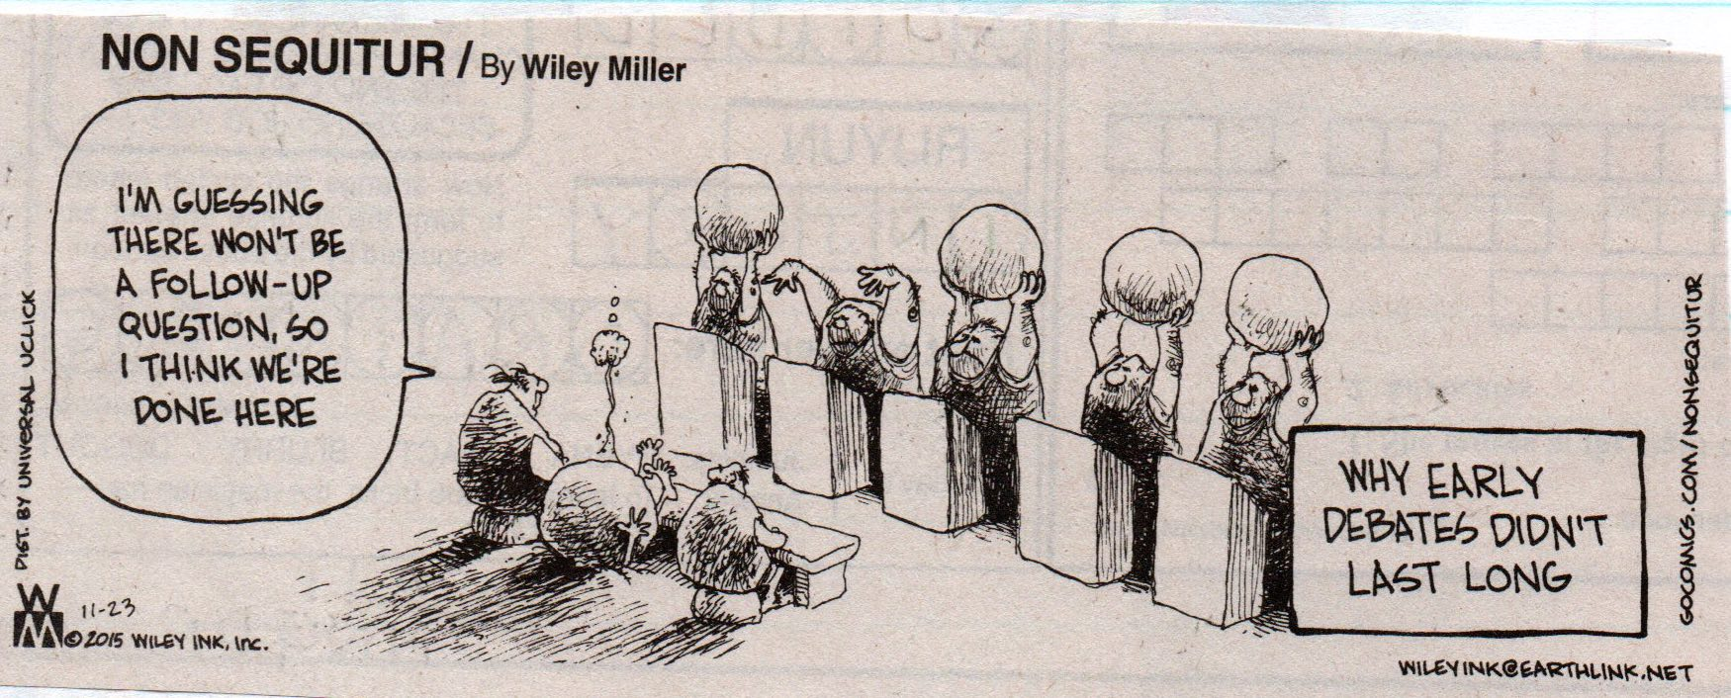

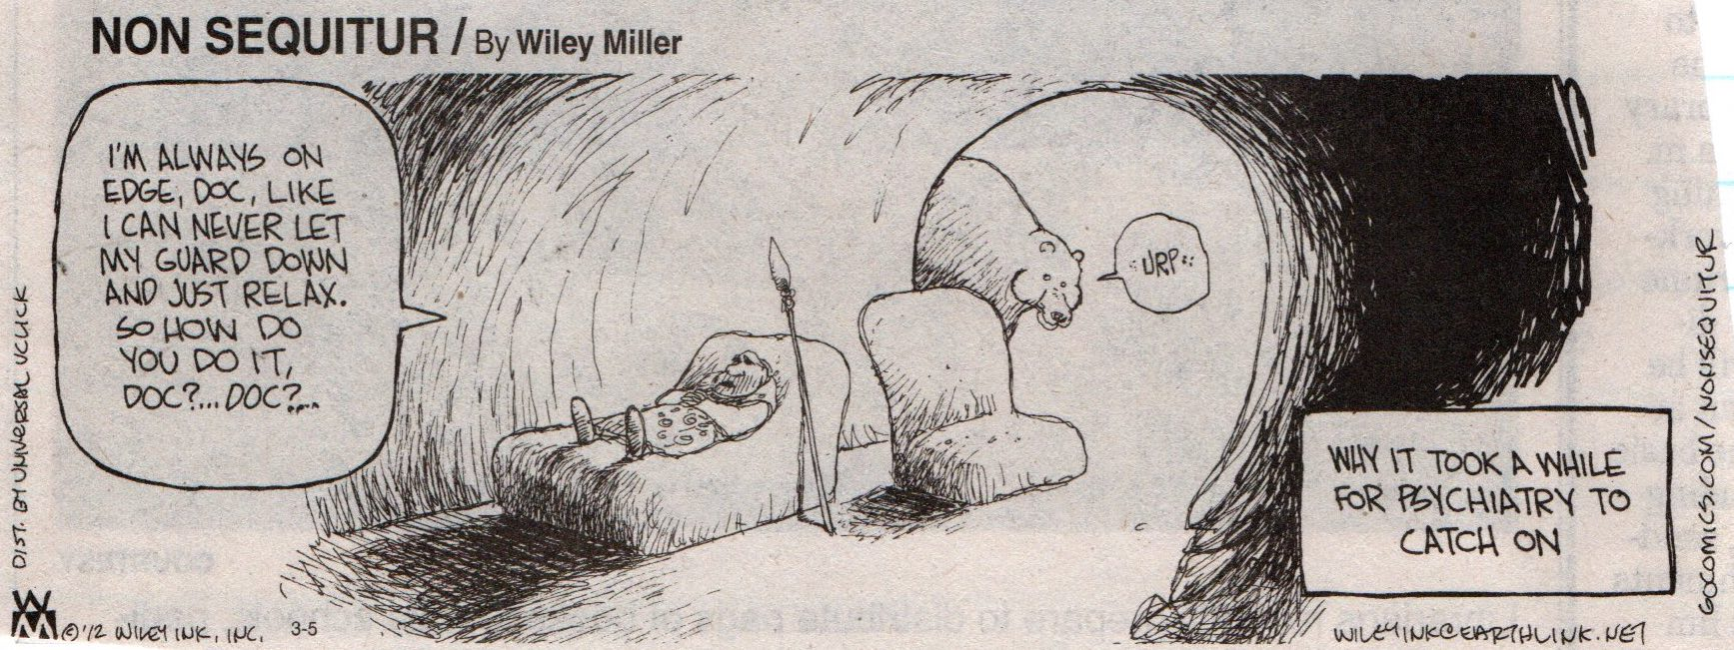
Wiley Miller, Non Sequitur.

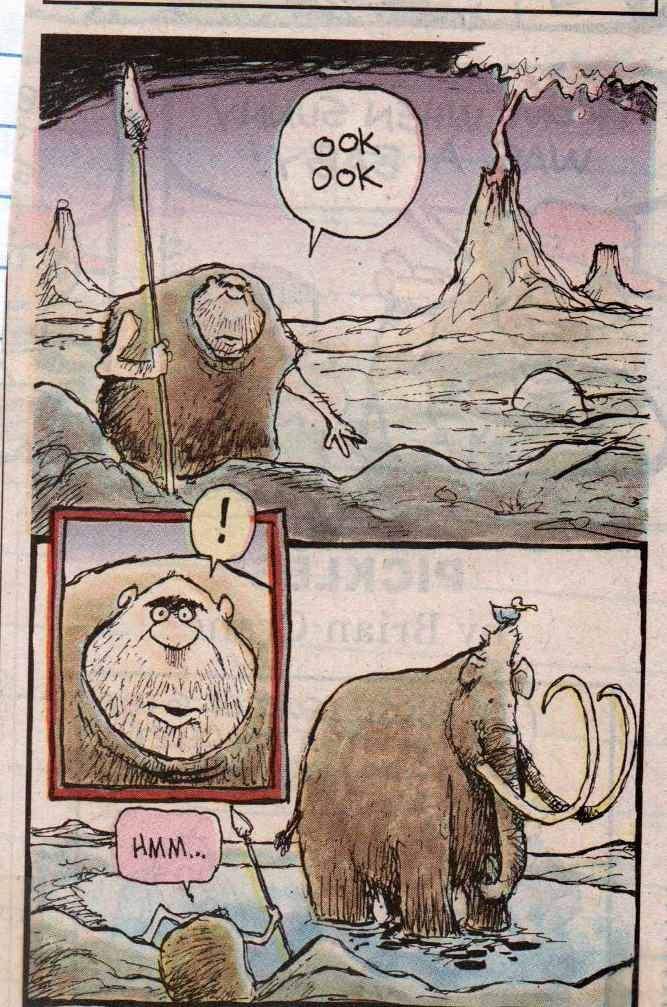  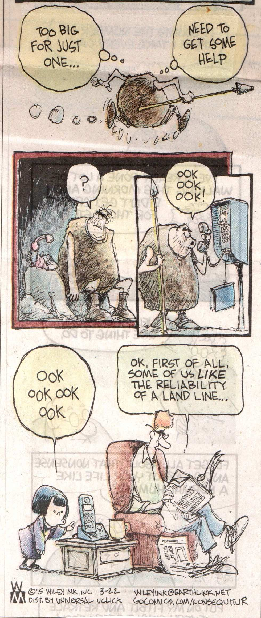 | 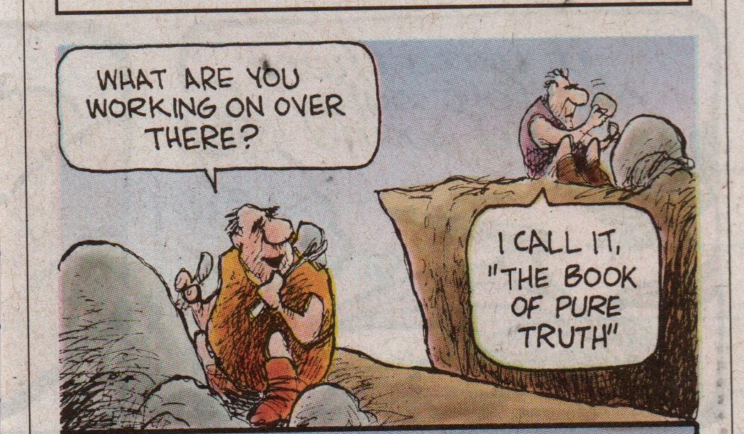
Wiley Miller, Non Sequitur.

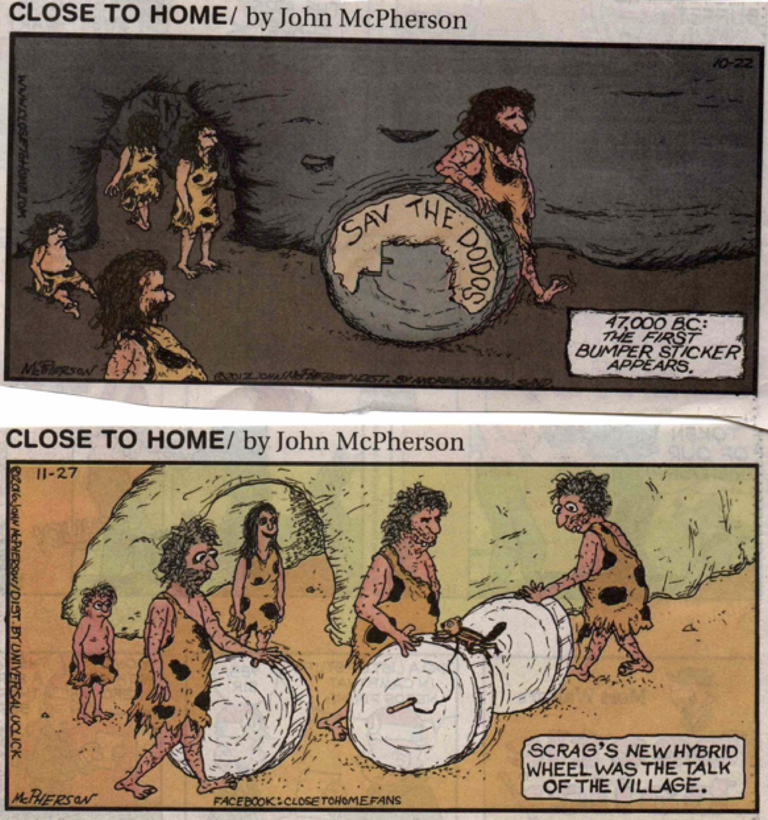

John McPherson, Close to Home.

John McPherson, Close to Home.

Dan Piraro, Bizaro.

Dan Piraro, Bizarro.

Thaves, Frank and Ernest.

Wacky Stonehenge

While New-Age druids make up rituals to commune with Stonehenge at the time of the solstice, comic strip artists use this ring of standing stones in the Salisbury Plain to make silly jokes.

John McPherson, Close to Home.

Dan Piraro, Bizaro.

Wiley Miller, Non Sequitur. | Mikael Wulff & Anders Morgenthaler, Wumo.

Ancient Egyptian Antics

Brian and Greg Walker, Hi and Lois.

In our cultural imagination, ancient Egypt is ageless. Never mind the fact that at the time when King Tut was alive, the Giza pyramids were already more than a thousand years old and Cleopatra was more than a thousand years in the future. We tend to view ancient Egypt through the wrong end of a telescope—it all looks so far away in time. For the comic strip artist, ancient Egypt, like the Stone Age, is a perfect vehicle to make anachronistic fun of our contemporary world.

Wiley Miller, Non Sequitur.

Wiley Miller, Non Sequitur.

Poking Fun at Pyramids

Before Erik von Däniken published The Chariot of the Gods in 1965, with its insulting pseudo-scientific claims, no one could have imagined that some would believe that the Egyptian pyramids—those marvelous examples of mid-third-millennium BCE human engineering skills—were built by extraterrestrials. Comic strip artists, at least, can laugh at this kooky idea.

Bill Amend, Foxtrot.

Jim Meddick, Monty.

Mike Peters, Mother Goose & Grimm.

Hilary B. Price, Rhymes with Orange.

Wiley Miller, Non Sequitur.

Wiley Miller, Non Sequitur.

Dan Piraro, Bizarro.

Mummy Mirth

The curse of the mummy is a meme for the vengeance visited upon those grave looters, and its origins stretch back to the journalistic sensationalism that surrounded Howard Carter’s 1922 discovery of the tomb of the boy-pharaoh Tutankhamen. For comic artists, a mummy is inherently funny and a good excuse for a bad pun.

Mike Peters, Mother Goose & Grimm.

Mikael Wulff & Anders Morgenthaler, Wumo.

Dan Piraro, Bizarro.

Biblical Boffos

Given the centrality of the Bible in Western culture, it might seem surprising that so few comic strips in this collection are based on Biblical subjects. But one must keep in mind that a significant proportion of the readership of traditional newspapers in the United States consists of older adults for whom religion is very important and who might be offended by comic strips that use the Bible to tell a joke. On the other hand, the relative scarcity of Biblical-theme comic strips in American newspapers may be as much a result of a general unfamiliarity with Biblical stories as it is of intolerant religious fundamentalism.
Although the sample size here is small, it is probably not an accident that all three of the Biblical-themed comic strips in this collection involve stories from the Old Testament. Adam and Eve, Lot’s wife, and David and Goliath are apparently fair game for humor while Jesus, Mary, and the Apostles are not.

Dan Piraro, Bizarro.

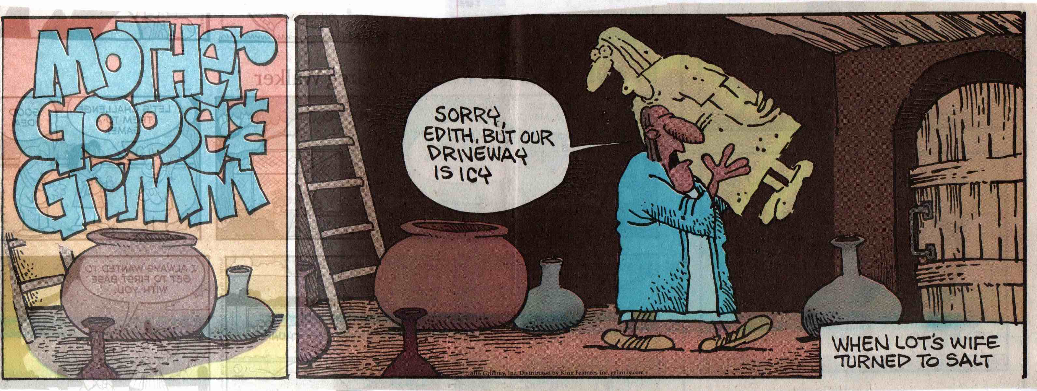
Mike Peters, Mother Goose & Grimm.

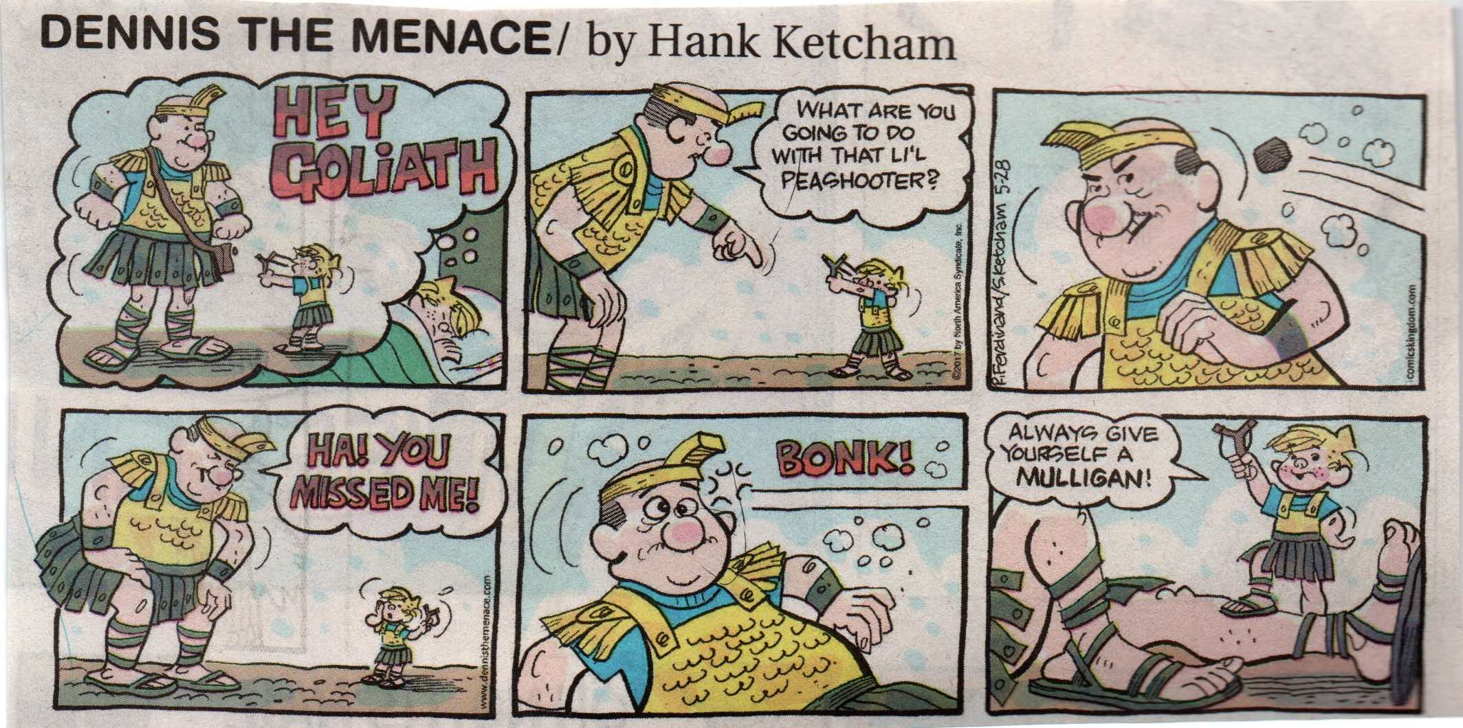
Hank Ketcham, Dennis the Menace.

Classical Comics

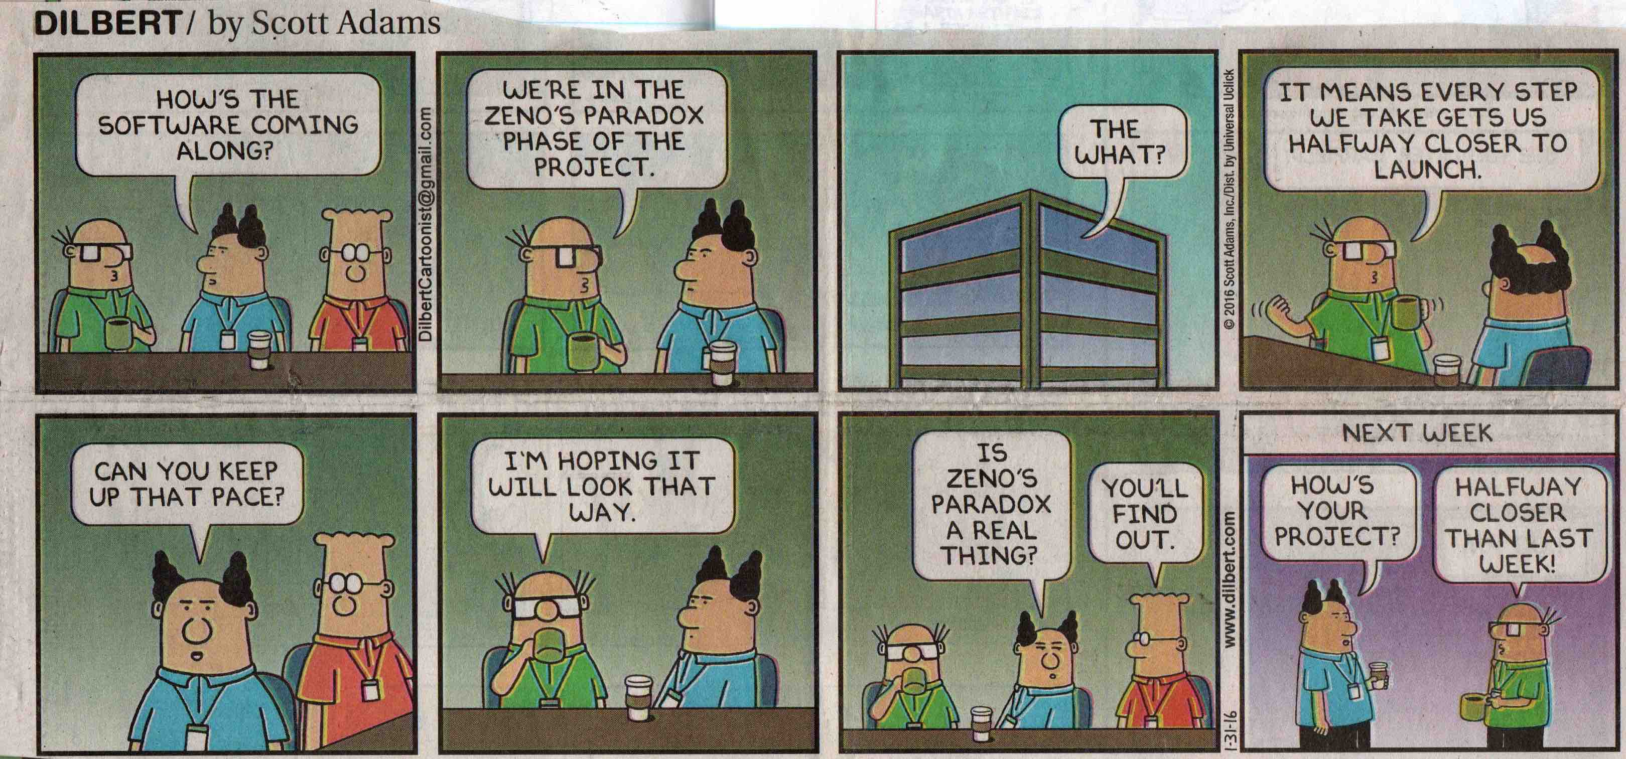
Scott Adams, Dilbert.

Unlike the popular comic memes of the Stone Age or ancient Egypt, many of the comic strips about ancient Greece and Rome in this collection actually assume a fairly sophisticated level of knowledge on the part of the viewer. It would seem that Americans are generally more familiar with Classical culture and mythology than they are up on Biblical stories or are conversant with Paleolithic or ancient Egyptian history.
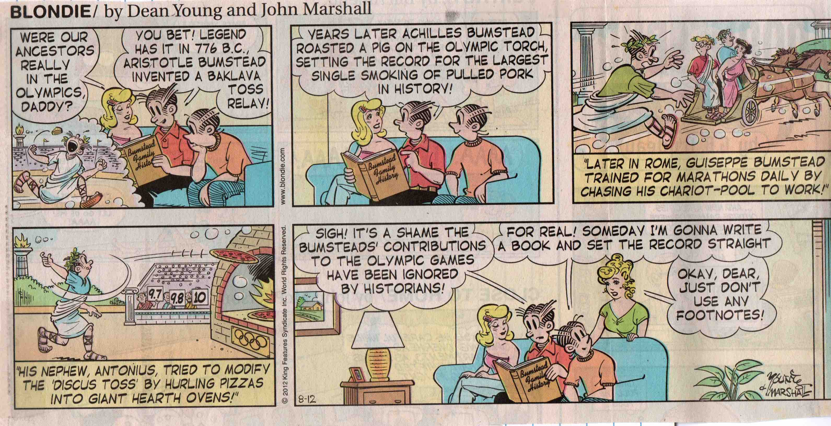
Dean Young and John Marshall, Blondie.

Medieval Minoans?

Prince Valiant—the only non-humorous adventure story included in this collection—was originally created by Hal Foster in 1937 and has been continued by a variety of different comic strip artists since 1970. Foster’s story of a Nordic prince in the court of King Arthur was set in the 5th century A.D, but here the team of Schultz and Yeates have Prince Valiant encounter a Siren who lives on an island with ruins that are closely modeled on the Minoan palace of Knossos, which was destroyed around 1400 B.C.
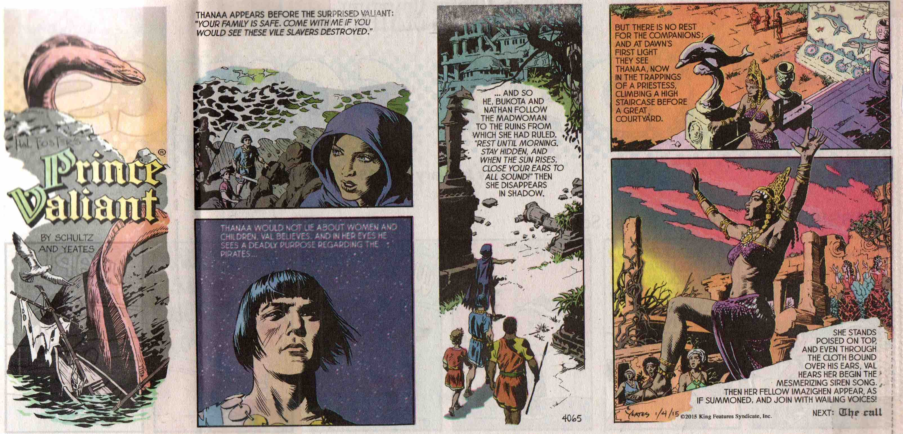

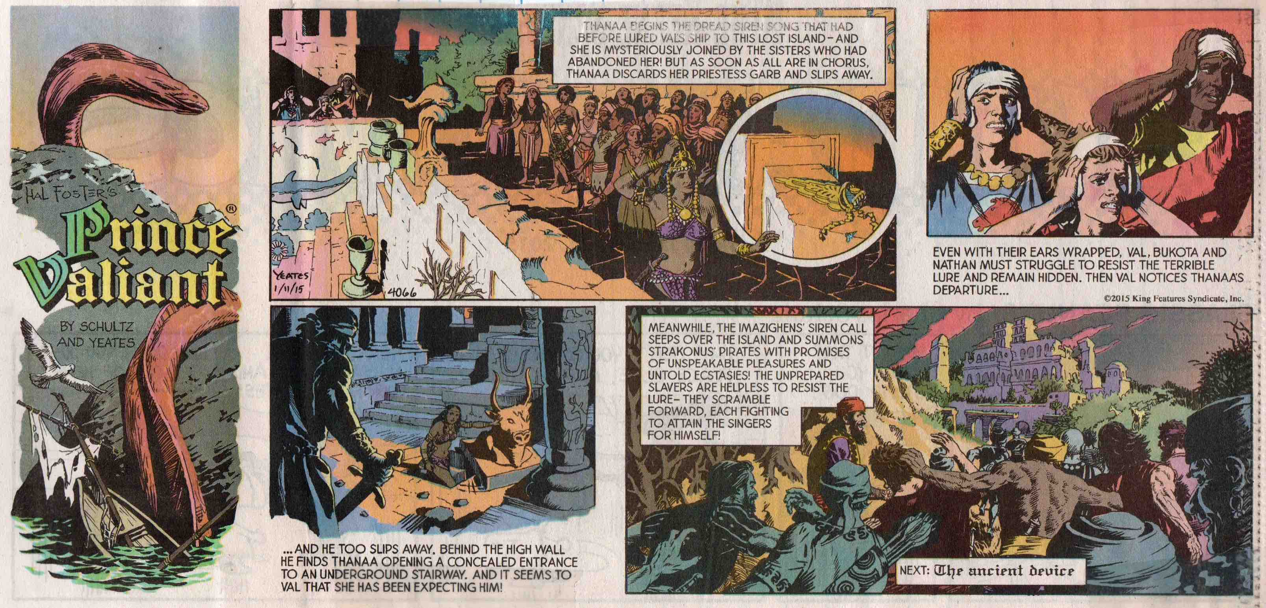
Mark Schultz and Thomas Yeates, Prince Valiant.

Goofy Greeks

Who doesn’t know the story of the Trojan horse, or who Medusa and Aphrodite were? The artists of the comic strips in this section assume that the viewer can recognize the visual jokes they are making about Greek mythology.

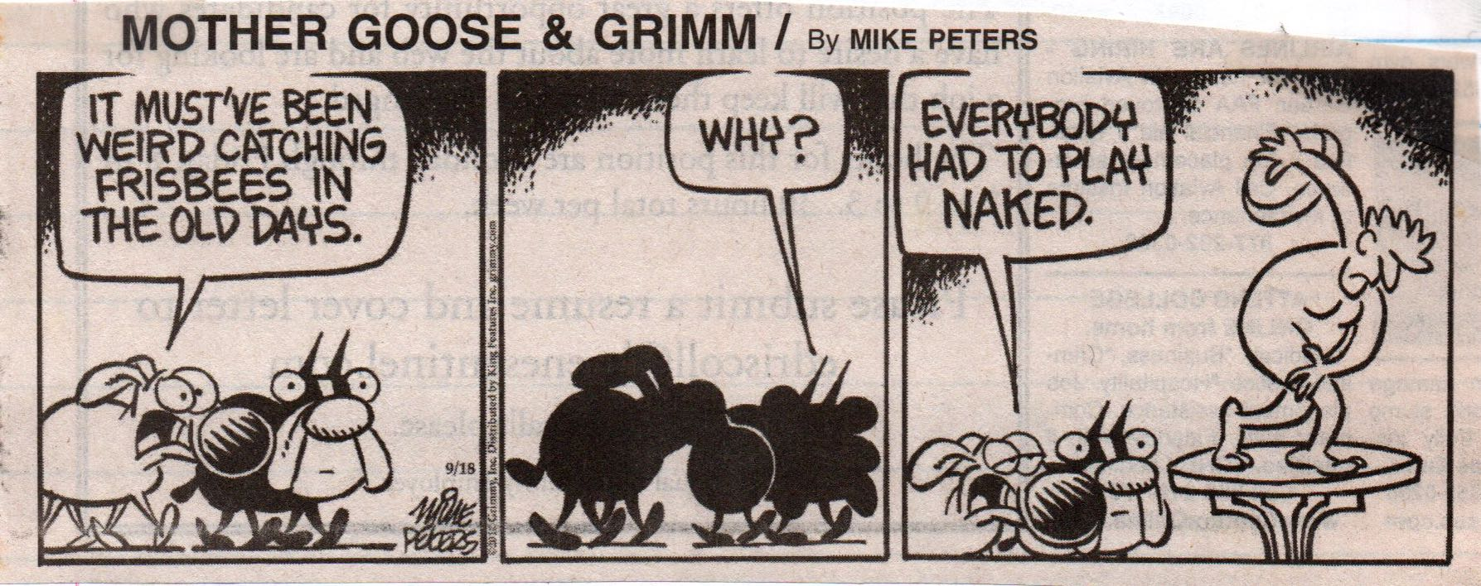

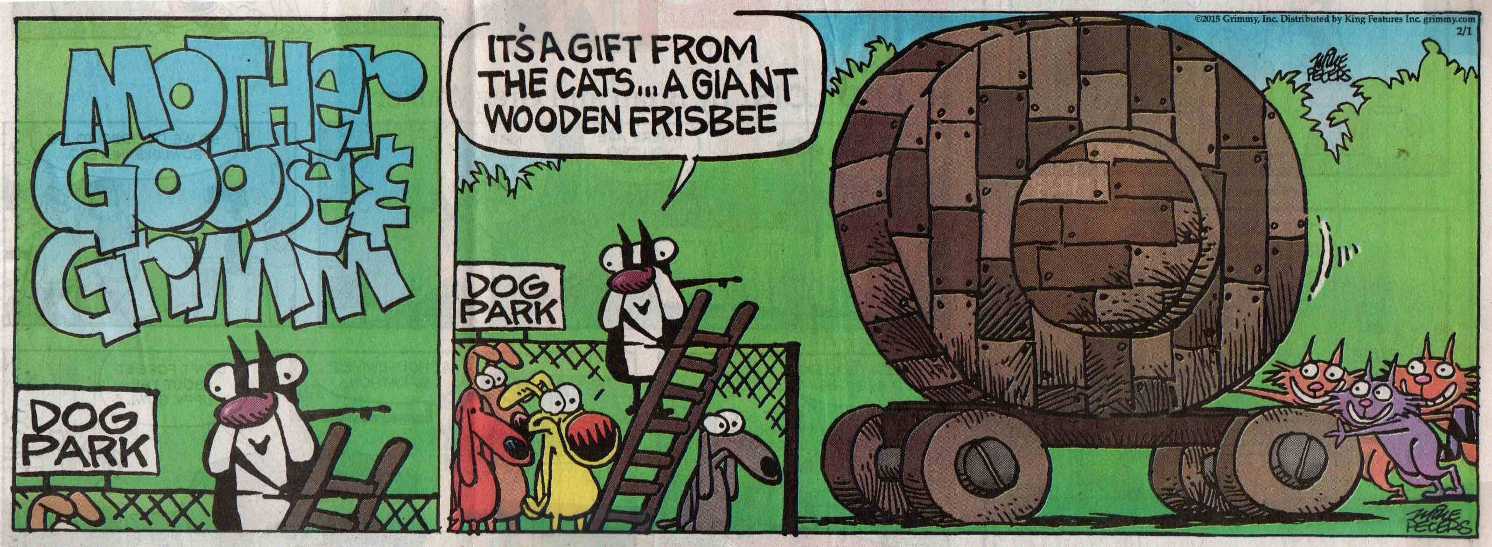
Mike Peters, Mother Goose & Grimm.

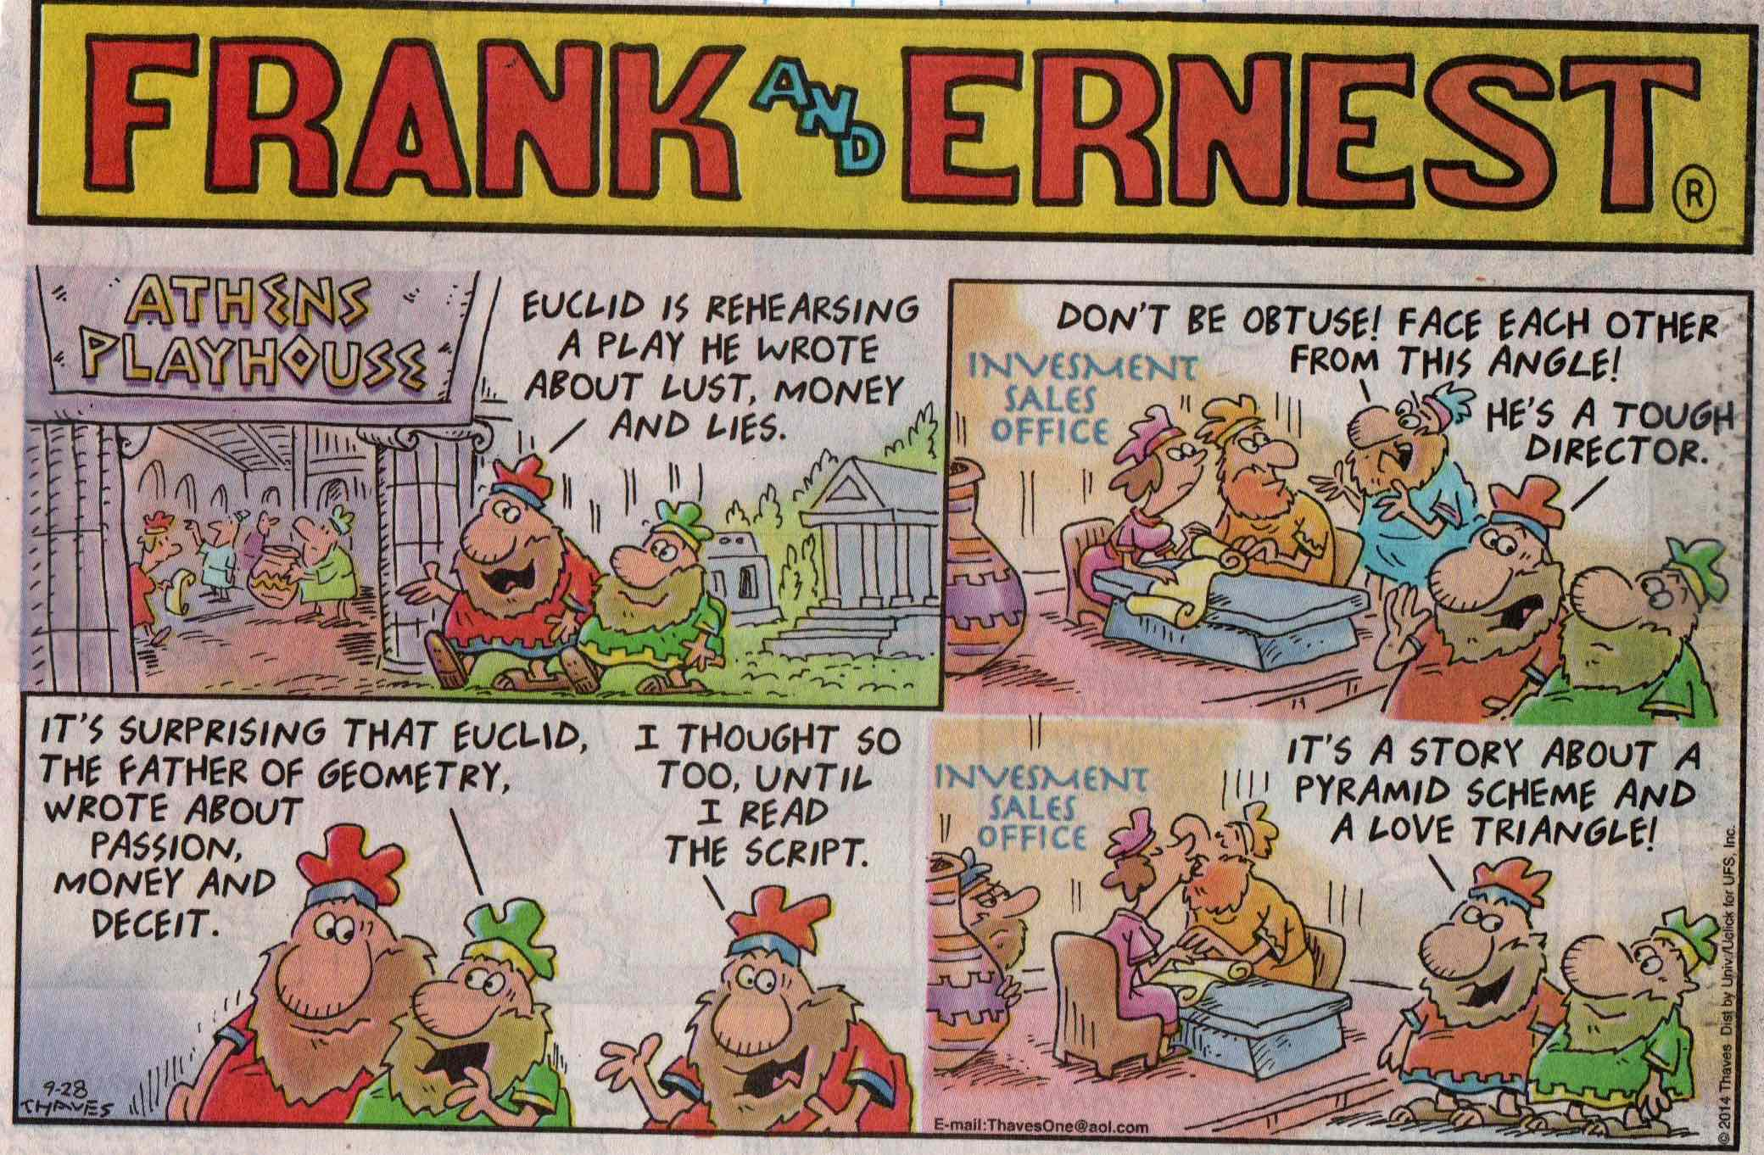
Thaves, Frank and Ernest.

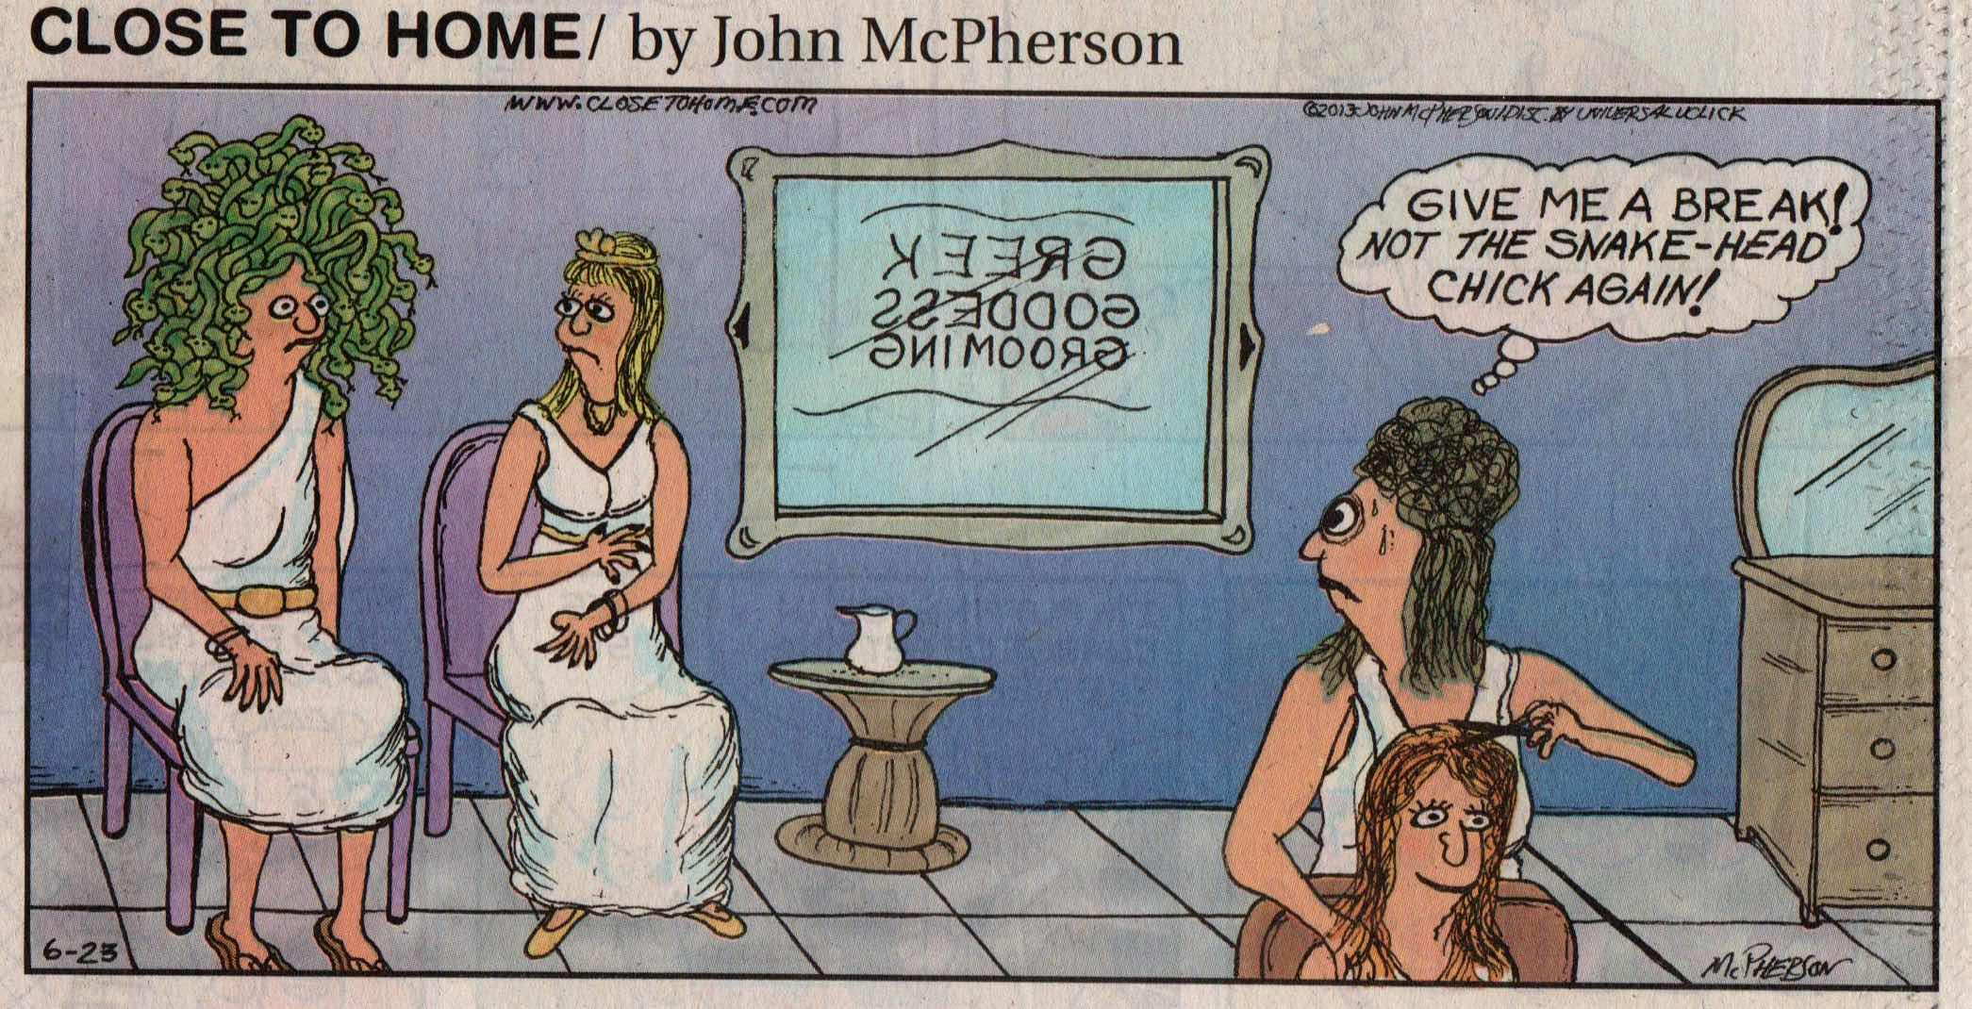
John McPherson, Close to Home.

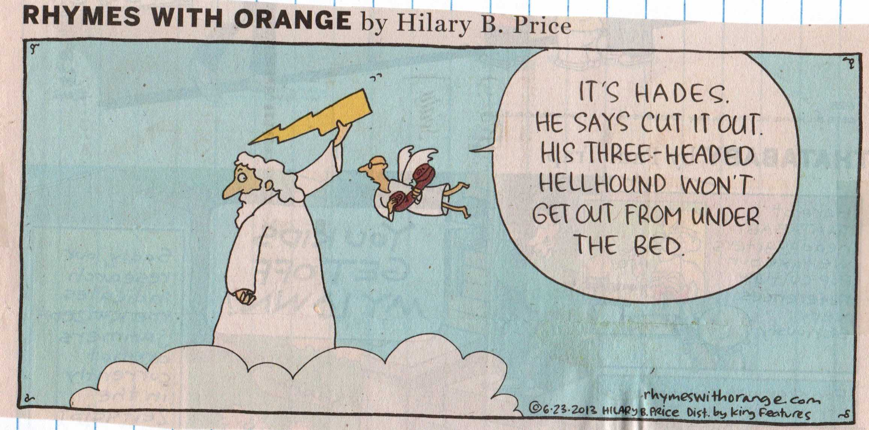

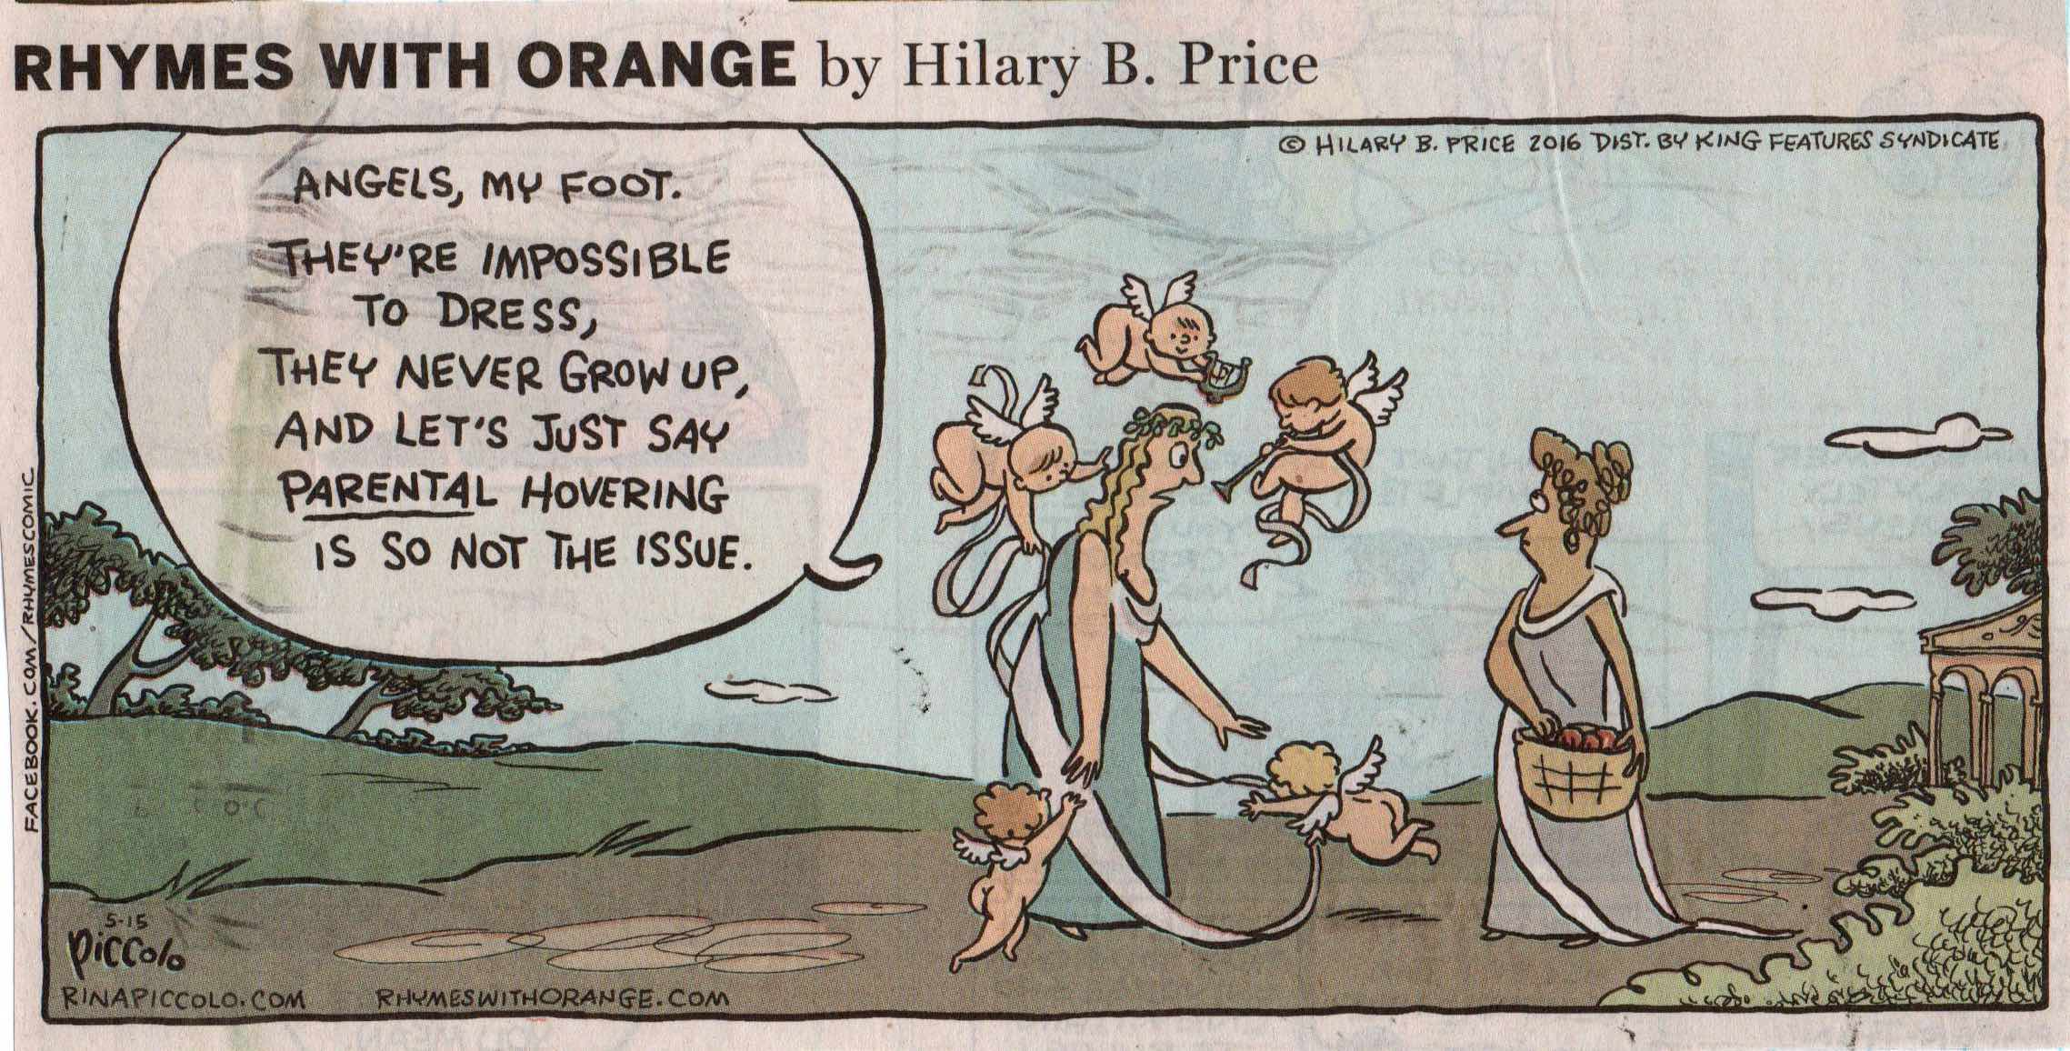
Hilary B. Price, Rhymes with Orange.

Amusing Atlas and Silly Sisyphus

For the ancients, the punishments meted out by Zeus on the Titan Atlas and on mischievous Sisyphus were warnings to humans about the consequences of defying the will of the Olympian gods. For Albert Camus, Sisyphus was a symbol of the existential absurdity in trying to find meaning in a meaningless world. For comic strip artists, carrying the world on your back or pushing a huge rock up a hill is just plain funny, just like Charlie Brown continually falling for Lucy’s pull-away-the-football trick.

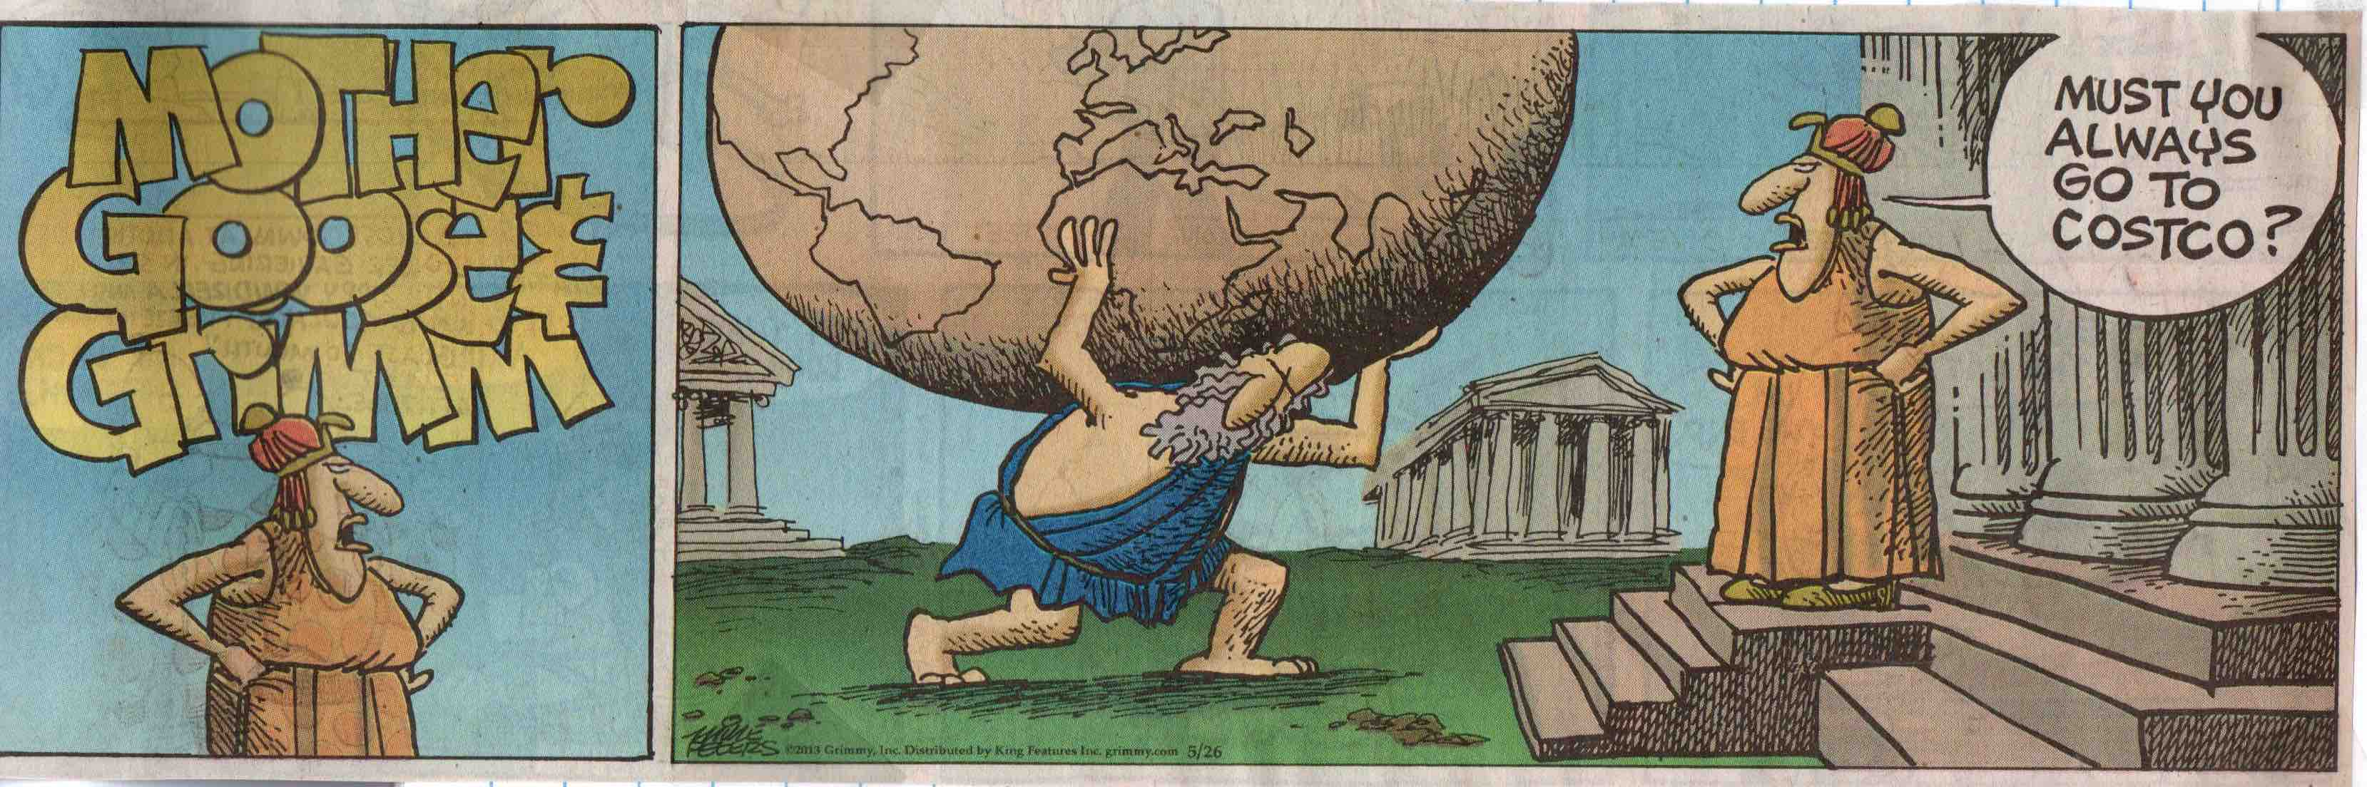
Mike Peters, Mother Goose & Grimm.

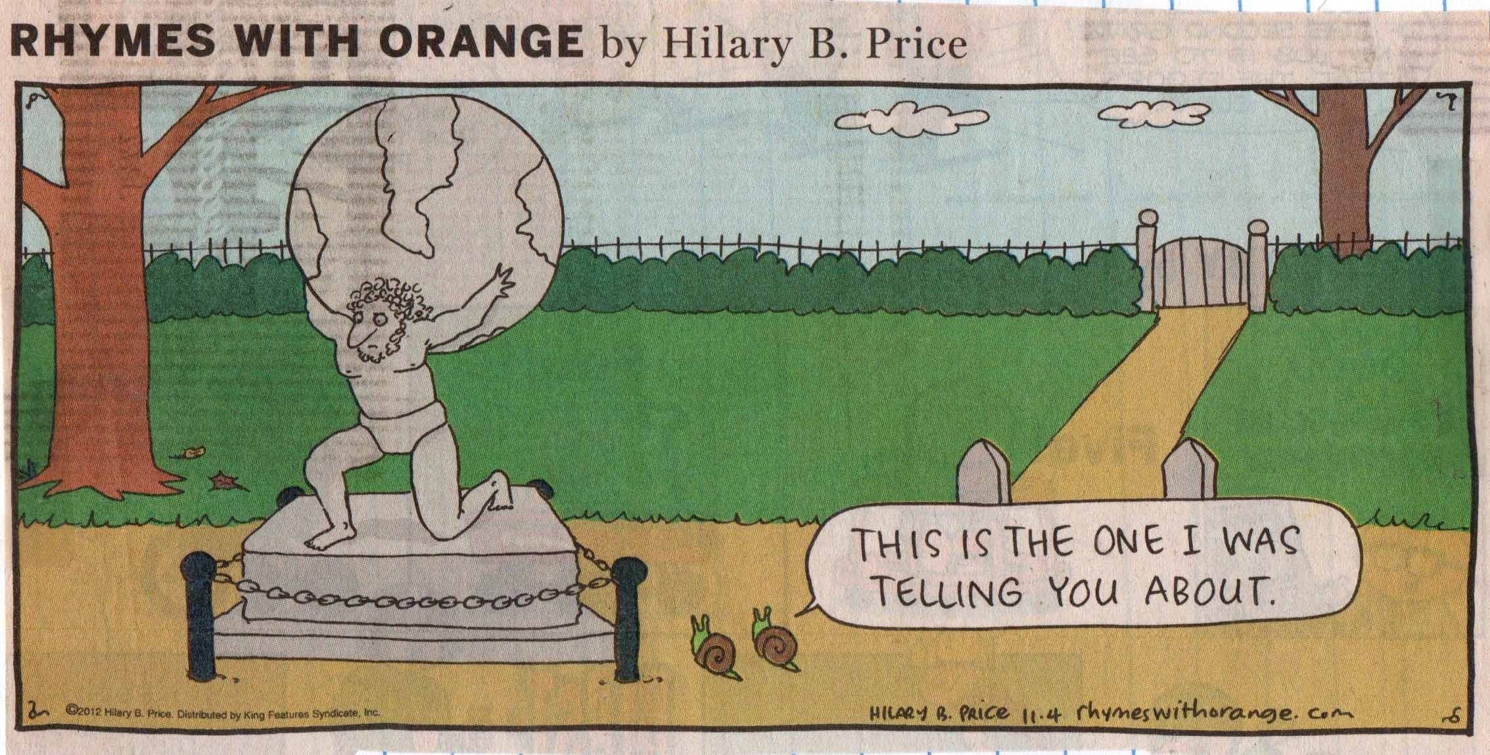
Hillary B. Price, Rhymes with Orange.

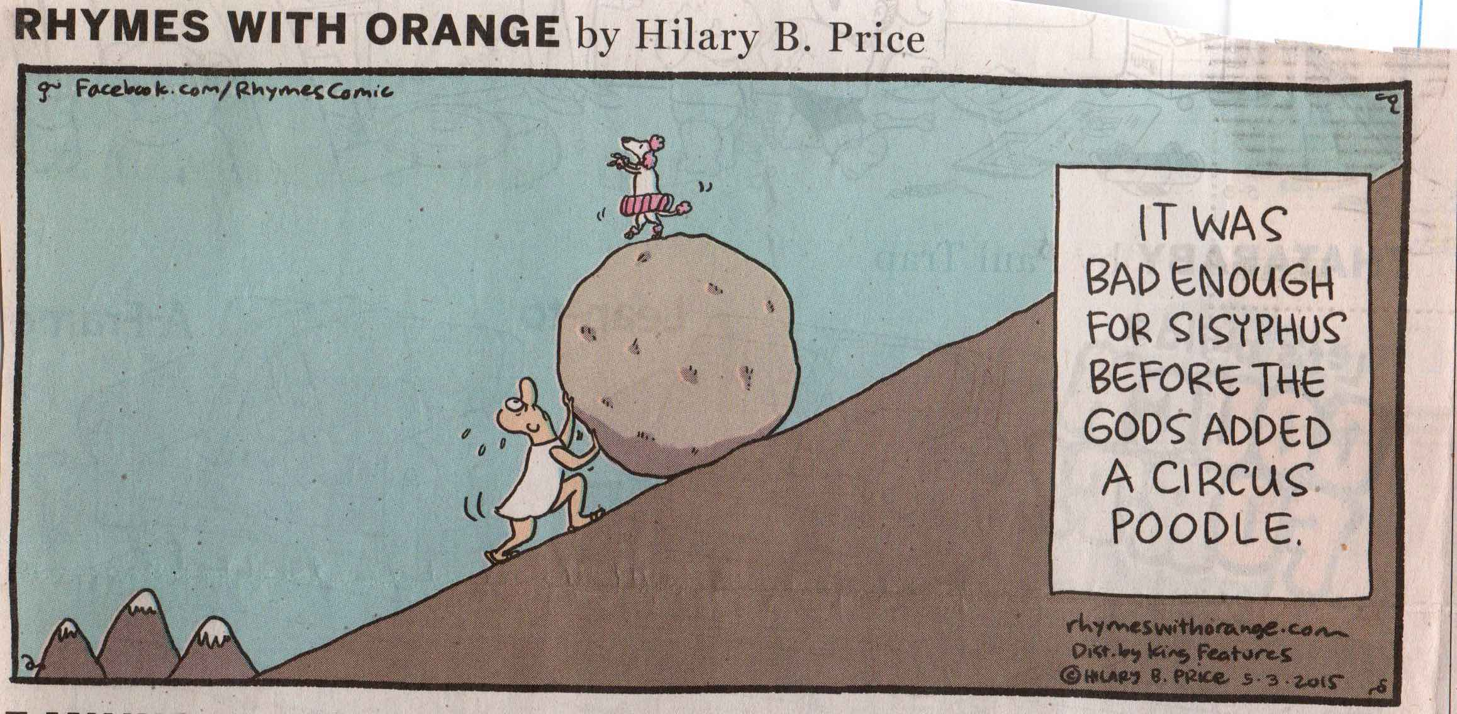
Hilary B. Price, Rhymes with Orange.

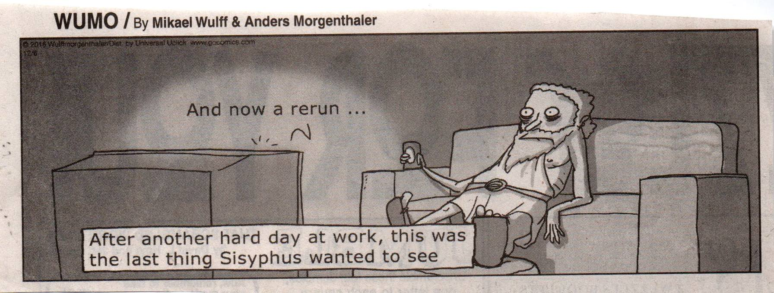
Mikael Wulff & Anders Morgenthaler, Wumo.

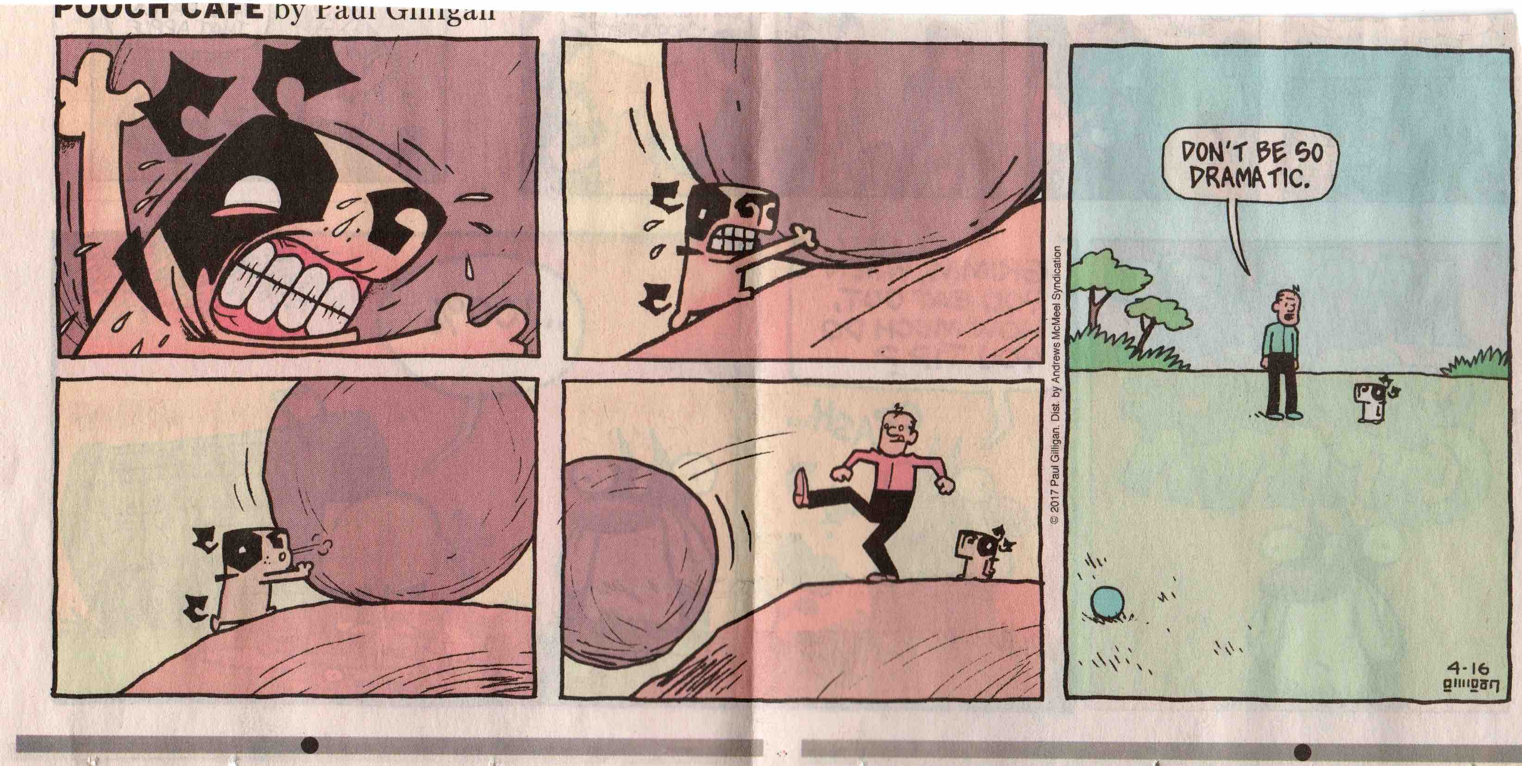
Paul Gilligan, Pooch Café.

Acropolis Absurdities

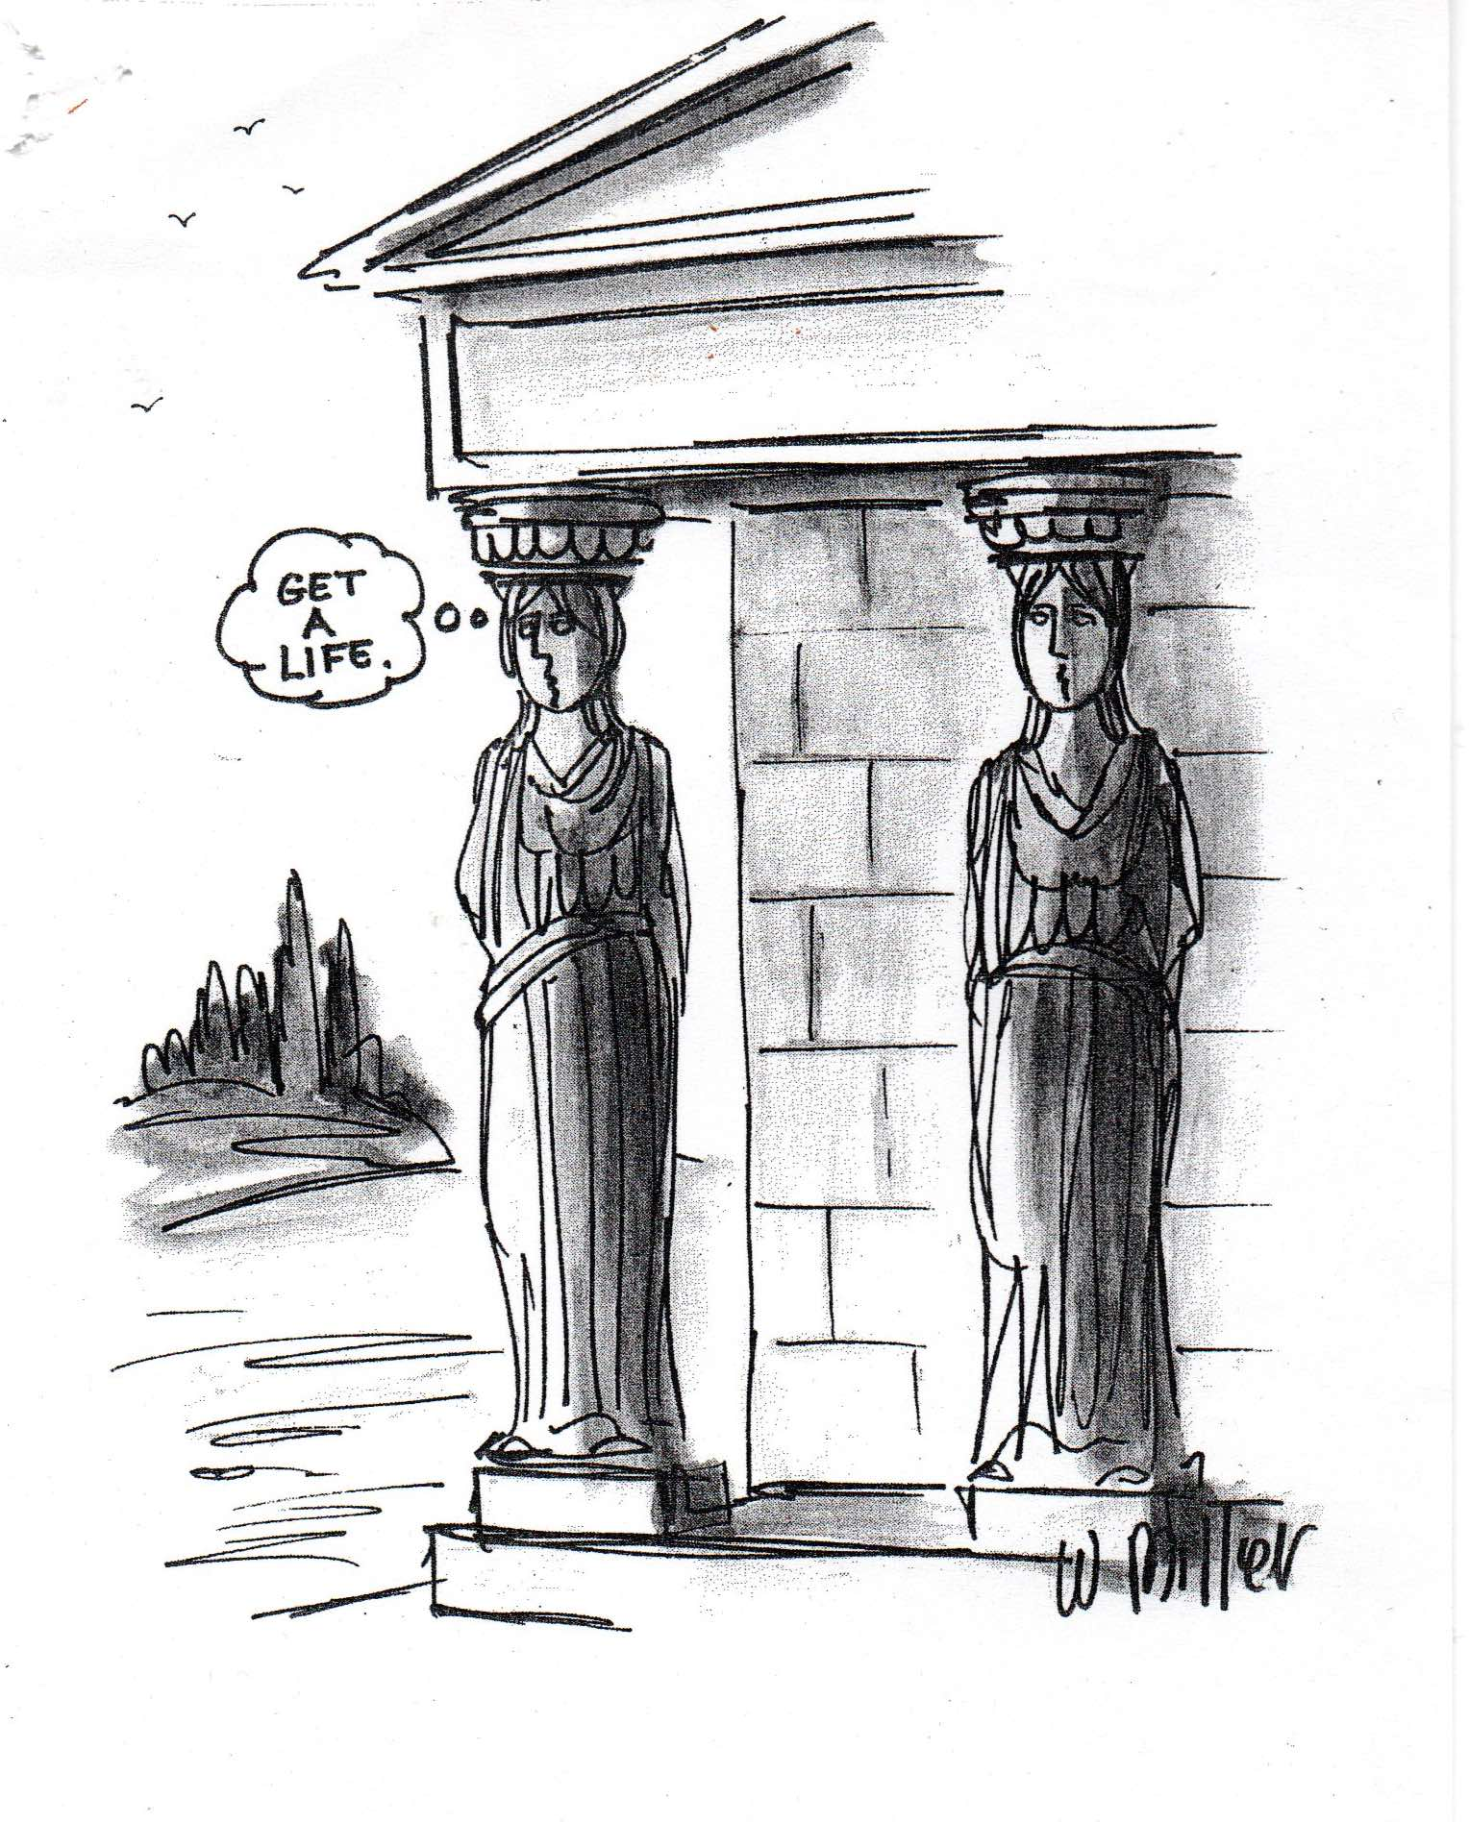
Wiley Miller.

The Parthenon is the epitome of everything we admire about the achievements of Classical Greece. This 5th-century BC Athenian monument to rationality and harmonious balance is a perfect foil for comic strip artists to make fun of our own foibles.

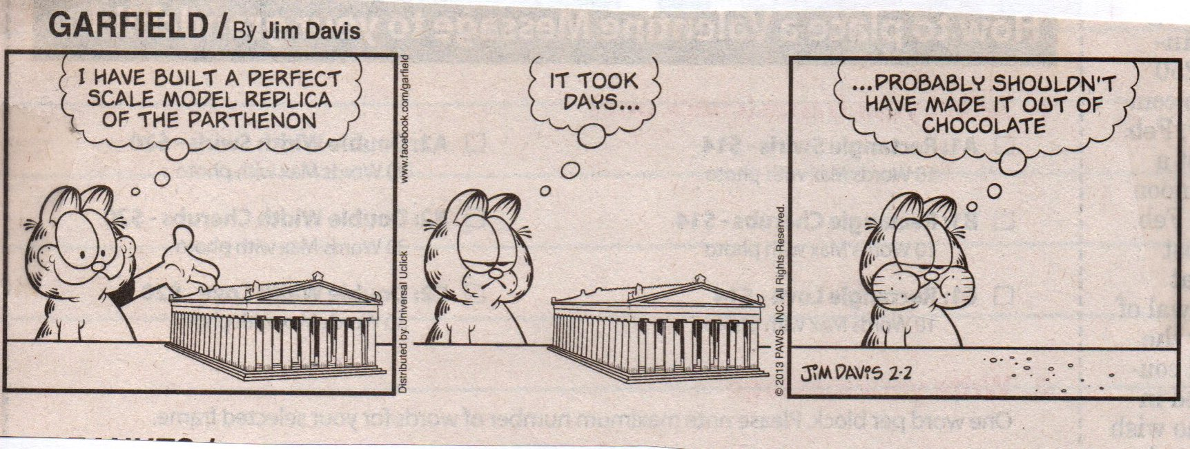
Jim Davis, Garfield.

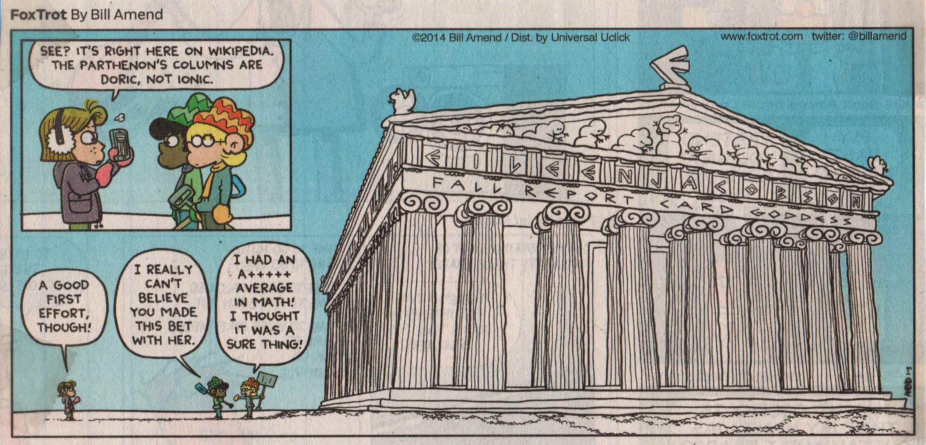
Bill Amend, FoxTrot.

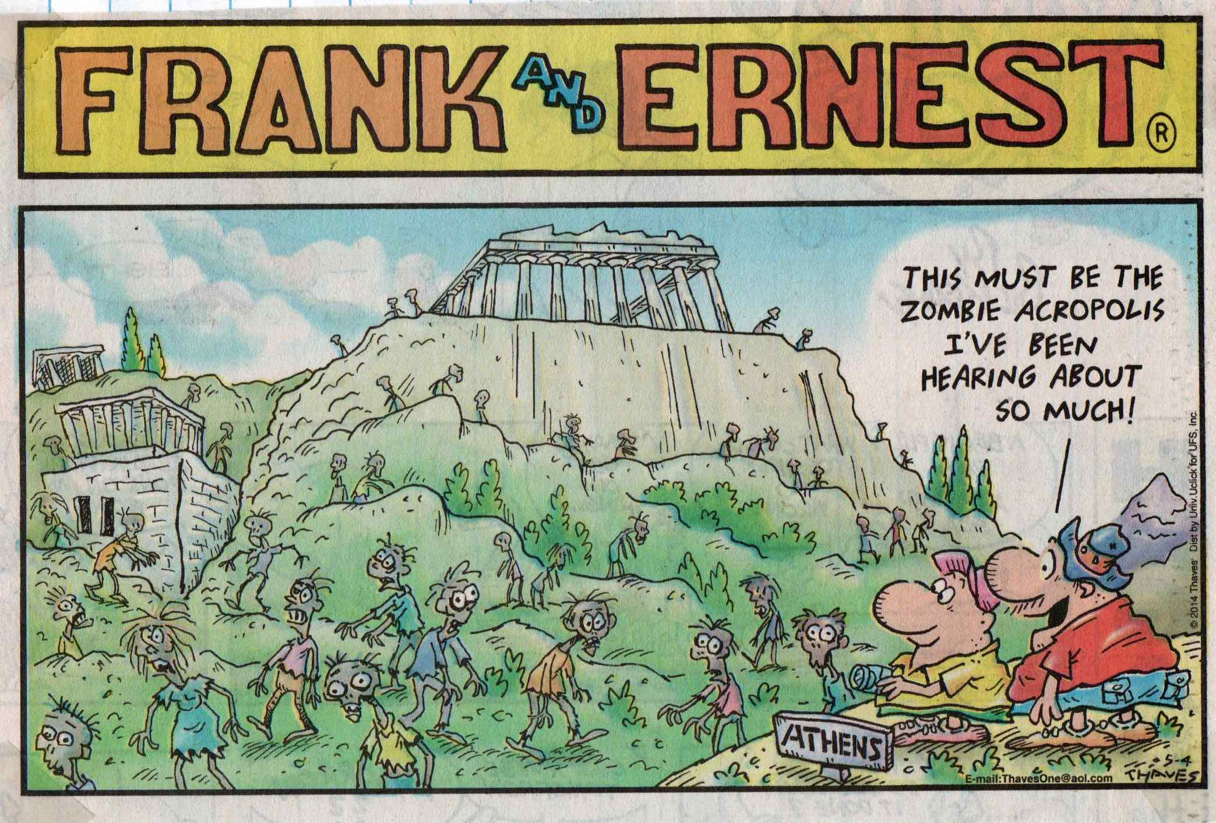
Thaves, Frank and Ernest.

Ridiculous Romans

The fact that this collection contains twenty strips about Classical Greece and only two on ancient Rome might suggest that comics don’t find pragmatic Romans as humorous as intellectual Hellenes.

Mike Peters, Mother Goose & Grimm.

Hilary B. Price, Rhymes with Orange.

Loony Easter Island

For the Rapa Nui people of Easter Island, the moai—the giant monolithic statues they erected between 1250 and 1500 AD around the perimeter of their island—represented the faces of deified ancestors who faced inward to protect clan lands. For the comic strip artist, these statues are irresistible subjects for wacky theories or stone-faced jokes.

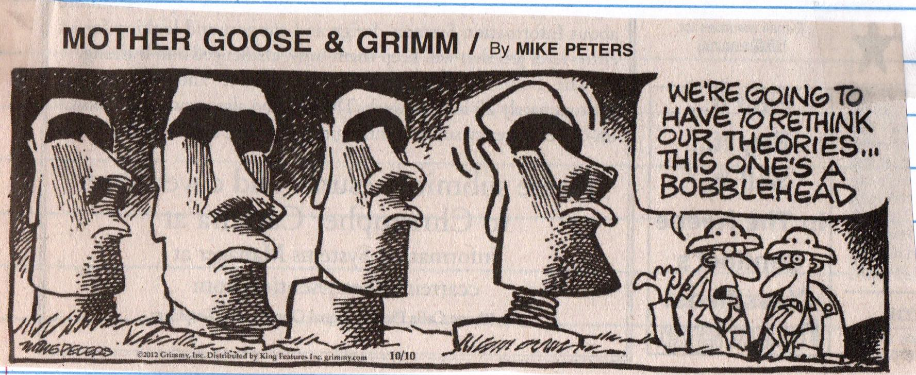

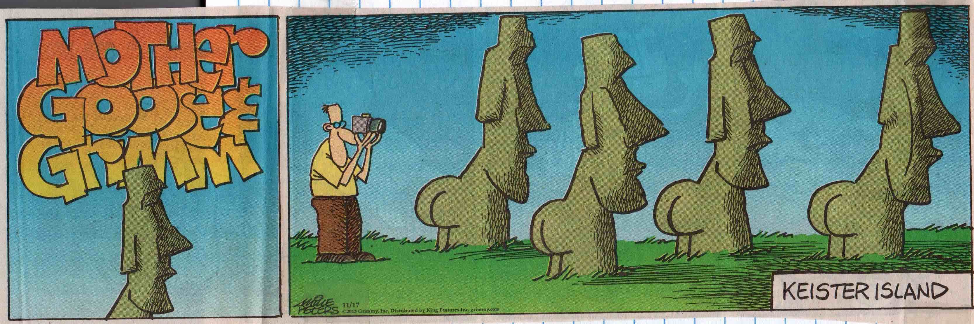
Mike Peters, Mother Goose & Grimm.

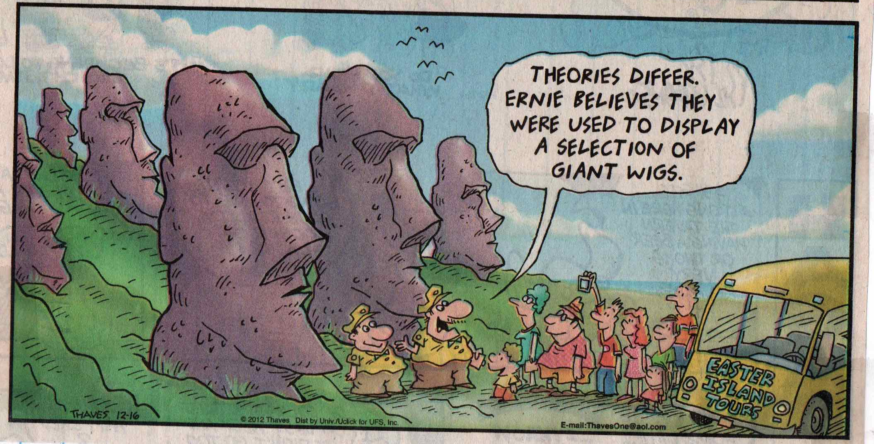
Thaves, Frank and Ernest.

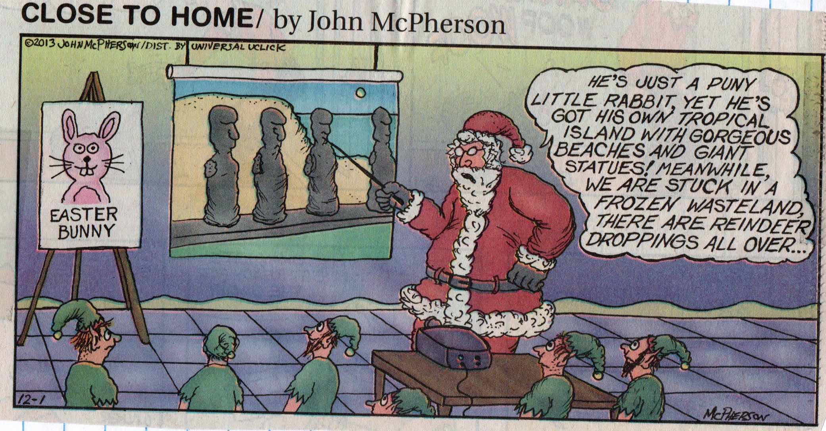
John McPherson, Close to Home.

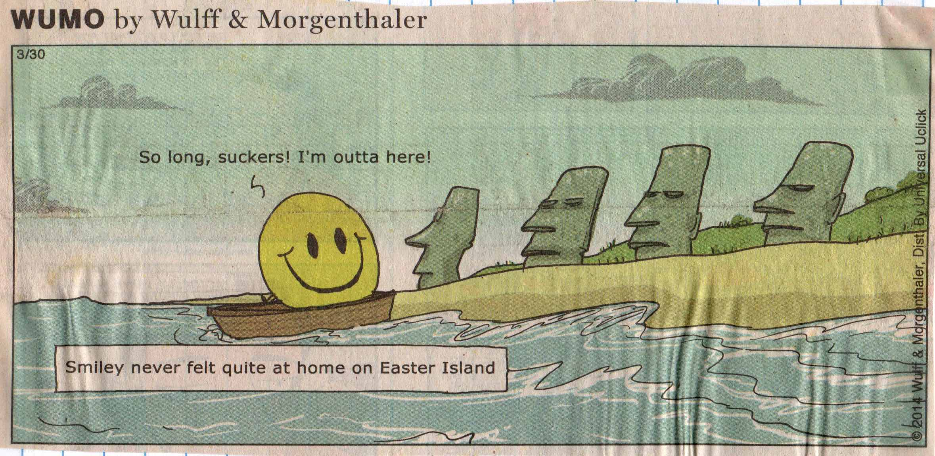
Mikael Wulff & Anders Morgenthaler, Wumo.

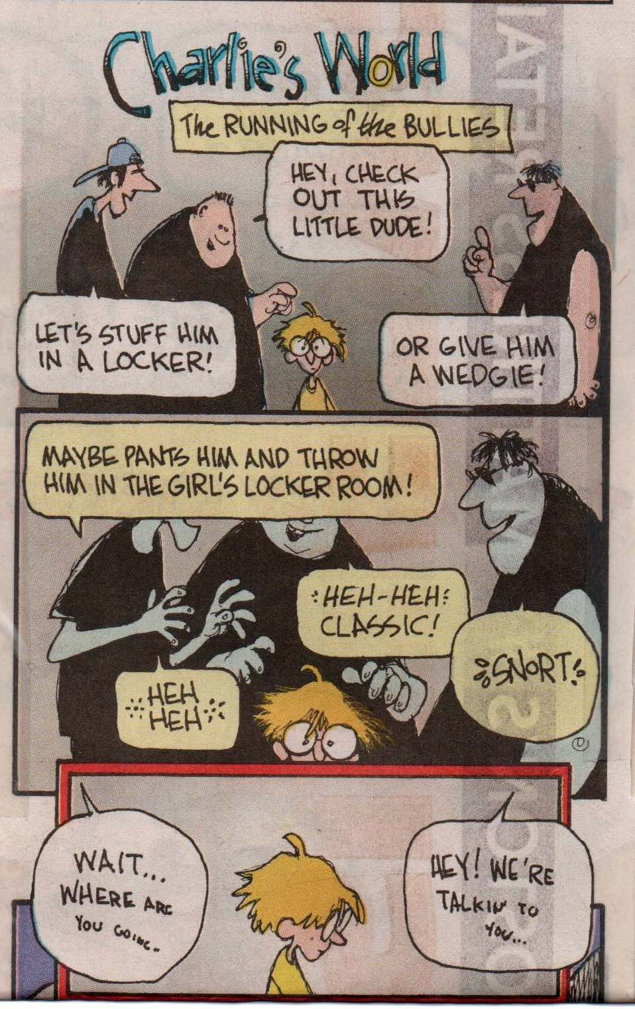  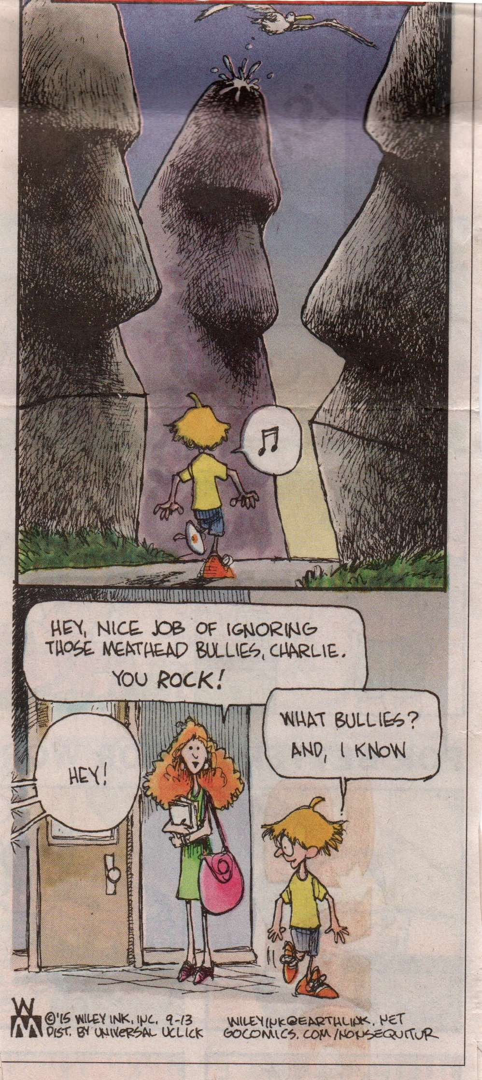 | 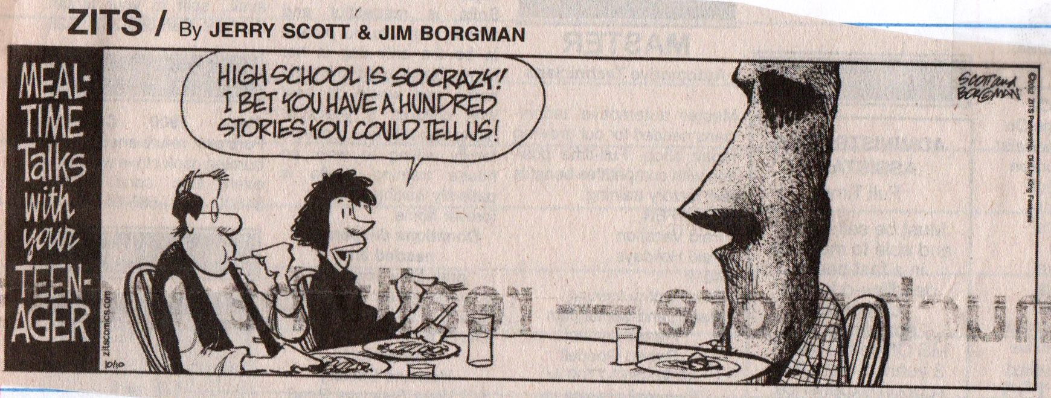
Wiley Miller, Non Sequitur. | Jerry Scott & Jim Borgman, Zits.

Amusing Americas

One might wonder whether the relative paucity of archaeology-themed comic strips about the ancient Americas in this collection is due to a general ignorance of pre-Columbian cultures or to a reluctance to try to find humor in a history of peoples who suffered from European colonialism and genocide.

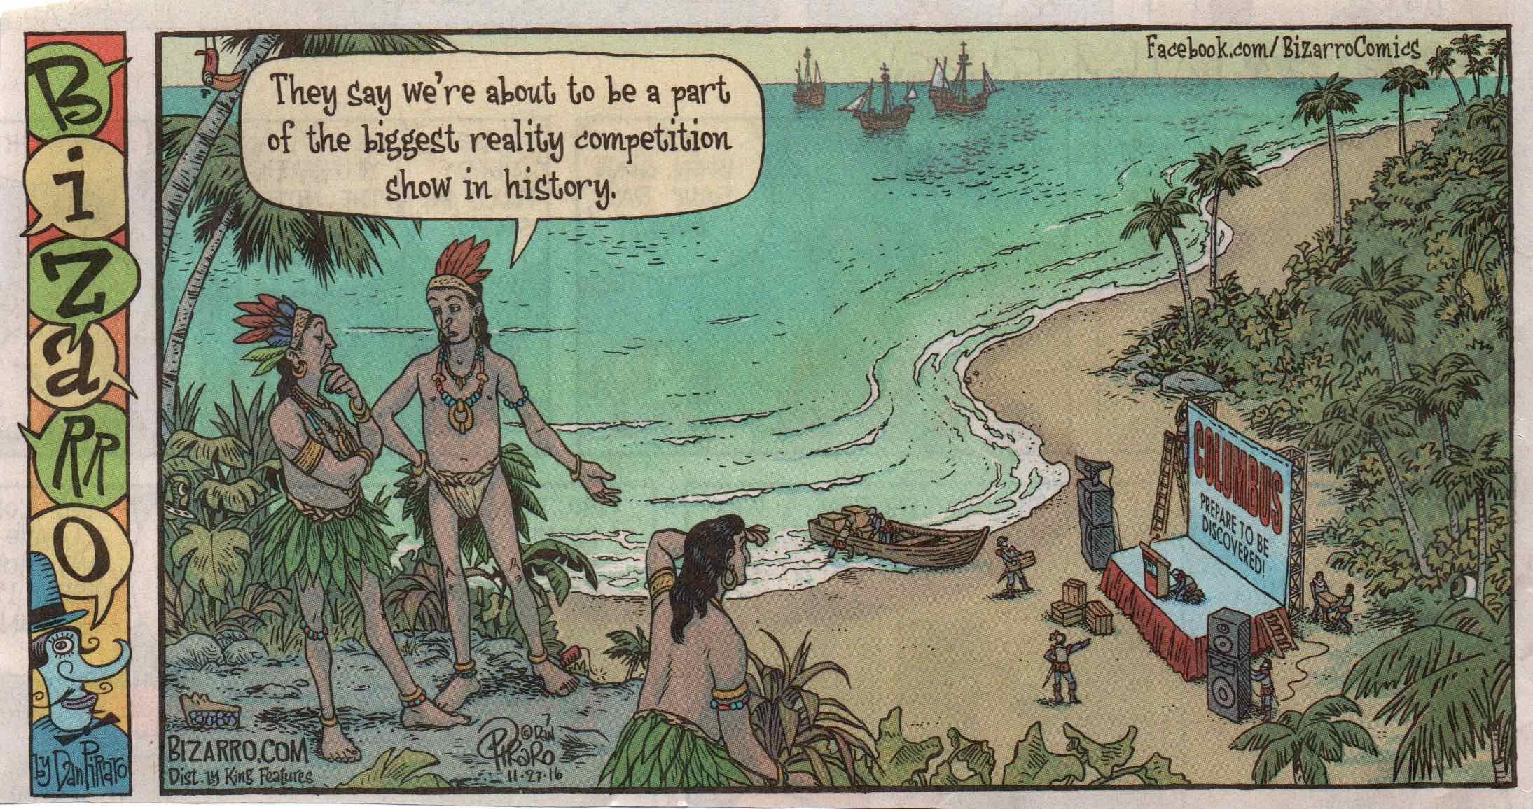
Dan Piraro, Bizarro.

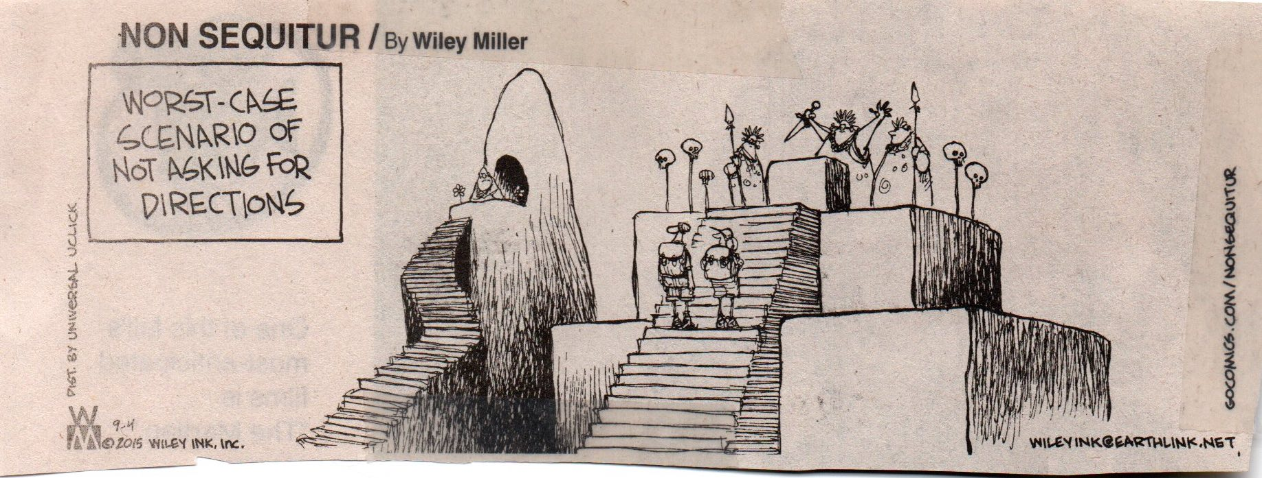
Wiley Miller, Non Sequitur.

Conclusion

The study of humor is a well established sub-discipline in linguistics, literary studies, philosophy, psychology, sociology, and anthropology, and scholars in these fields have developed a wide range of theoretical approaches to the topic. While this voluminous body of scholarly research provides valuable insights into the nature of humor and its social functions, as a whole it confirms what E. B. and Katherine White famously wrote in the preface to their A Subtreasury of American Humor (New York: Coward McCann, 1941): “Humor can be dissected, as a frog can, but the thing dies in the process and the innards are discouraging to any but the pure scientific mind.” Curiously, comic strip humor remains largely overlooked in this scholarly literature, and the few studies that examine the content of comic strips have only focused on such general topics as gender or social relationships and not on specific themes like medicine, art, or archaeology.

Garry Trudeau, Doonesbury, 1989.

While this presentation of one ad hoc collection of art- and archaeology-themed comic strips does not pretend to be a contribution to the scholarly literature on humor, it is hoped that it provides some insights into how syndicated comic strip artists have approached art and archaeology related issues in American newspapers from 2011 to 2017. In particular, this collection reveals a number of prevalent trends in these comic strips—most importantly in the repeated expropriation of certain iconic art or archaeology images. Comic strip representations of such cultural icons as Michelangelo’s Sistine Chapel, Paleolithic cave paintings, or the Egyptian pyramids function as memes—units of cultural information—that are used to establish a comic incongruity whose resolution is the punch line of the visual joke. When viewers notice a cartoon smiley-face painted on a Paleolithic cave or carved on an Egyptian tomb, they turn to the text for the humorous explanation. These types of comic expropriations not only serve to perpetuate the established meanings of the original meme but also to subvert and transform those meanings—that is, to create what might be termed a sub-meme. While real Paleolithic cave paintings are emblematic of the vast antiquity of the human artistic spirit, or real ancient Egyptian monuments serve as reminders that even the proudest of political states will eventually crumble to dust, the cartoons have transmogrified them into sub-memes suggesting that the pettiness and absurdities of modern life are intrinsic features of the human condition. Thus, in the above comic strip, Garry Trudeau has transformed the meme of the real Sistine Chapel—the agony an artist experiences in trying to capture the divine spirit of humanity—into a sub-meme of the crassness of modern American culture, in this case in the form of the buffoonish Donald Trump.

Lest the humorous frog perish on this sort of analytical dissecting table, I end here with thanks to Pam for allowing me to play around with her comic strip collection and with the hope that the reader of this presentation has had a chuckle or two along the way.

Index of Comic Strip Artists

Adams, Scott, 111
Addams, Charles, 9
Amend, Bill, 36, 58, 102, 119
Armstrong, Robb, 39, 46
Bernstain, Stanley and Janice, 11
Berry, Jim, 12
Billingsley, Ray, 81
Brady, Pat & Don Wimmer, 45
Breathed, Berke, 13
Brookins, Gary & Susie MacNelley, 14, 15, 53
Carrillo, Tony, 35, 38
Casssatt, Chris & Gary Brookins & Susie MacNelley, 38
Conley, Darby, 33, 48
Converly, Dave, 66
Crane, Brian, 24, 25
Davis, Jim, 28, 118
Edwing, Duck, 12
Gilligan, Paul, 46, 83, 117
Griffith, Bill, 6, 74–75
Hoest, Bunny & John Reiner, 54–55, 69, 73
Johnson, Jimmy, 14, 18, 36
Johnston, Lynn, 14, 16
Jon, Paul, 33
Ketcham, Hank, 34, 55, 110
Marciuliano, Francesco & Jim Keefe, 14, 16, 17
McDonnell, Patrick, 27
McPherson, John, 82, 91, 95, 96, 99, 114, 122
Meddick, Jim, 6, 21, 22, 23, 49–52, 83, 103
Miller, Wiley, 6, 11, 14, 19, 29, 56, 67, 84, 88, 89, 90, 93, 94, 100, 101, 102, 104, 105, 118, 123
Myers, Russell, 26
Parker & Hart, 32
Peirce, Lincoln, 24, 39, 58
Peters, Mike, 5, 14, 15, 26, 36, 57, 66, 71, 87, 103, 107, 110, 113, 116, 120, 121
Pilburn, Scott, 23
Piraro, Dan, 6, 31, 38, 44, 65, 72, 86, 96, 97, 99, 106, 108, 109, 124
Price, Hilary B., 6, 20, 31, 32, 44, 47, 72, 91, 103, 115, 116, 117, 120
Rickard, Tim, 68
Rockwell, Norman, 59
Schultz, Mark & Thomas Yeates, 112
Schulz, Charles, 1, 79
Scott, Jerry & Jim Borgman, 34, 71, 73, 85, 123
Thaves, 5, 10, 62–64, 82, 92, 114, 119, 122
Toomey, Jim, 56
Trap, Paul, 40–43, 66, 68, 70
Trudeau, Garry, 3, 6, 10, 60, 76–80, 125, 126
Walker, Brian and Greg, 45, 101
Walker, Mort, 69
Weingartens & Clark, 14, 44, 48
Wulff, Mikael & Anders Morgenthaler, 6, 14, 18, 21, 28, 44, 48, 57, 70, 100, 107, 117, 123
Young, Dean & John Marshall, 20, 26, 112

An excellent introduction to the scholarly research on humor can be found in Victor Raskin (ed.) The Primer of Humor Research, Berlin/New York: Mouton de Gruyter, 2008.
Exceptions include Lawrence E. Mintz (“Humor and Popular Culture,” in Raskin, op. cit., pp. 281 – 302), who provides a brief discussion of comic strips, and Christian F. Hempelmann and Andrea C. Samson (“Cartoons: Drawn Jokes?” in Raskin, op. cit., pp. 609 – 640), who survey cognitive and psychological studies of visual humor; cf. also Elizabeth El Reife, “Understanding Visual Metaphor: The Example of Newspaper Cartoons,” Visual Communication 2(1), 2003, pp. 75 –95, a useful study of political cartoons.

